

**FACULTY OF SCIENCE**

**SCHOOL OF COMPUTER SCIENCE**

**2021-2022**

**A**

**PROJECT REPORT**

**ON**

**PG Locator System**

**BY**

**Madhav Parikh (MCA-52)**

**Bhupender Kumar (MCA-35)**

**Nishant Jain (MCA-24)**

**Trilok Sharma (MCA-65)**

**IN PARTIAL FULFILLMENT OF**

**MASTER OF COMPUTER APPLICATION (SCIENCE)**

**MIT WORLD PEACE UNIVERSITY**



**SCHOOL OF COMPUTER SCIENCE**

Certificate

This is to certify that**, Madhav Parikh, Bhupender Kumar, Nishant Jain, Trilok Sharma** studentof MCA (Computer Science) Trimester II have successfully completed the project in partial fulfilment of M.Sc. Computer Science under MIT World Peace University, for the academic year 2021-2022

Dr. Jalinder Gandal

Internal Guide

Date: 14/05/2022

**ACKNOWLEDGEMENT**

We wish to express our gratitude to all the people involved in contributing this project of our web application **“PG Locator System”.** We take this opportunity to thank all who have helped us during the project work.

We would like to thank our college, MIT WPU for providing us the opportunity to work on project and gain experience from the same. We present our heartful thanks to **Jalindar Gandal**, our internal guide for her critical reviews of the project which help us to make this more presentable. His gentle support and direction guided us in all aspects of the project.

Last but not the least we would like to express our sincere thanks to our parents for their precious support and their motivation for completing this project.

**DECLARATION**

We certify that this assignment/report is our own work, based on our personal study and/or research and that we have acknowledged all material and sources used in its preparation, whether they be books, articles, reports, lecture notes, and any other kind of document, electronic or personal communication. We also certify that this assignment/report has not previously been submitted for assessment in any other unit. We have not copied in part or whole or otherwise plagiarised the work of other students and/or persons.

Madhav Parikh (MCA-52)

Bhupender Kumar (MCA-35) 15/05/2022

Nishant Jain (MCA-24)

Trilok Sharma (MCA-65)

**INDEX**

| **Sr. No.** | **Contents** | **Page No.** |
| --- | --- | --- |
| **Chapter 1** | **INTRODUCTION** |  |
| 1.1 Existing System | 1 |
| 1.2 Problem Definition- Need of Computerization | 1 |
| **Chapter 2** | **PROPOSED SYSTEM** |  |
| 2.1 Proposed System | 2 |
| 2.2 Objectives of System | 4 |
| 2.3 User Requirements | 5 |
| 2.4 Operating Environment – Hardware and Software | 5 |
| **Chapter 3** | **ANALYSIS AND DESIGN** |  |
| 3.1 ERD | 6 |
| 3.2 Data Dictionary | 7-11 |
| 3.3 Screen Layouts | 12-42 |
| 3.4 Reports | 43-54 |
| **Chapter 4** | **CONCLUSION** |  |
| 5.1 Limitations & Drawbacks | 55 |
| 5.2 Future Enhancement | 55 |
| 5.3 Conclusion | 55 |
| 5.4 References & Bibliography | 55 |

**INTRODUCTION**

**EXISTING SYSTEM**

* If you are new in the city and looking for some accommodations to stay, you will have to explore across the city that surely will take a lot of time!
* The process will start as you will contact the PG owner through an advertisement or through someone’s reference.
* You might not have an idea about how many beds are available in a room for booking.
* As a result, it becomes much more difficult for an individual and very time consuming.
* So, to take care of this, we have proposed a system which makes it much easier.

**PROBLEM DEFINITION- NEED OF COMPUTERIZATION**

The Technology is nowadays modern every Customer has atleast one Mobile or Laptop and everyone wants a simple process for the whole scenario of the PG Booking.

So instead of paperwork and full of hassle work, we focus on a direct online process where Customers can directly browse throughout the website and search a relevant PG suitable to his budget and can request to book a bed in any room easily.

**PROPOSED SYSTEM**

**PROPOSED SYSTEM**

* Sole purpose of this Web Application is to provide the Customers/users seamless process throughout the process of PG Booking.
* Customers will have access to all the PGs registered and authorised on the website.
* Customer can simply request for booking a bed in any room suiting his requirements.
* For Booking he/she must have to pay a reasonable token amount.
* After the Owner of the PG accepts/rejects the requests for booking, the same will be reflected in the customer bookings. If rejected, then the token amount paid by the customer will be reflected to his/her bank account within 3 business days.

**(i) Administrators:**

**a)** Admin can manage the users/owners of the website by Activating or Deactivating them.

**b)** Admin can view total bookings made on the website.

**c)** Admin can view total feedbacks sent on the website.

**d)** Admin can manage the PGs registered on the website by Activating or Deactivating them.

**e)** Admin can generate reports (User Wise, PG Owner Wise, PG Wise, PG Rooms Wise, Booking and Transaction Wise, Feedback Wise) as well as he can export every report as PDF and Excel sheet.

**(ii) Customer/users:**

**a)** User will be able to update his profile.

**b)** User can search PGs by using filters like name of pg / location of pg / type of pg.

**c)** The relevant ads will be shown on the first page, he/she can get more details about that PG then he/she can request for booking for a room.

**d)** He/she can also save the PGs he/she likes to his/her favourites, Same will be reflected in My favourites tab.

**e)** He/she can view the location of the PG on the Google Maps.

**f)** After placing the request for booking he/she can view his booking status whether it is Approved, Rejected or Pending.

**g)** He/she will be able to pay the token amount only after the request for booking has been accepted. Same will be reflected in the payment status tab.

**(iii) Owner:**

**a)** Owner will be able to update his profile.

**b)** Owner can see all the properties listed by him from view all pg tab.

**c)** Owner can Hide the PG, Delete the PG, View/Add/Update the Rooms of a PG.

**d)** Owner can also update the details of the PGs listed by him/her.

**e)** Owner can Add a new PG by providing all the appropriate and relevant information about the PG.

**f)** Owner will be able to Accept / Decline the booking requests made by customersfrom the pending section.Same will be reflected in the Bookings tab.

**OBJECTIVES OF SYSTEM**

Our main objective behind this Project (PG Locator System) is to provide a very seamless process in PG booking with the live availability of the beds available.

• It is been designed to handle some basic problems which a user may face while booking PG.

• This would be a user-friendly platform where user can see every detail regarding the PG and request for booking for the same.

• This platform will turn out to be useful as a user will not have to visit the PG physically to check the availability of the beds.

• This project will be designed and developed using Python flask (venv) and database backend will be SQL Workbench.

• Focus of this project is to provide one stop solution in the process of PG accommodation booking.

• This platform shows every detail regarding the facilities (Ordinary and Special), token amount, live availability of beds, total number of beds, details of PG Owner and many more.

**USER REQUIREMENTS**

**User Interfaces**

The set of User Interfaces consists of,

**a)** To Login to their accounts after registering.

**b)** To Search among the list of available PGs.

**c)** To Book a room with a reasonable amount in the form of token.

**Hardware Interfaces**

Following could be the hardware which can be considerable for our system:

Standard Keyboard, Pointing Device, Display Monitor, Normal Configuration (RAM > 2GB, Graphics integrated, Storage min 256 GB max 500 GB).

**Software Interfaces**

The following could be the software which can be considerable for our system:

Operating System- Windows (Versions > windows xp).

Frontend :- HTML 5 + CSS + JS + Bootstrap + JQuery + MS Excel.

Backend :- Python flask + No Database Required (Cloud Database).

This Website platform would be securely accessible through internet (wired or wireless).

**OPERATING ENVIRONMENT – HARDWARE AND SOFTWARE**

This software is expected to work in the following atmosphere:

i) OS:- Windows 7 , 8, 10.

iii) SQL Workbench.

iv) Python flask.

**ANALYSIS AND DESIGN**

**ERD**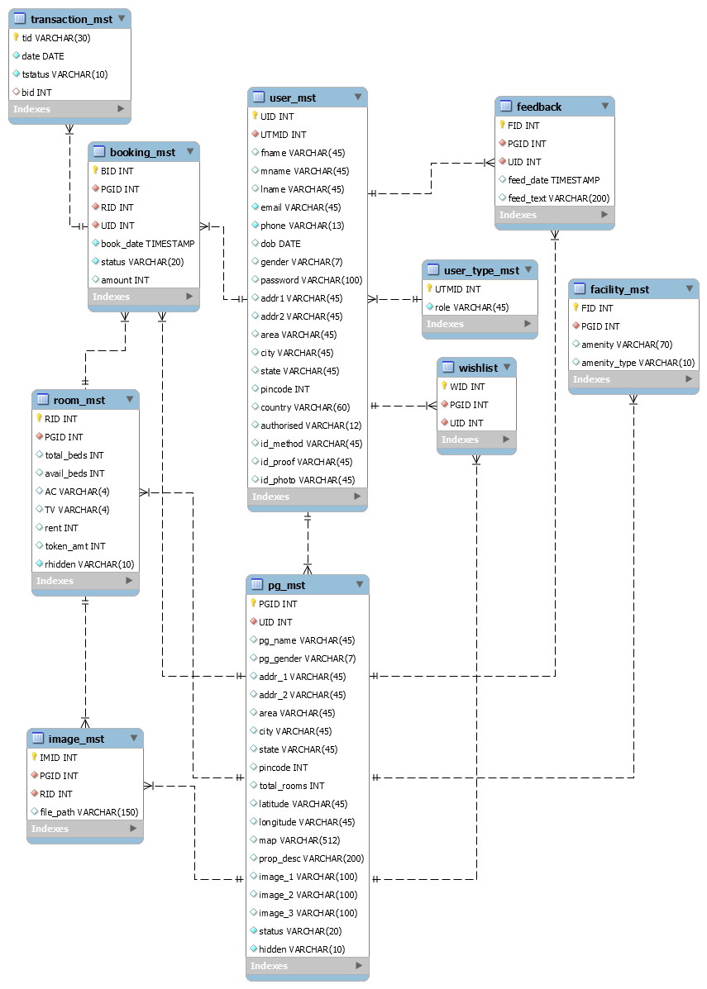

**DATA DICTIONARY**

| **user_mst** | | | | |
| --- | --- | --- | --- | --- |
| Field Name | Data type | Size | Constraint | Description |
| UID | Int | 20 | Primary Key | It stores the unique user id |
| UTMID | Int | 20 | Foreign Key | It stores the user type master id |
| fname | Varchar | 45 | Not Null | It stores the first name |
| mname | Varchar | 45 | Not Null | It stores mother name |
| lname | Varchar | 45 | Not Null | It stores the last name |
| email | Varchar | 45 | Not Null | It stores the email |
| phone | Varchar | 13 | Not Null | It stores the Contact number. |
| dob | Date |  | Not Null | It stores DOB |
| gender | Varchar | 7 | Not Null | It stores gender |
| password | Varchar | 100 | Not Null | It stores password |
| addr1 | Varchar | 45 | Not Null | It stores address part 1 |
| addr2 | Varchar | 45 | Not Null | It stores address part 2 |
| area | Varchar | 45 | Not Null | It stores name of the area |
| city | Varchar | 45 | Not Null | It stores name of the city |
| state | Varchar | 45 | Not Null | It stores the name of state |
| pincode | Int | 7 | Not Null | it stores the pin code |
| country | Varchar | 45 | Not Null | it stores the country name |
| authorised | Varchar | 45 | Not Null | it stores the status of authorized(Yes/No) |
| id_method | Varchar | 45 | Not Null | it stores the method of identification used |
| id_proof | Varchar | 45 | Not Null | It stores the ID proof location |
| id_photo | Varchar | 45 | Not Null | it stores the ID photo location |

| **pg_mst** | | | | |
| --- | --- | --- | --- | --- |
| Field Name | Data type | Size | Constraint | Description |
| pgid | Int | 20 | Primary Key | It stores the unique PG id |
| uid | Int | 20 | Foreign Key | It stores the user ID |
| pg_name | Varchar | 45 | Not Null | it stores the PG name |
| pg_gender | Varchar | 7 | Not Null | it stores the type of pg |
| addr1 | Varchar | 45 | Not Null | it stores the address of the PG |
| addr2 | Varchar | 45 | Not Null | it stores the address of the PG |
| area | Varchar | 45 | Not Null | it stores the area of the PG |
| city | Varchar | 45 | Not Null | it stores the city of the PG |
| state | Varchar | 45 | Not Null | It stores the state of the PG |
| pincode | Int | 7 | Not Null | it stores the pin code |
| total_rooms | Int | 100 | Not Null | It stores the total number of rooms |
| latitude | Varchar | 300 | Not Null | it stores lattitude of the location of PG |
| longitude | Varchar | 300 | Not Null | it stores the longitude of the location of PG |
| map | Varchar | 1000 | Not Null | it stores the URL of the location of PG on map |
| prop_desc | Varchar | 200 | Not Null | it stores the description of the property listed |
| image1 | Varchar | 100 | Not Null | It stores the path of the image |
| image2 | Varchar | 100 | Not Null | it stores the path of the image |
| image3 | Varchar | 100 | Not Null | it stores the path of the image |
| status | Varchar | 20 | Not Null | it stores the status of the PG (activated or deactivated) |
| hidden | Varchar | 10 | Not Null | it stores whether the PG is visible or not (yes or No) |

| **user_type_mst** | | | | |
| --- | --- | --- | --- | --- |
| Field Name | Data type | Size | Constraint | Description |
| UTMID | Integer | 20 | Primary Key | it stores the unique user type master ID |
| role | Varchar | 45 | Not Null | it stores the role of the user(admin or owner or customer) |

| **room_mst** | | | | |
| --- | --- | --- | --- | --- |
| Field Name | Data type | Size | Constraint | Description |
| RID | Int | 20 | Primary Key | it stores the unique room ID |
| PGID | Int | 20 | Foreign key | it stores the PG ID |
| total_beds | Int | 20 | Not Null | it stores the number of total beds in a room |
| avail_beds | Int | 20 | Not Null | It stores the total number of available beds in the room |
| AC | Varchar | 4 | Not Null | it is stores the value of AC (0 or 1) |
| TV | Varchar | 4 | Not Null | it stores the value of TV (0 or 1) |
| rent | Int | 10 | Not Null | it stores the amount of rent |
| token_amt | Int | 10 | Not Null | it stores the token amount |
| rhidden | Varchar | 10 | Not Null | hey it stores the value of visibility of room (yes or no) |

| **booking_mst** | | | | |
| --- | --- | --- | --- | --- |
| Field Name | Data type | Size | Constraint | Description |
| BID | Int | 20 | Primary Key | It stores the unique booking ID |
| PGID | Int | 20 | Foreign key | it stores the pgid |
| RID | Int | 20 | Foreign Key | it stores the room id |
| UID | Int | 20 | Foreign Key | It stores the user ID |
| book_date | Timestamp |  | Not Null | it stores the date of booking |
| status | Varchar | 20 | Not Null | It stores the status of booking |
| amount | Integer | 30 | Not Null | it stores the amount of booking paid |

| **transaction_mst** | | | | |
| --- | --- | --- | --- | --- |
| Field Name | Data type | Size | Constraint | Description |
| Tid | Varchar | 30 | Primary Key | it stores the unique transaction id |
| date | Date |  | Not Null | it stores the date of transaction |
| tstatus | Varchar | 10 | Not Null | it stores the status of transaction |
| bid | Int | 20 | Not Null | It stores the booking id |

| **image_mst** | | | | |
| --- | --- | --- | --- | --- |
| Field Name | Data type | Size | Constraint | Description |
| IMID | Int | 20 | Primary Key | It stores the unique image id |
| PGID | Int | 20 | Foreign Key | It stores the pg id |
| RID | Int | 30 | Foreign Key | It stores the room id |
| file_path | Varchar | 150 | Not Null | It stores the path of the image |

| **facility_mst** | | | | |
| --- | --- | --- | --- | --- |
| Field Name | Data type | Size | Constraint | Description |
| FID | Integer | 20 | Primary Key | It stores the unique fid |
| PGID | Integer | 20 | Foreign Key | It stores the PGID |
| amenity | Varchar | 70 | Not Null | It stores the amenities |
| amenity_type | Varchar | 10 | Not Null | It stores the amenities type |

| **feedback** | | | | |
| --- | --- | --- | --- | --- |
| Field Name | Data type | Size | Constraint | Description |
| FID | Integer | 20 | Primary Key | It stores the unique FID |
| PGID | Integer | 20 | Foreign Key | It stores the PGID |
| UID | Int | 20 | Foreign Key | It stores the uid |
| feed_date | Timestamp |  | Not Null | It stores the feedback date |
| feed_text | Varchar | 200 | Not Null | It stores the feedback message |

| **wishlist** | | | | |
| --- | --- | --- | --- | --- |
| Field Name | Data type | Size | Constraint | Description |
| WID | Integer | 20 | Primary Key | It stores the unique WID |
| PGID | Integer | 20 | Foreign key | It stores the PGID |
| UID | Integer | 20 | Foreign Key | It stores the UID |

**Screen Layouts**

Homepage

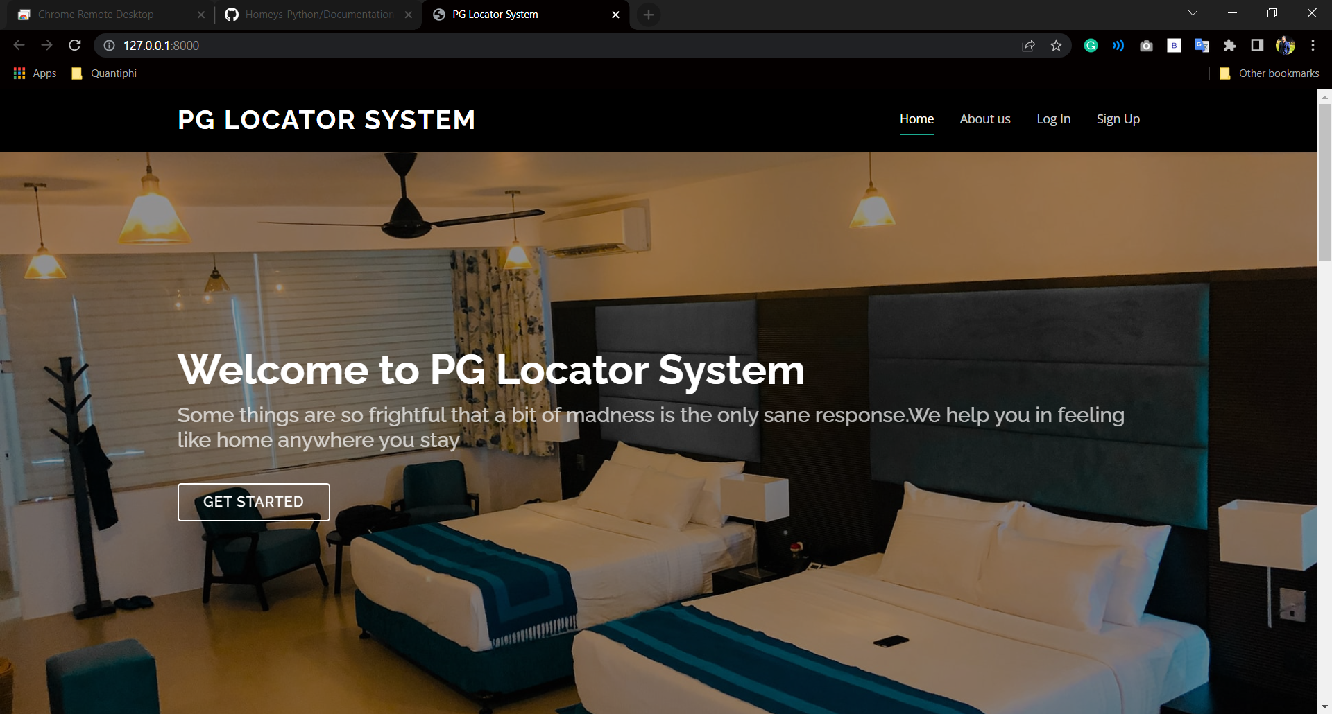

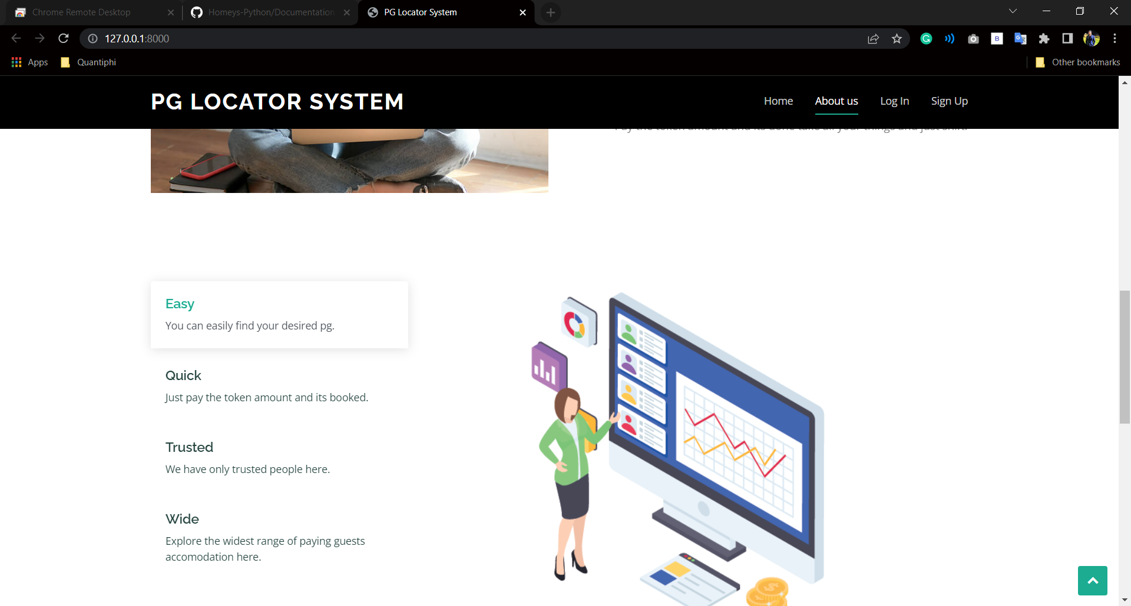

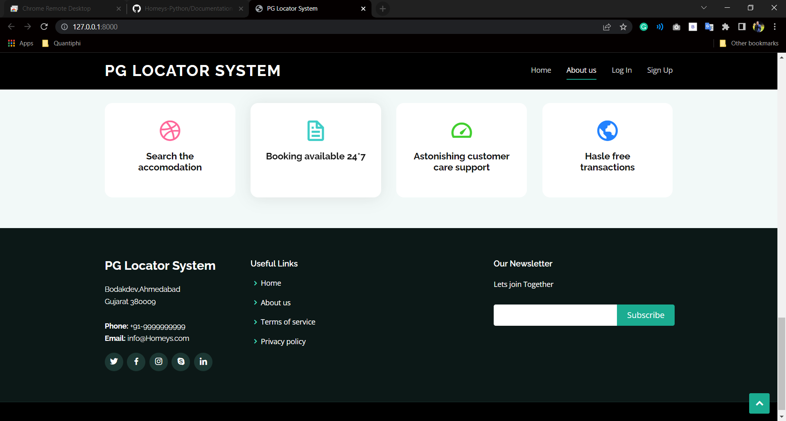

Login

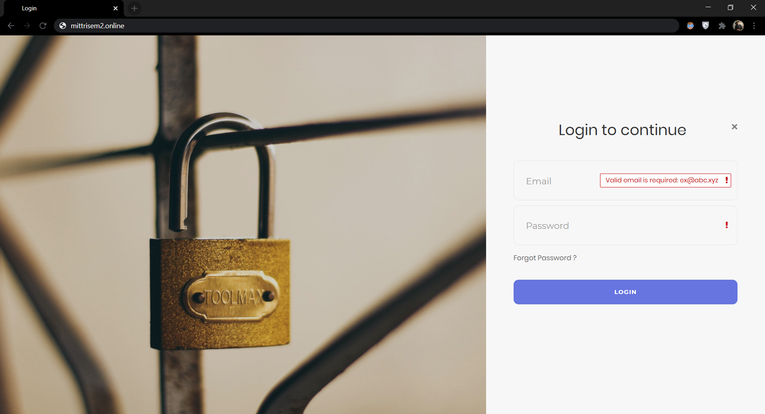

Forgot Password

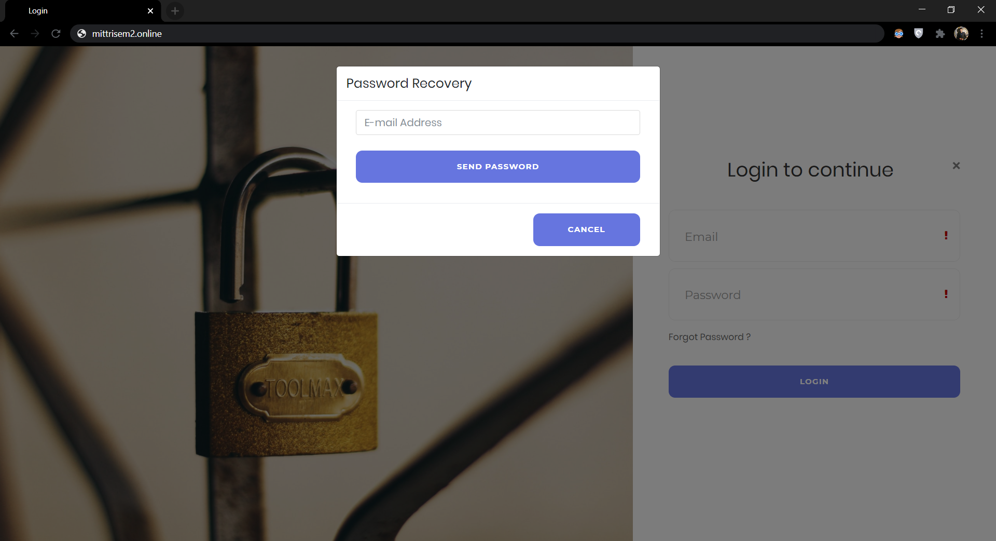

Registeration

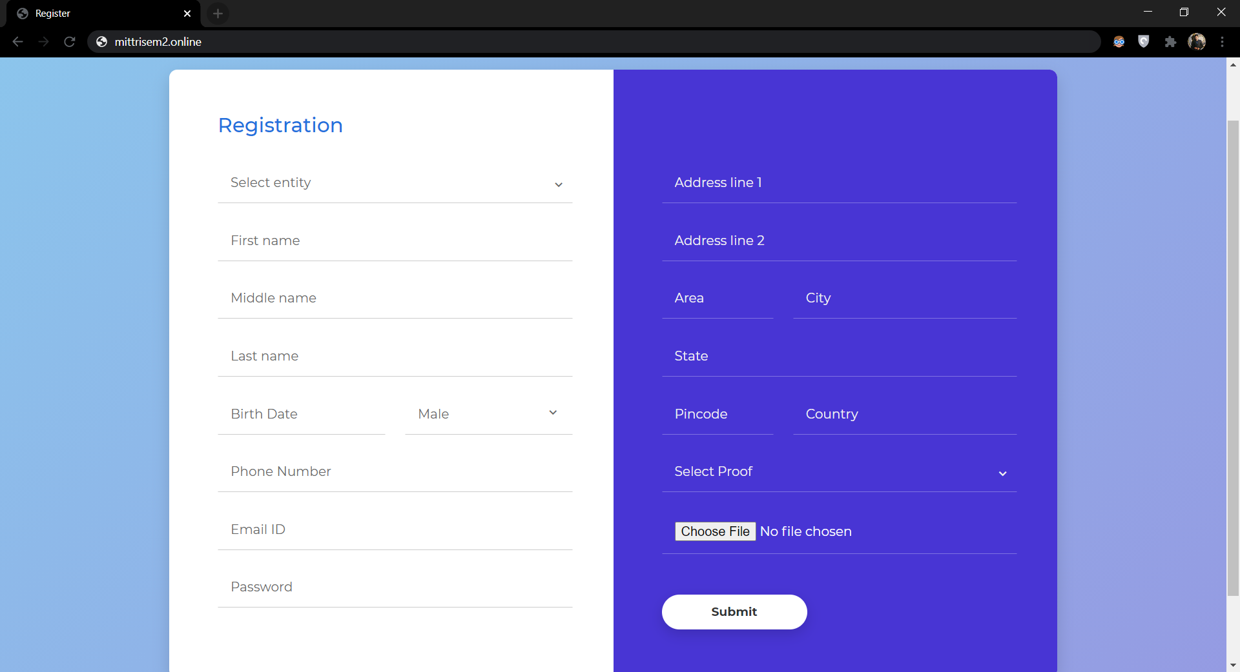

**PG Owner**

Dashboard

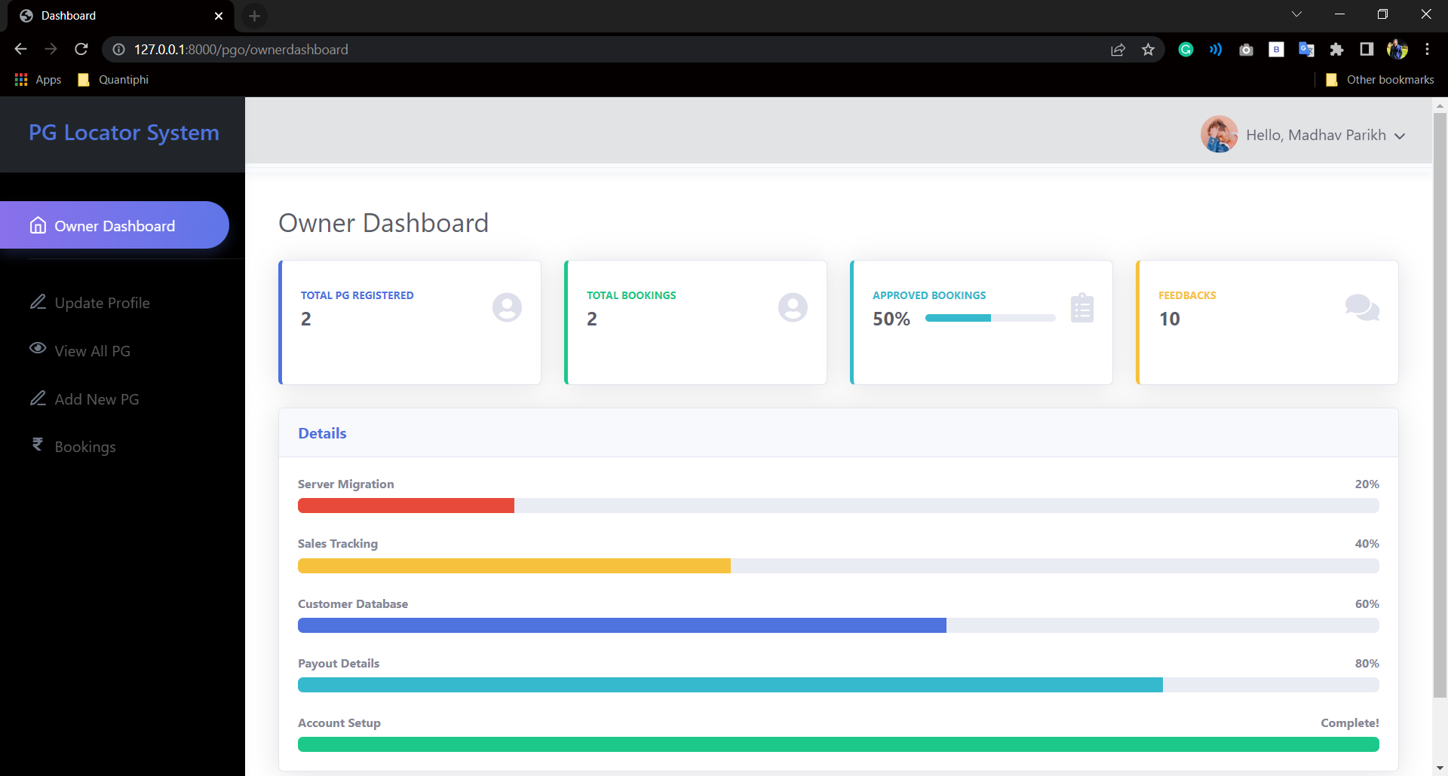

Update Profile

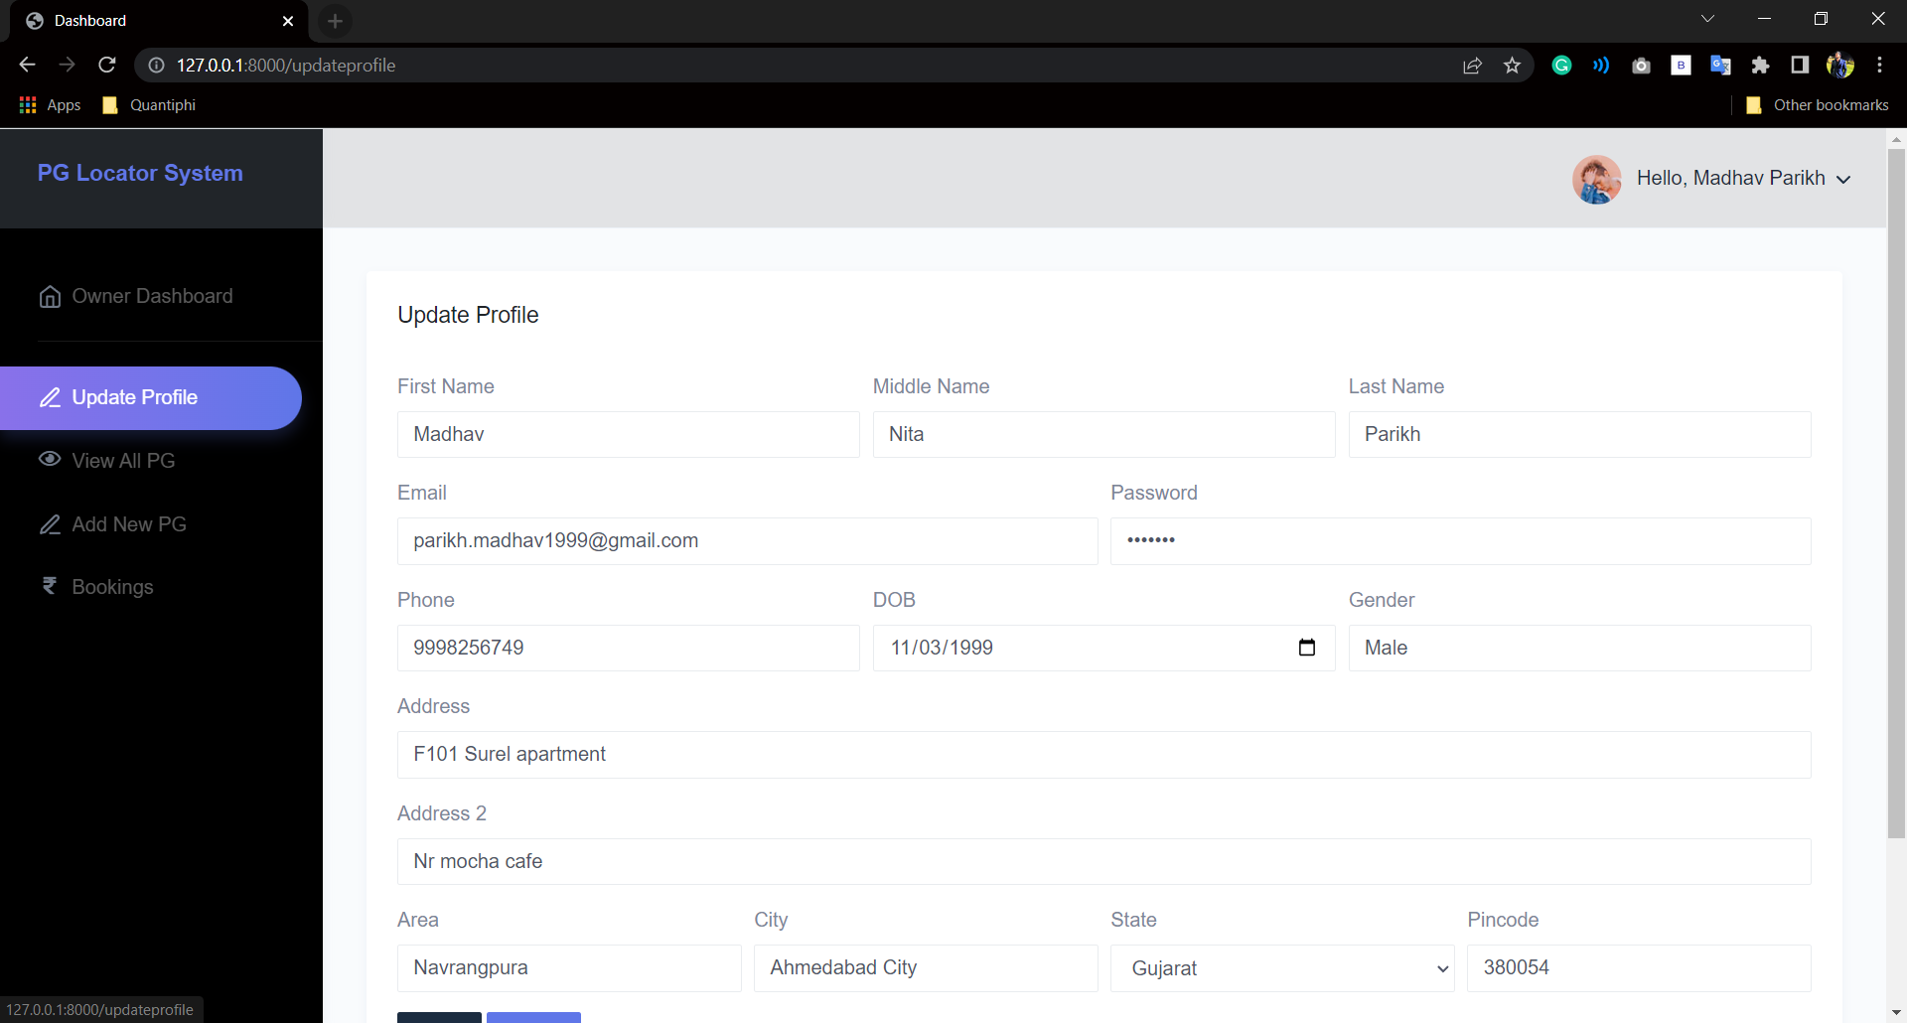

View All PG

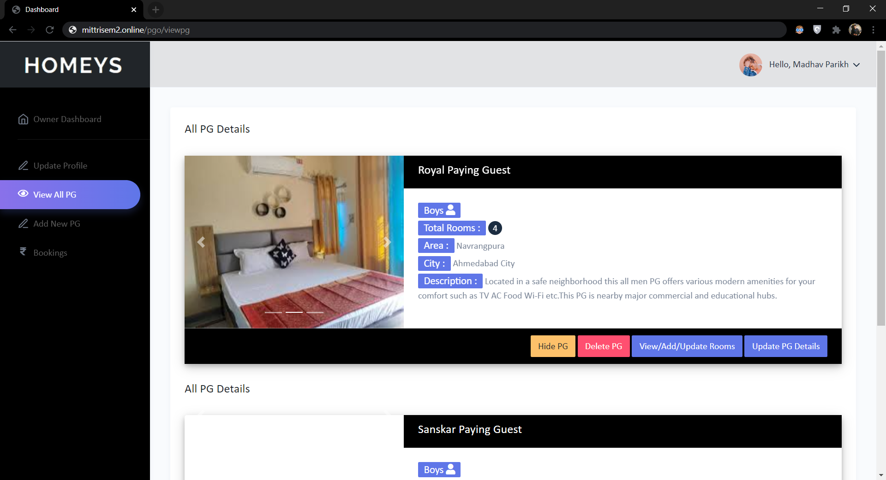

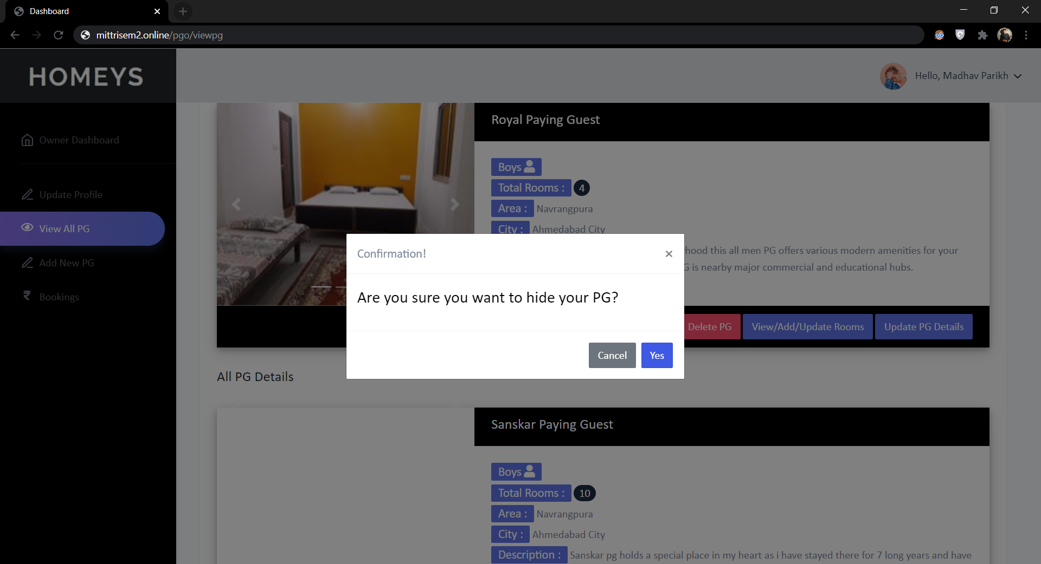

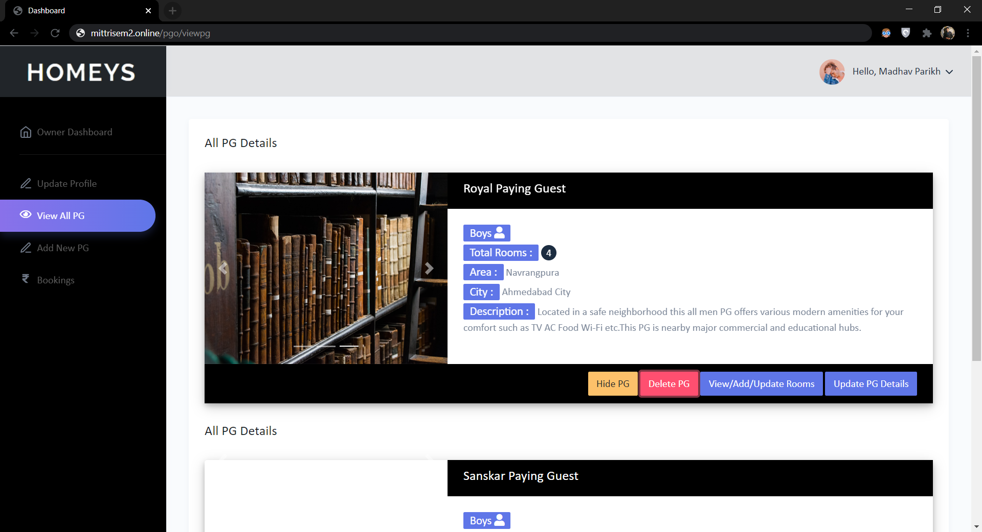

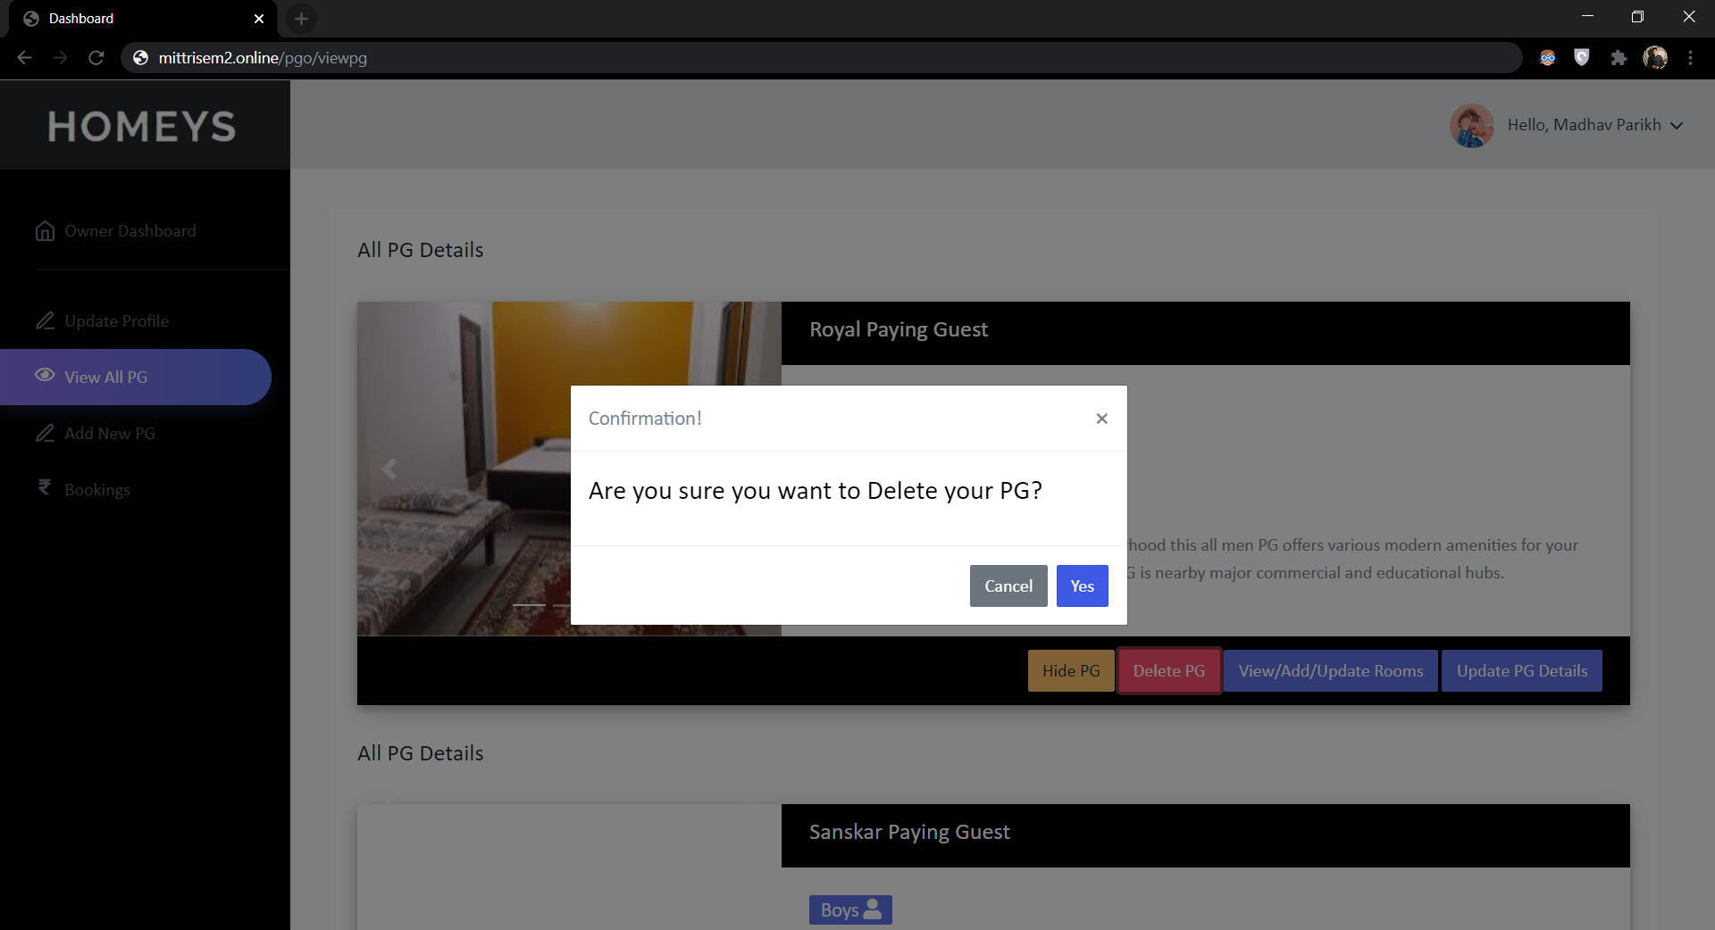



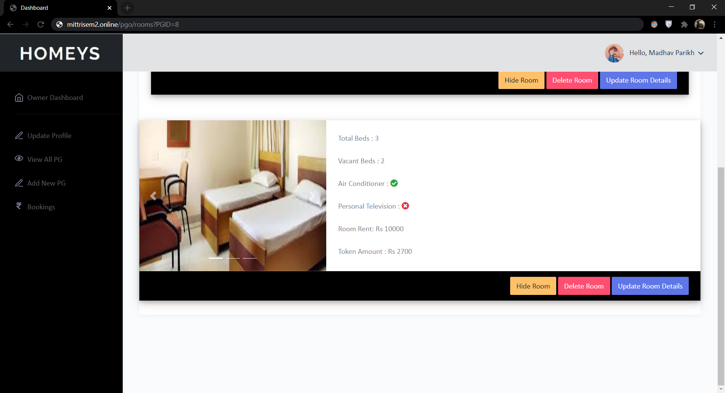



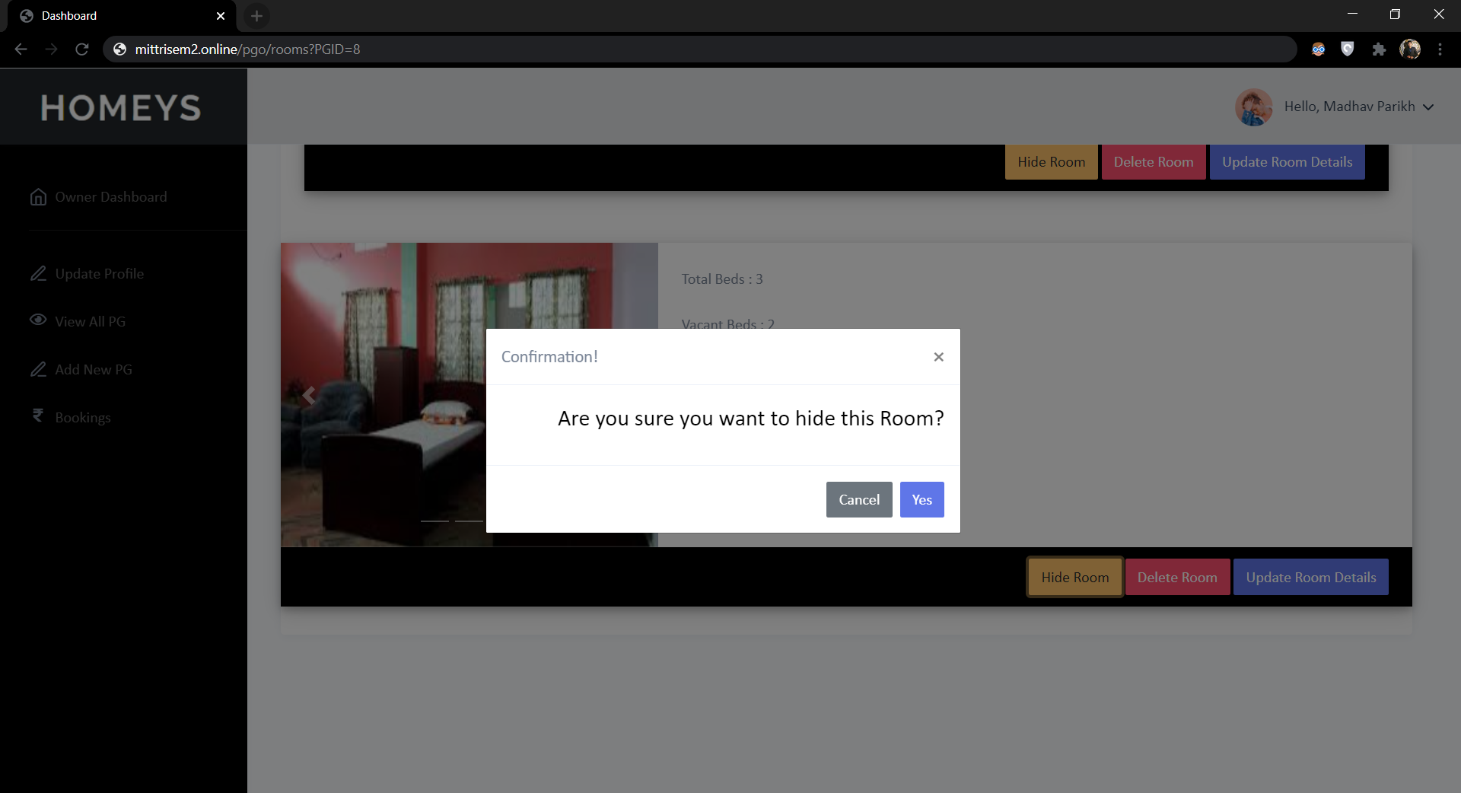

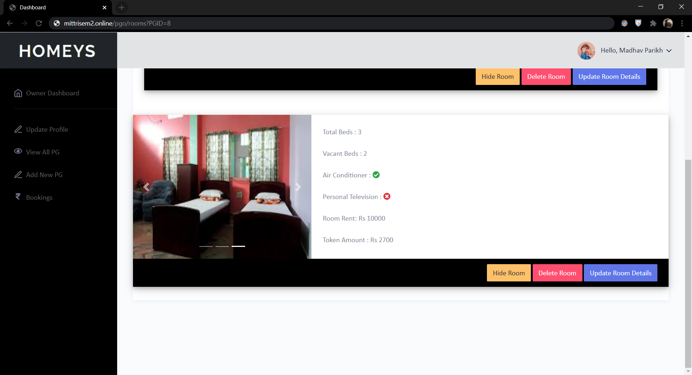

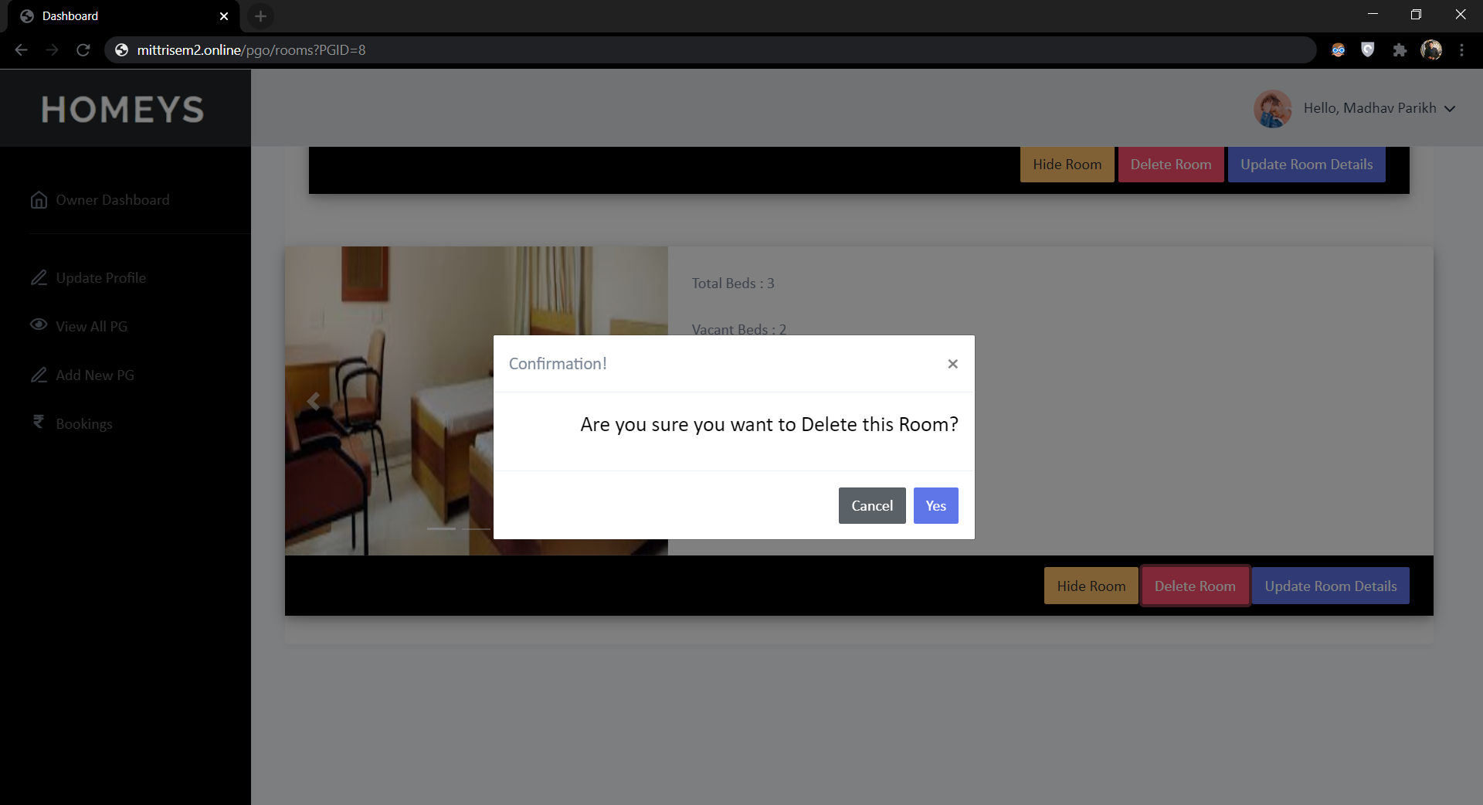

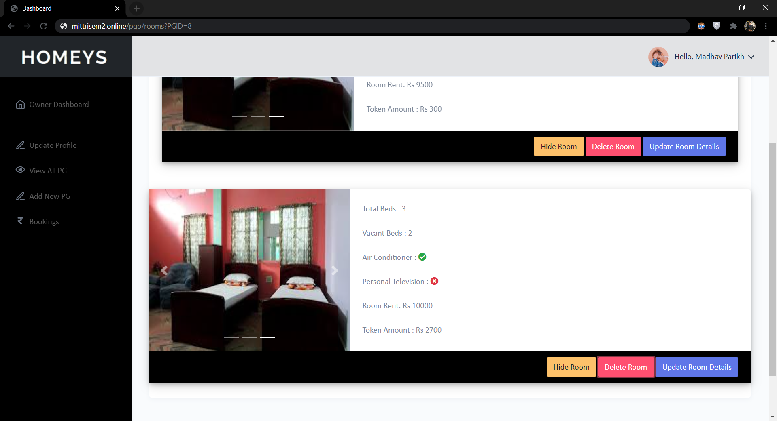

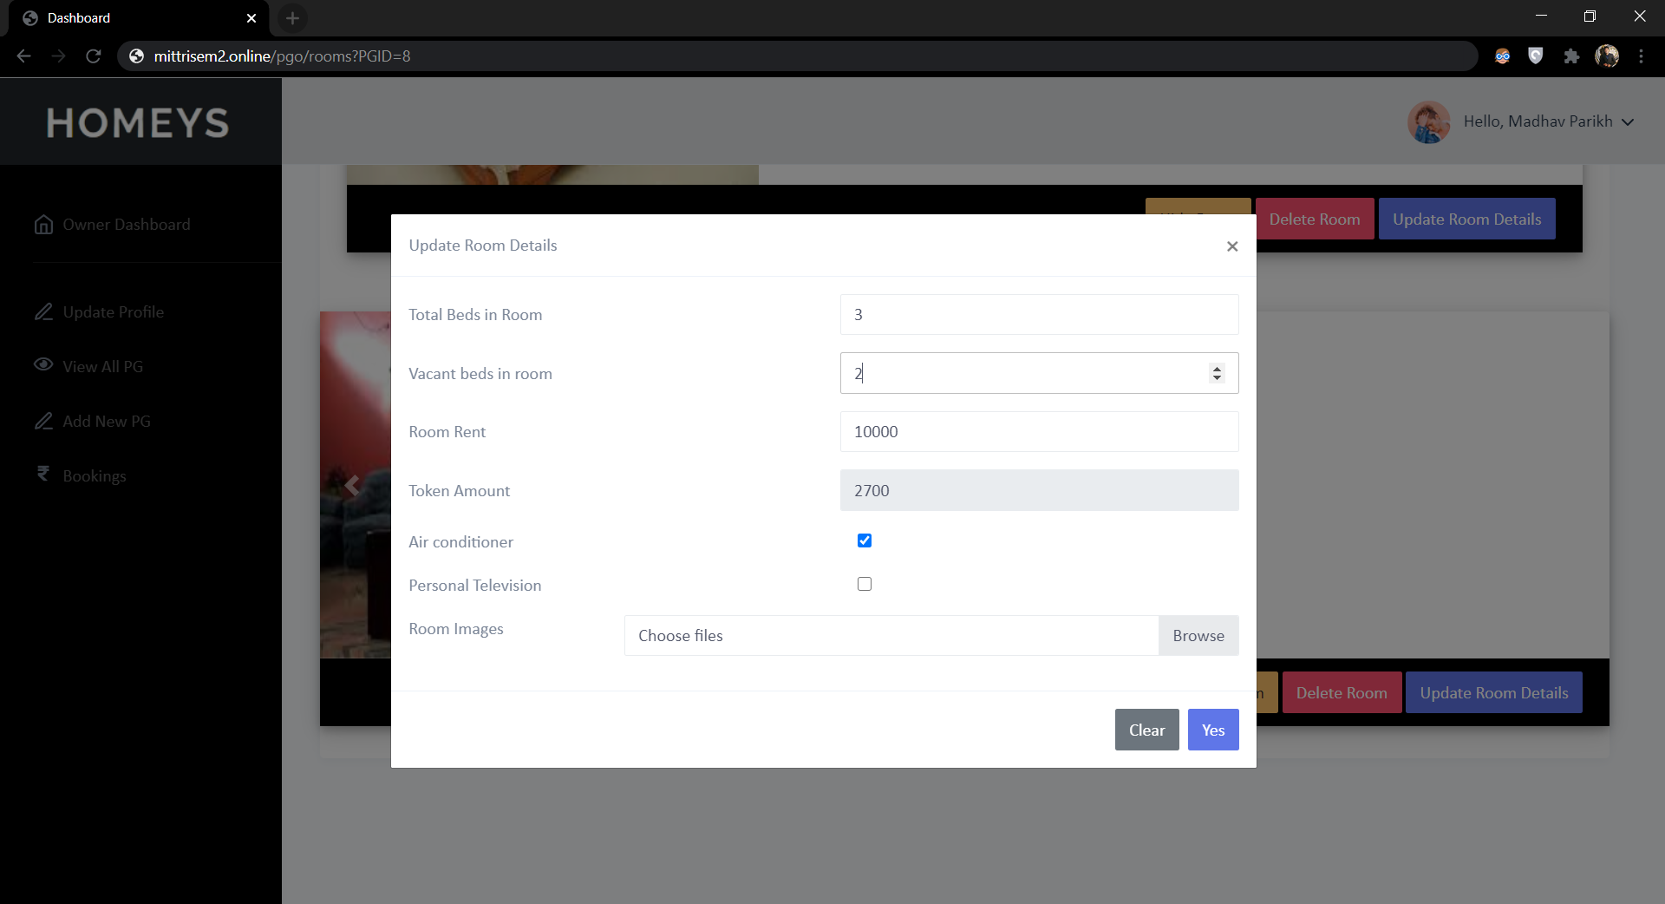

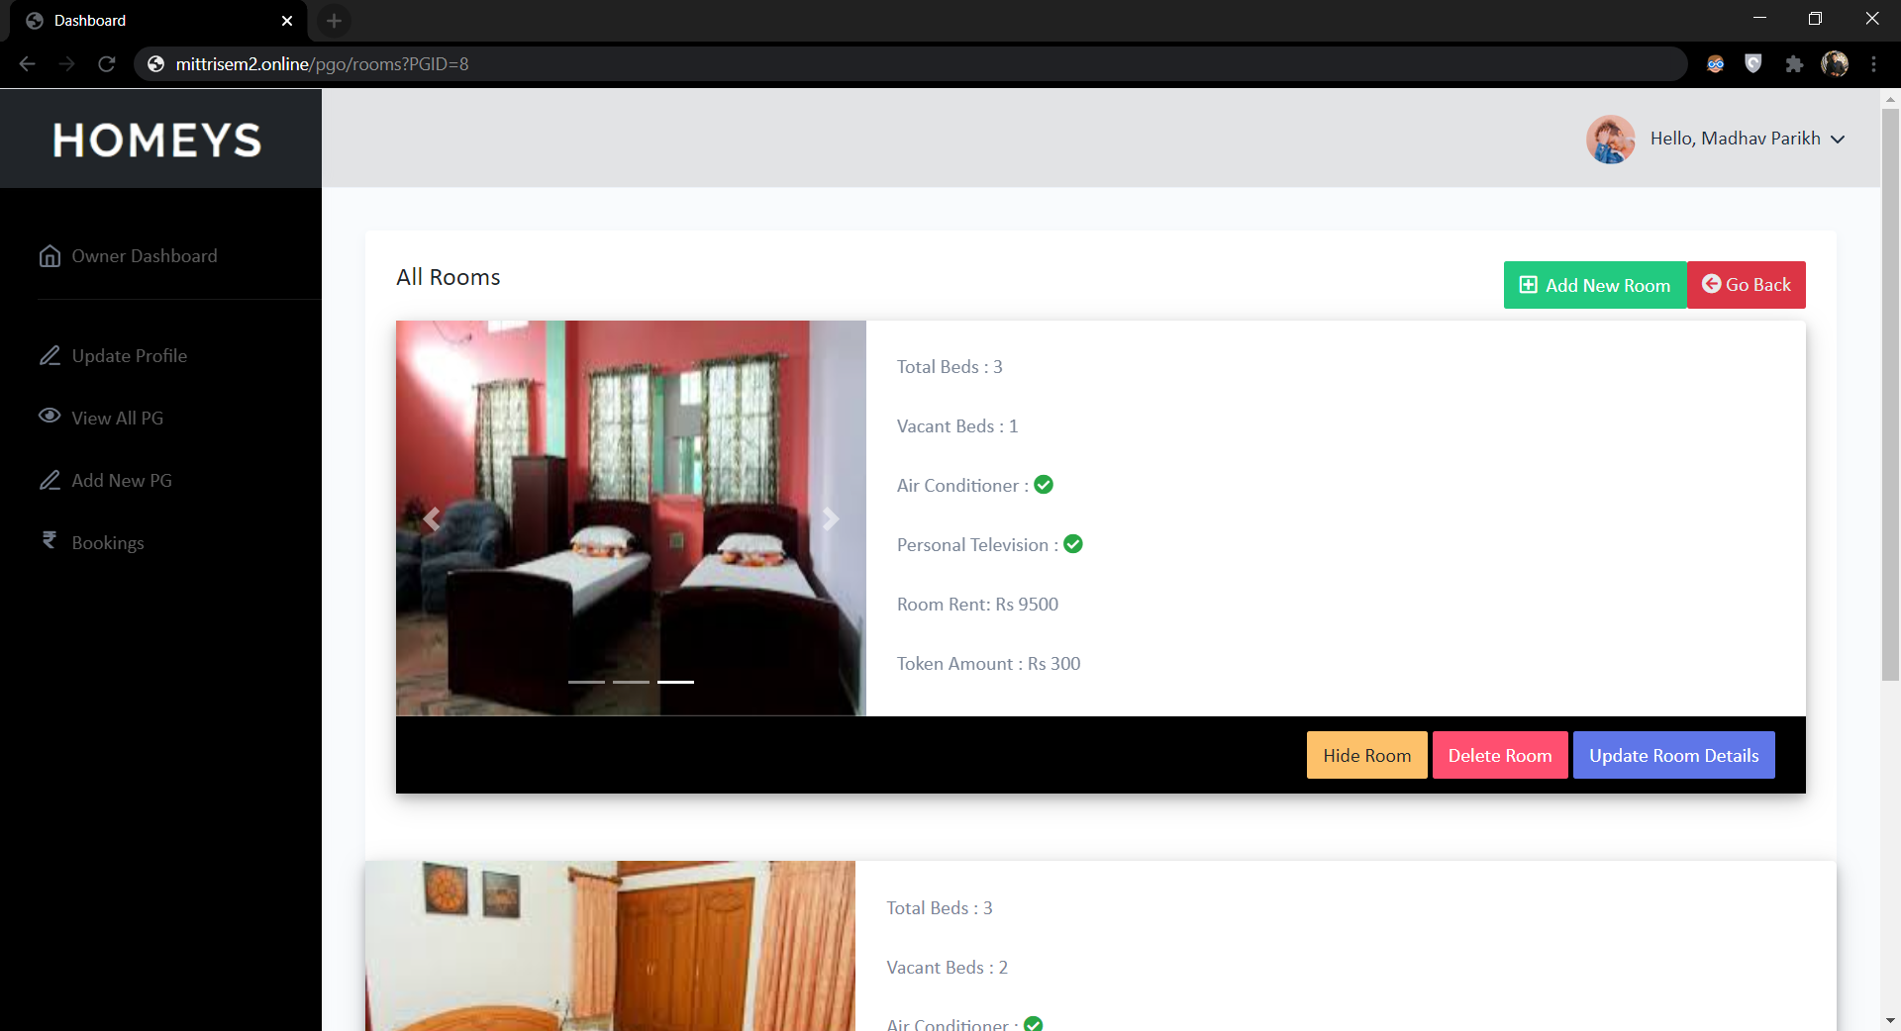

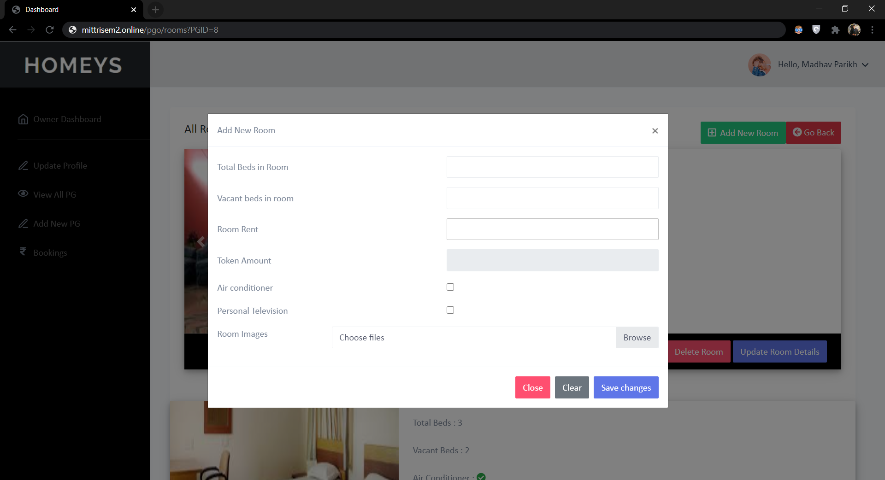

Add New PG

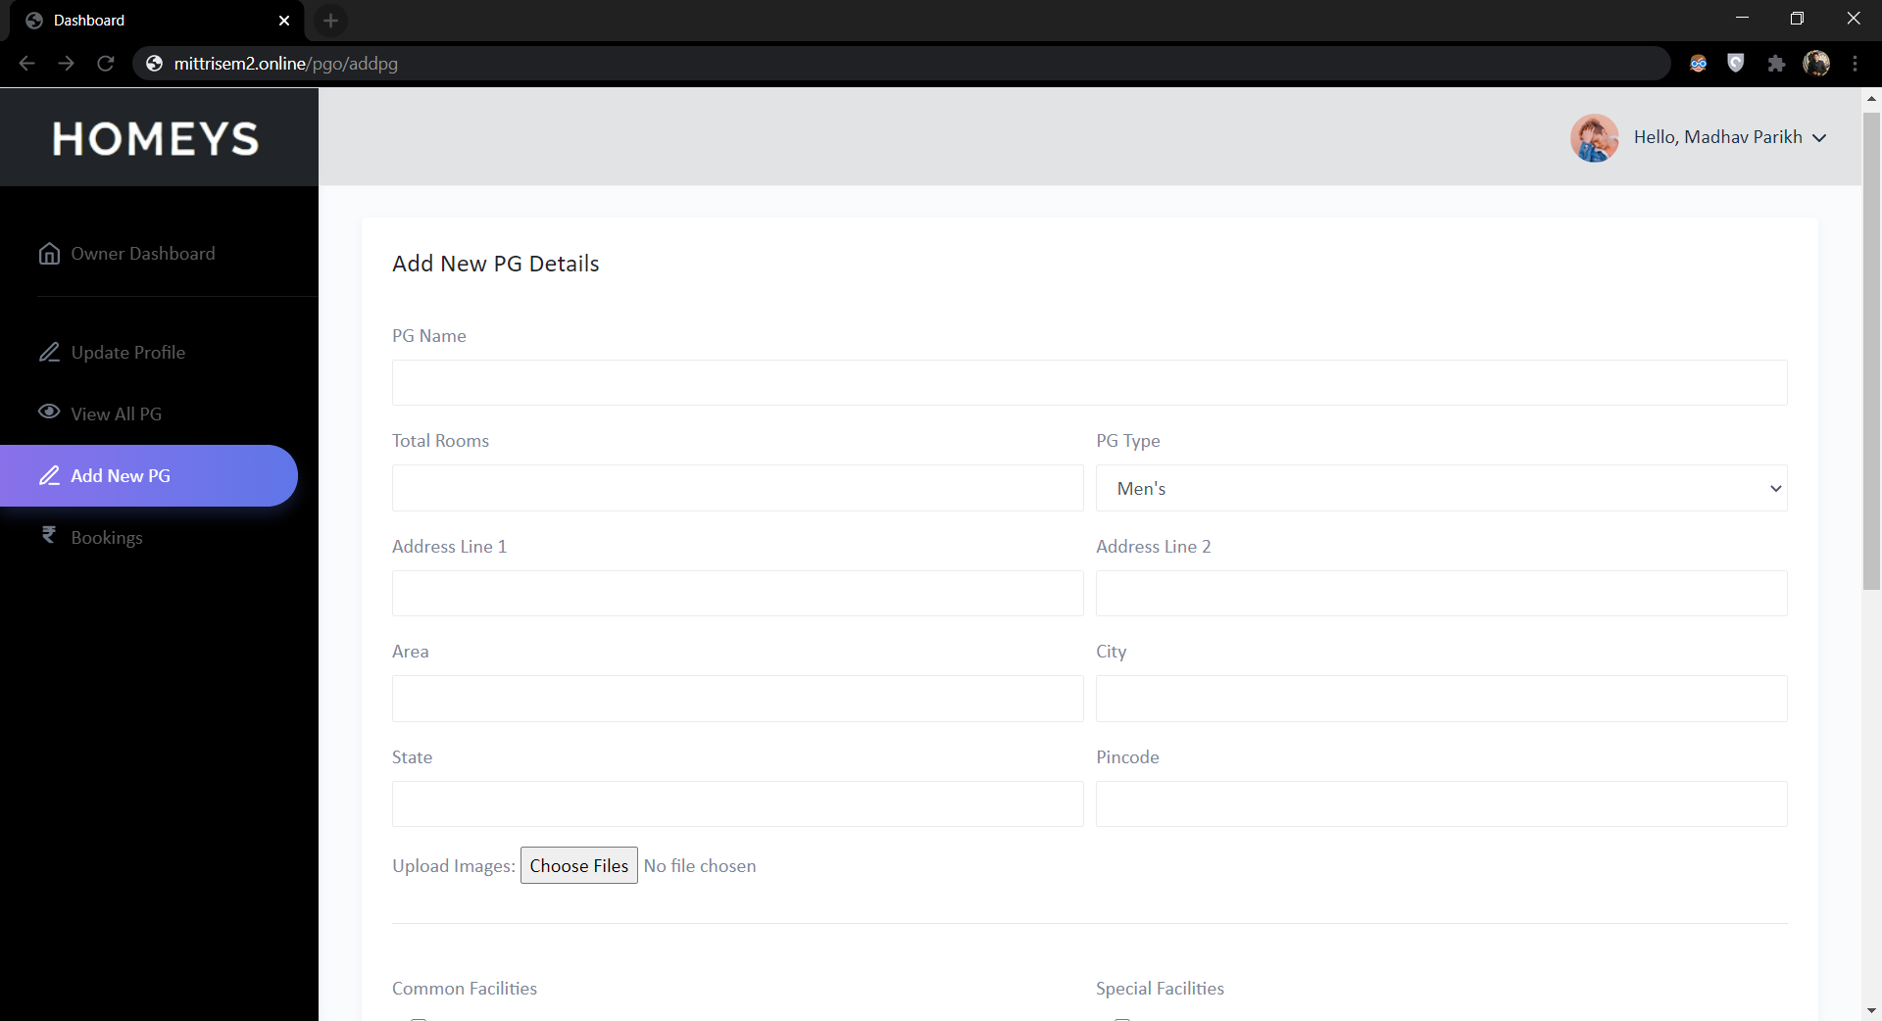

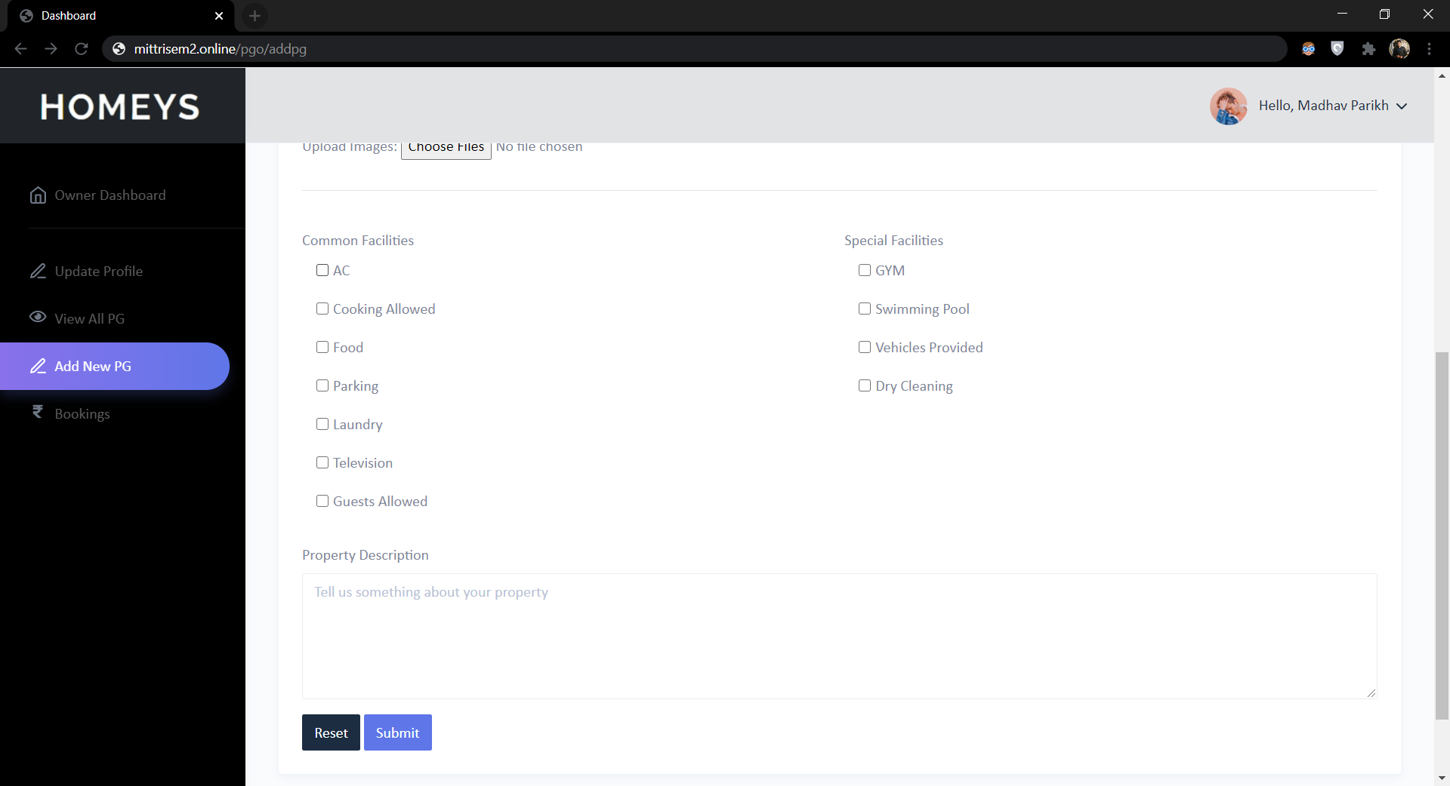

Bookings

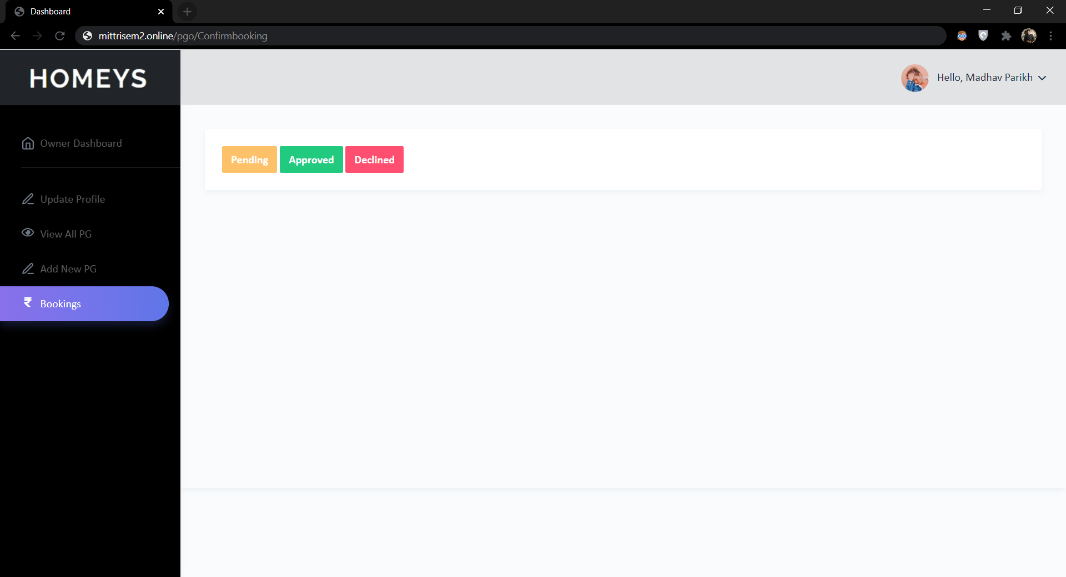

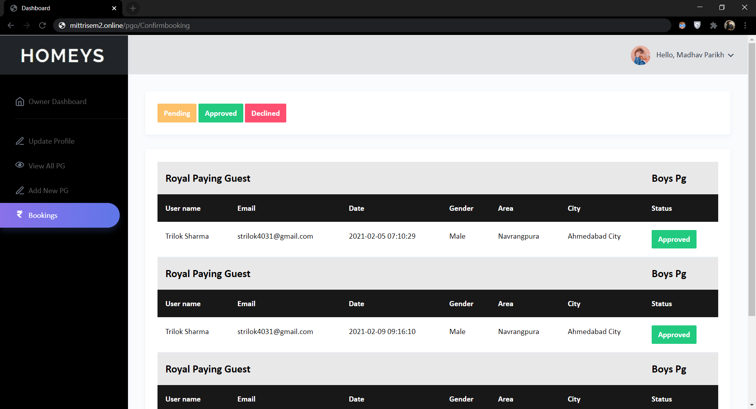

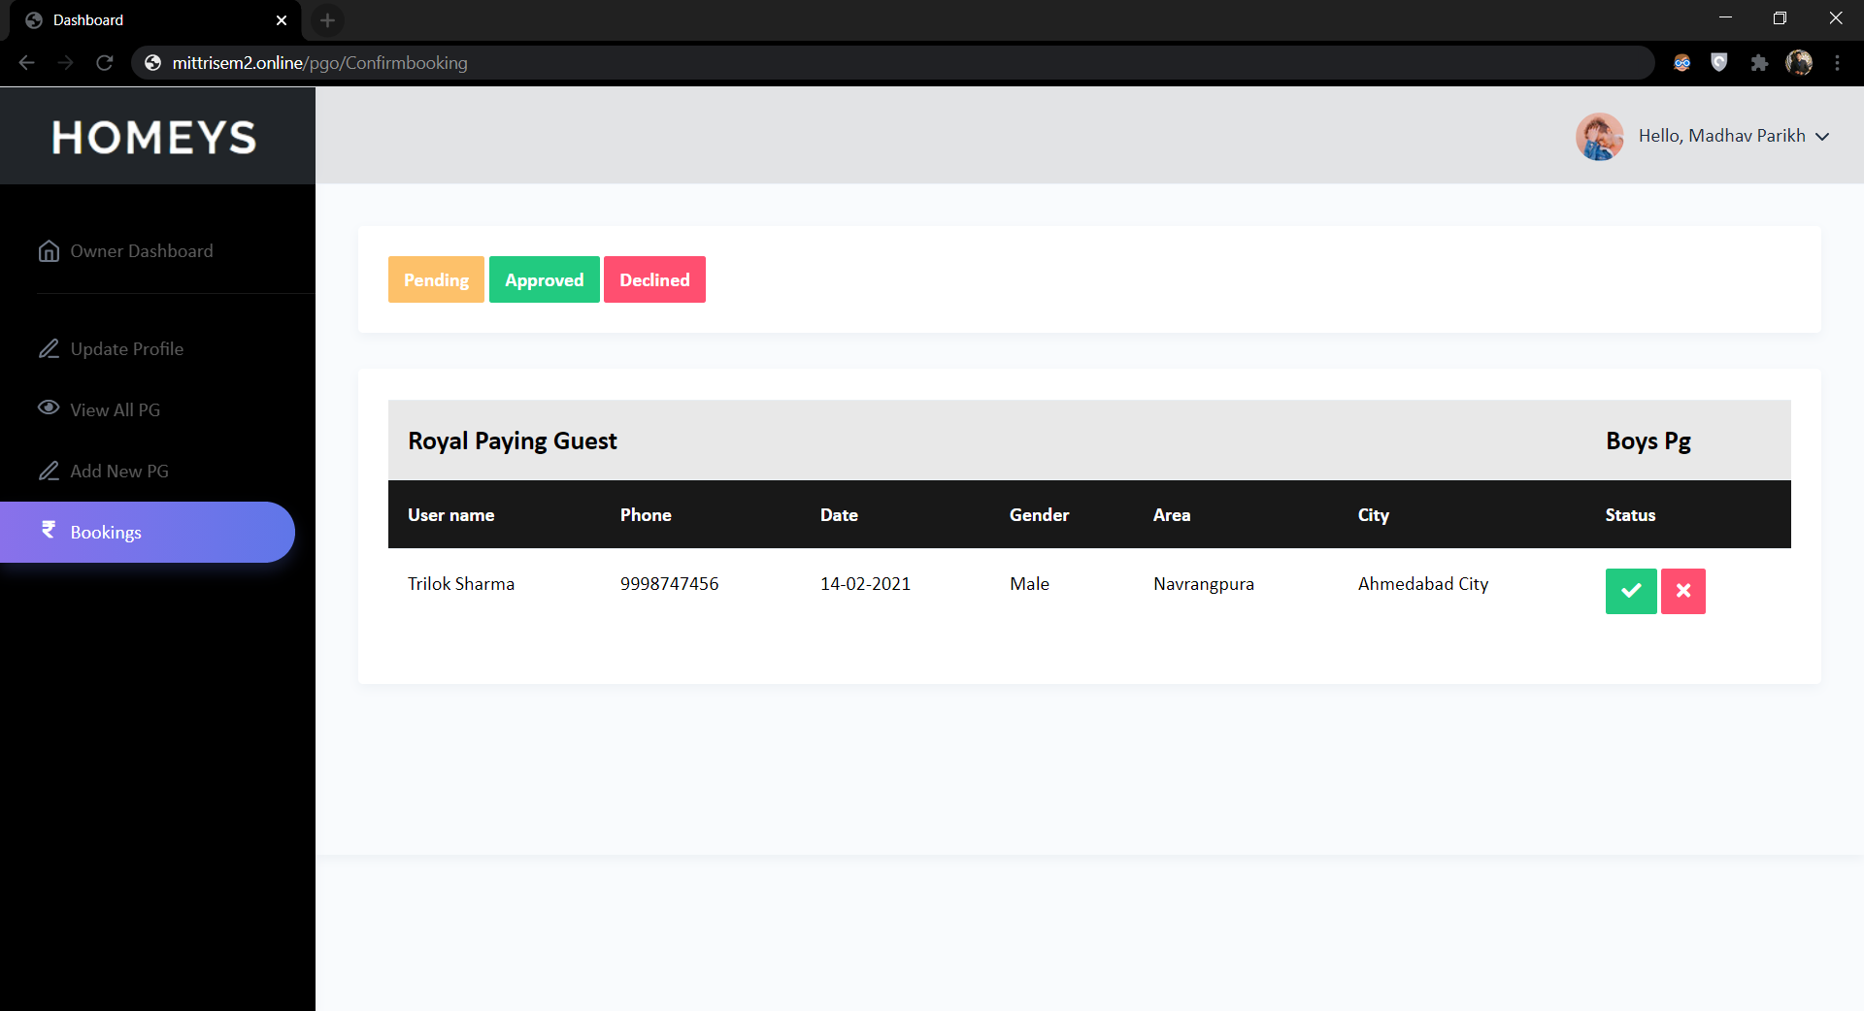



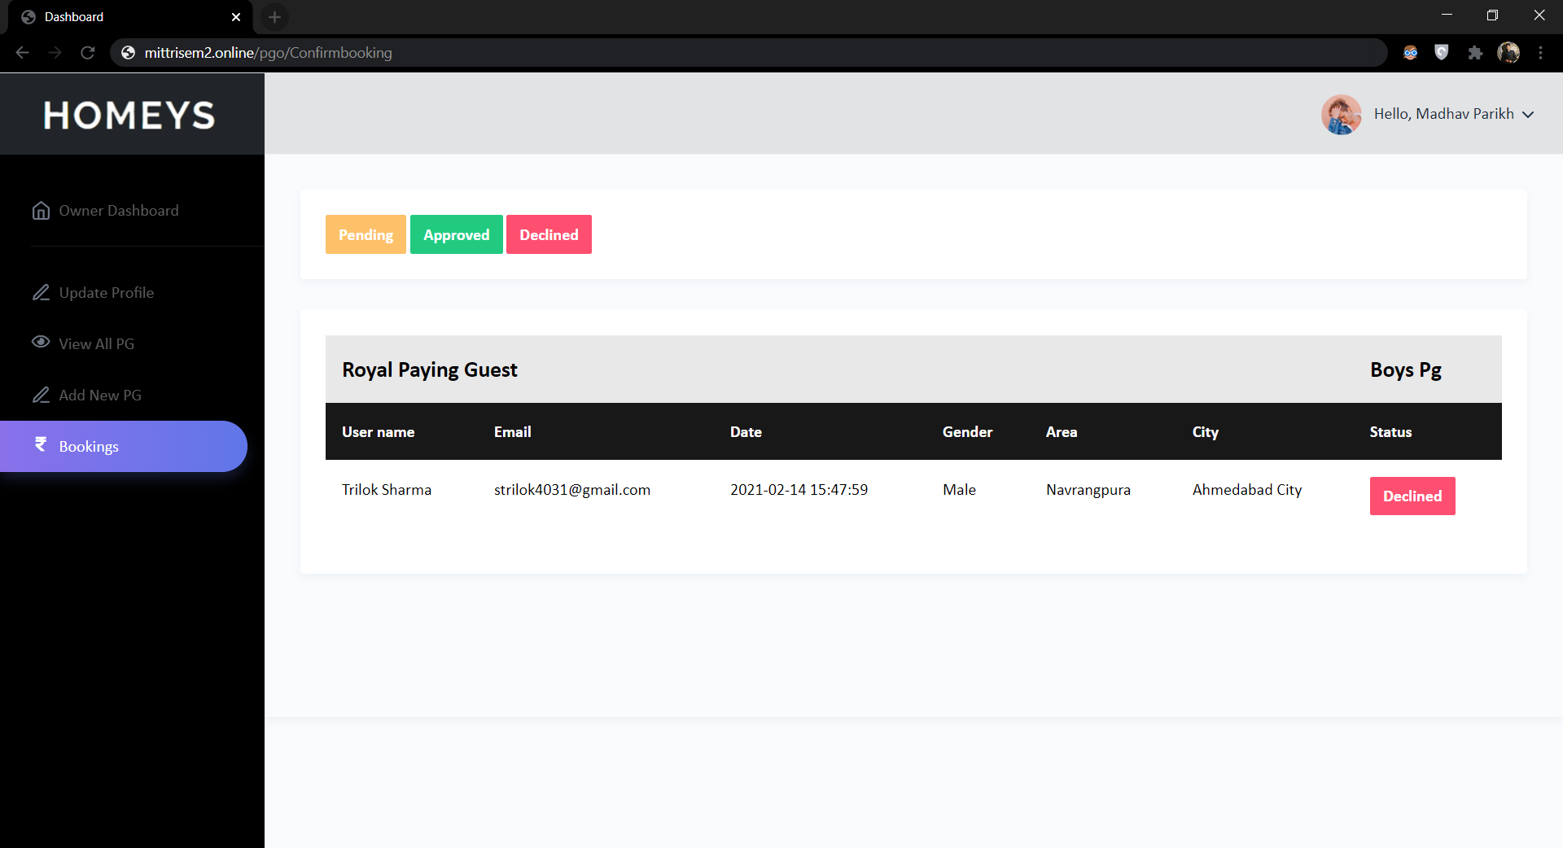

**User**

Homepage

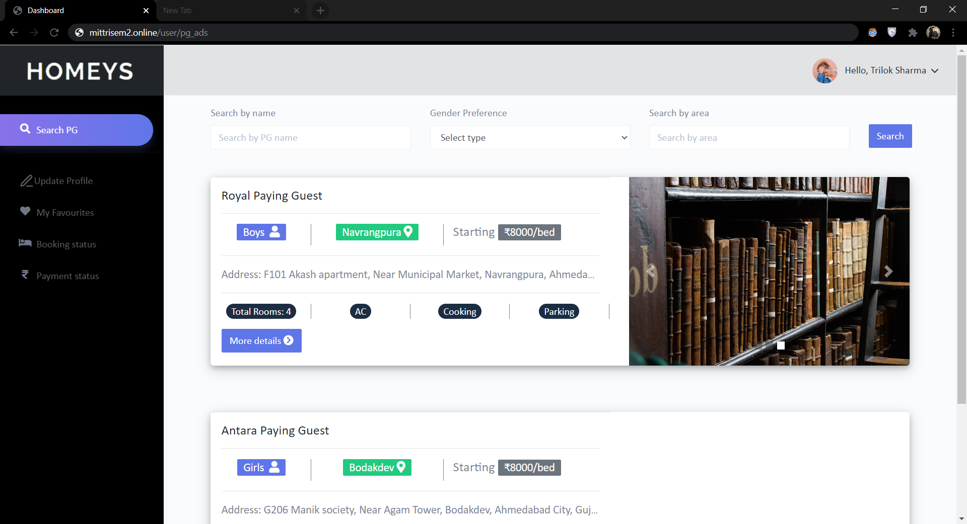



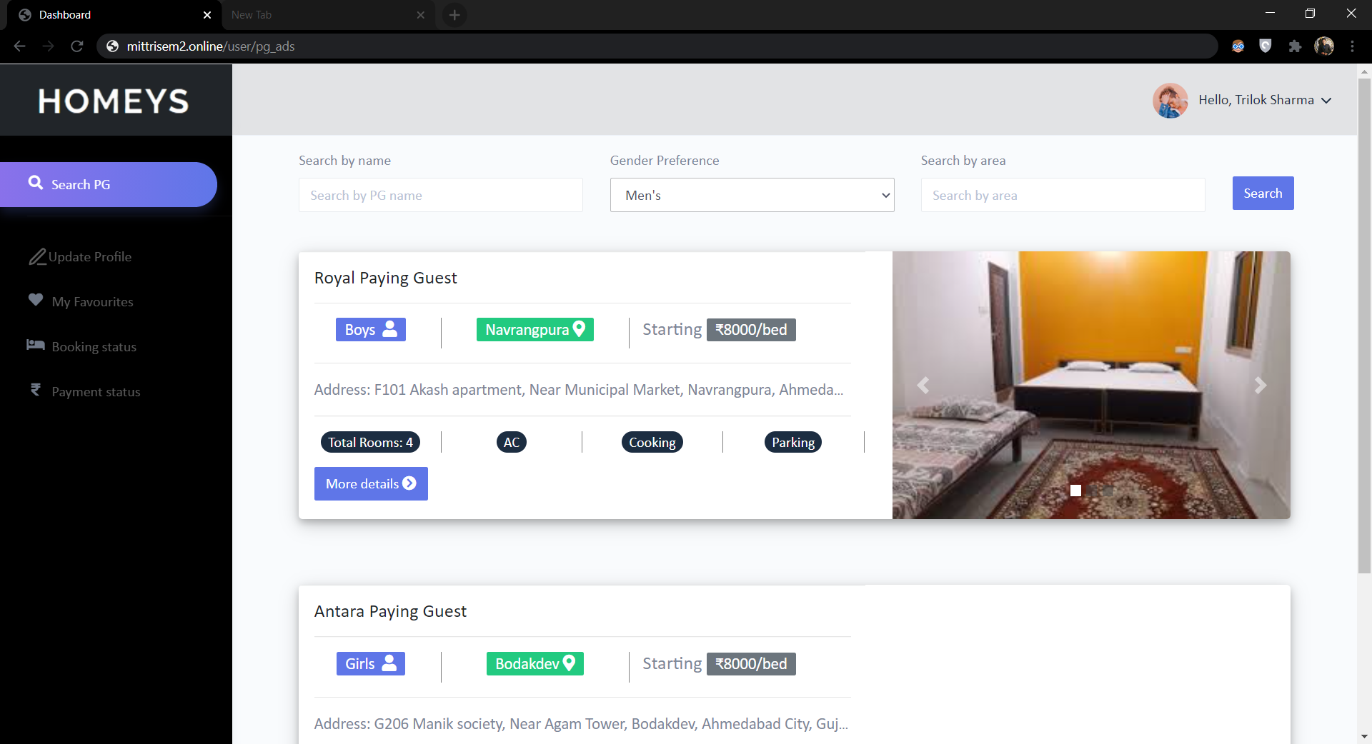

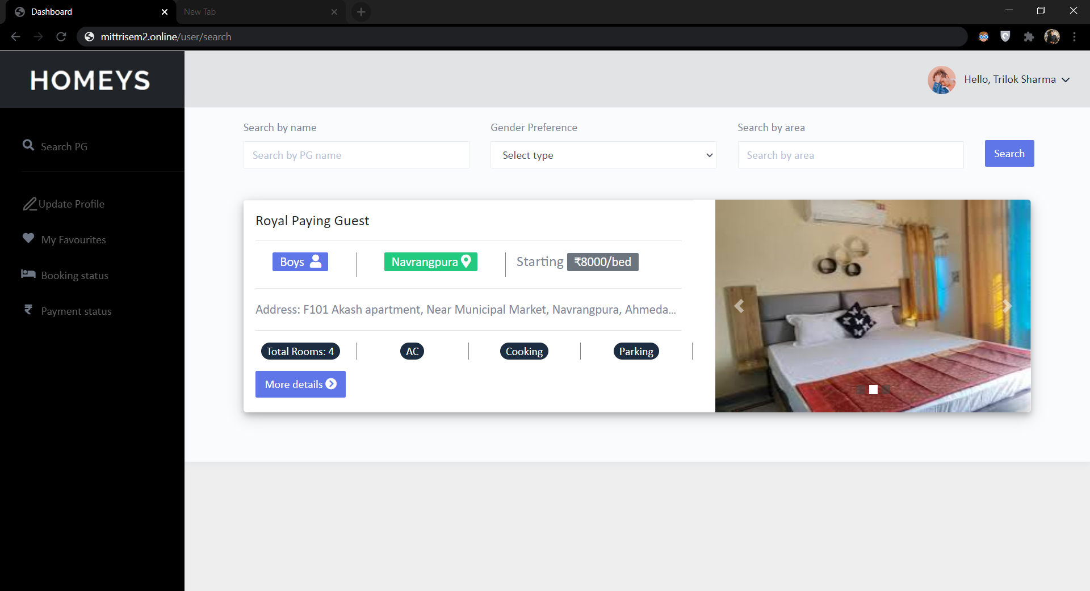

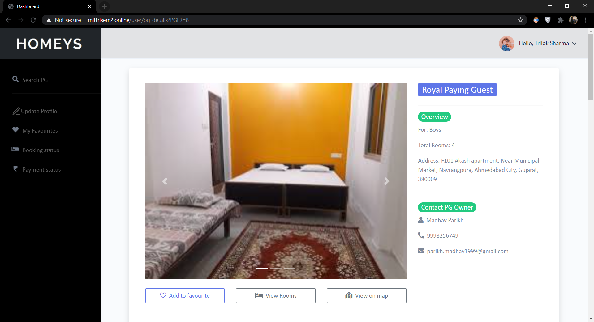

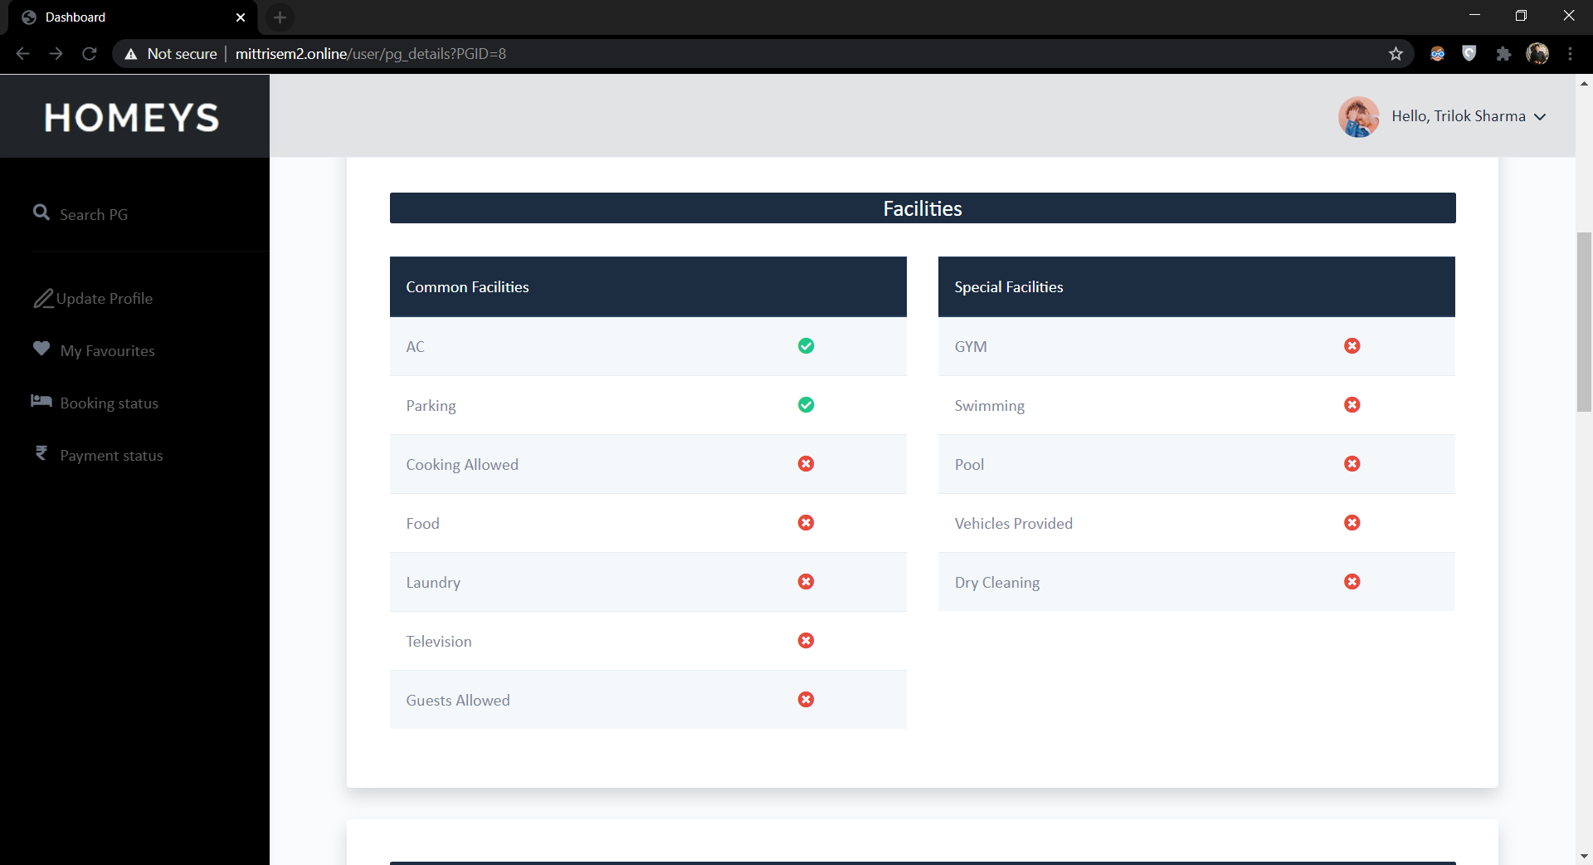

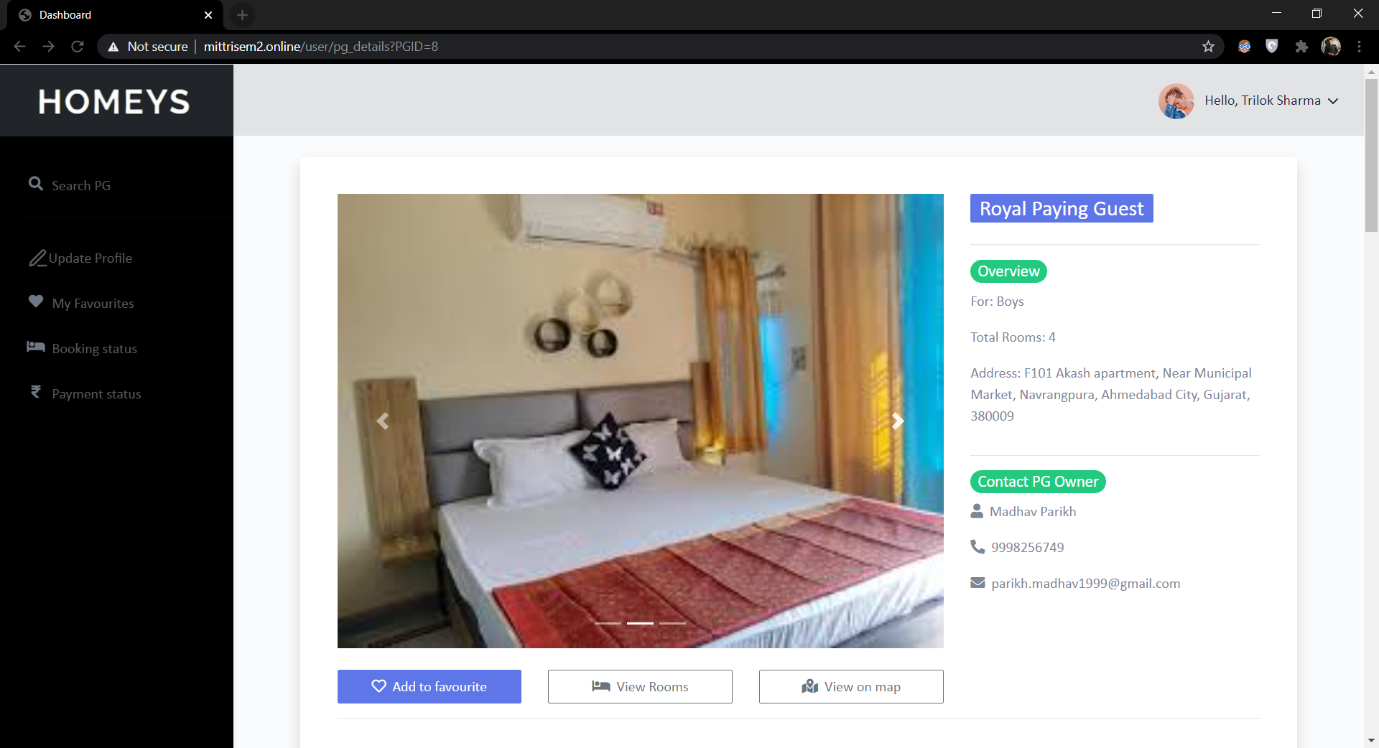

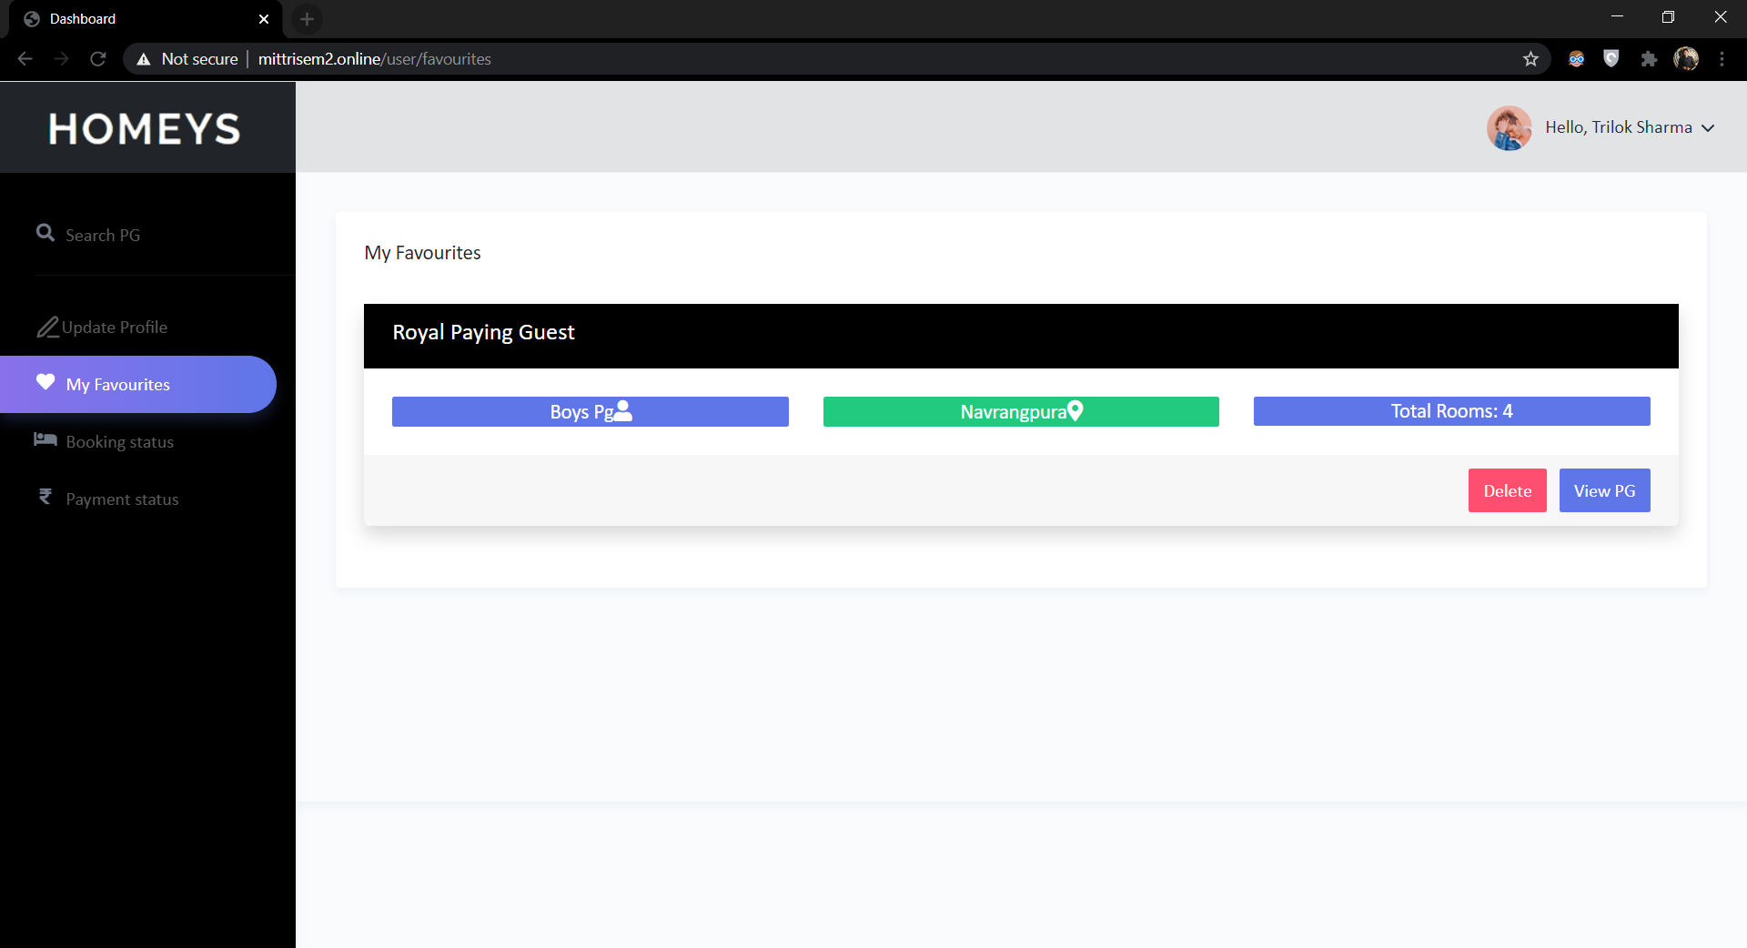

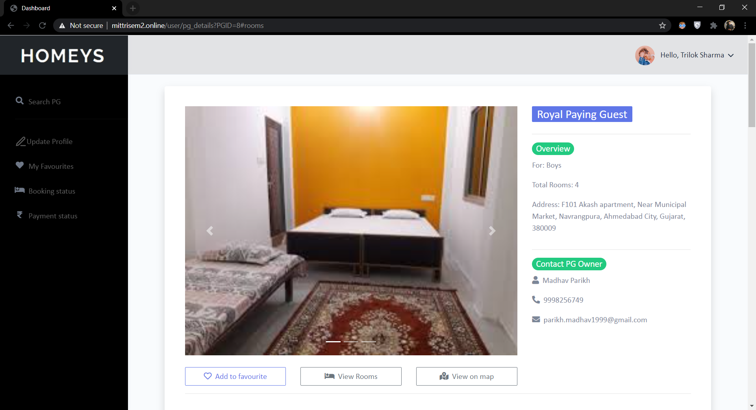

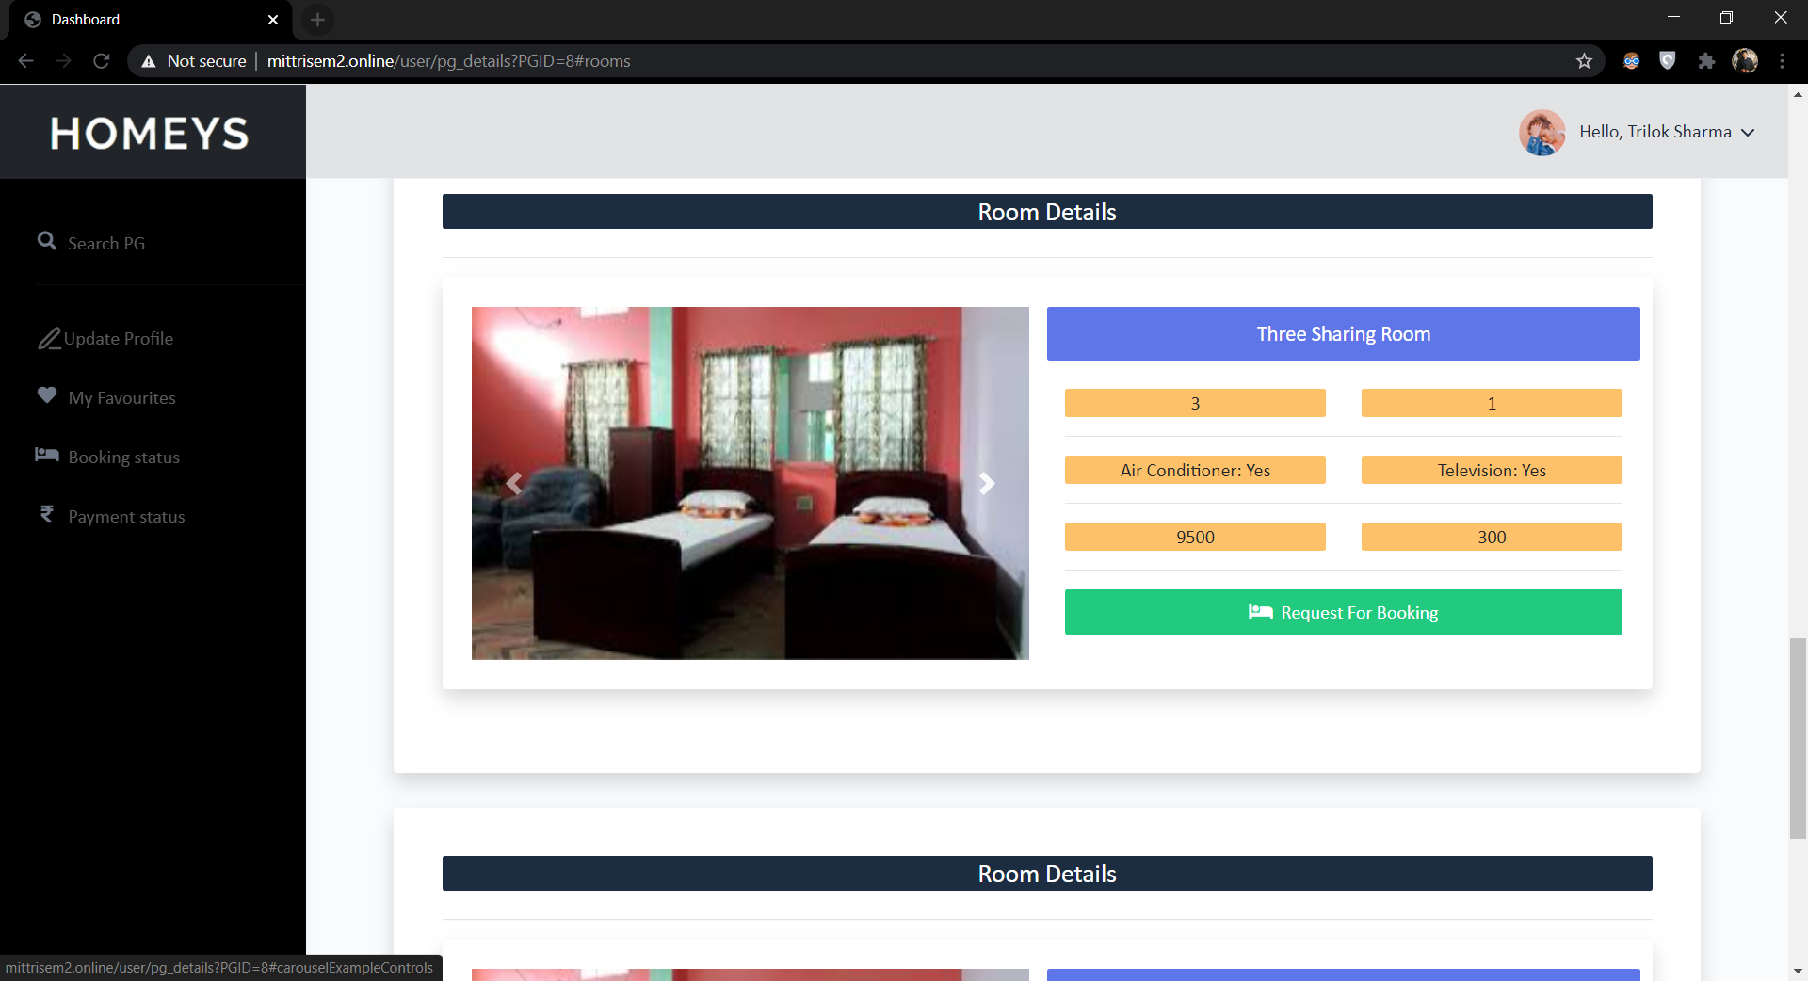

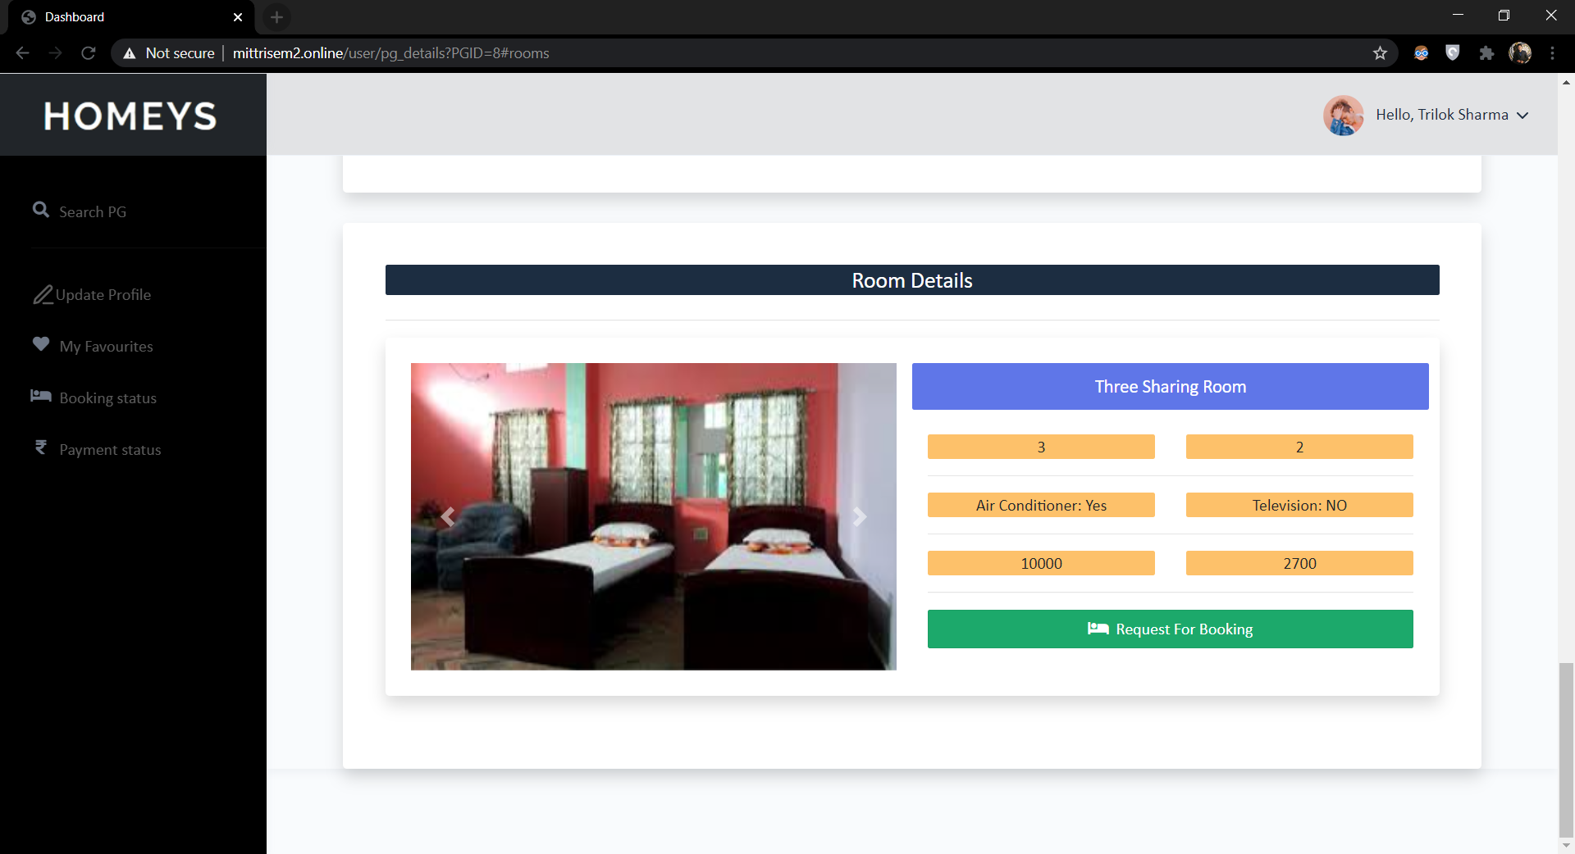

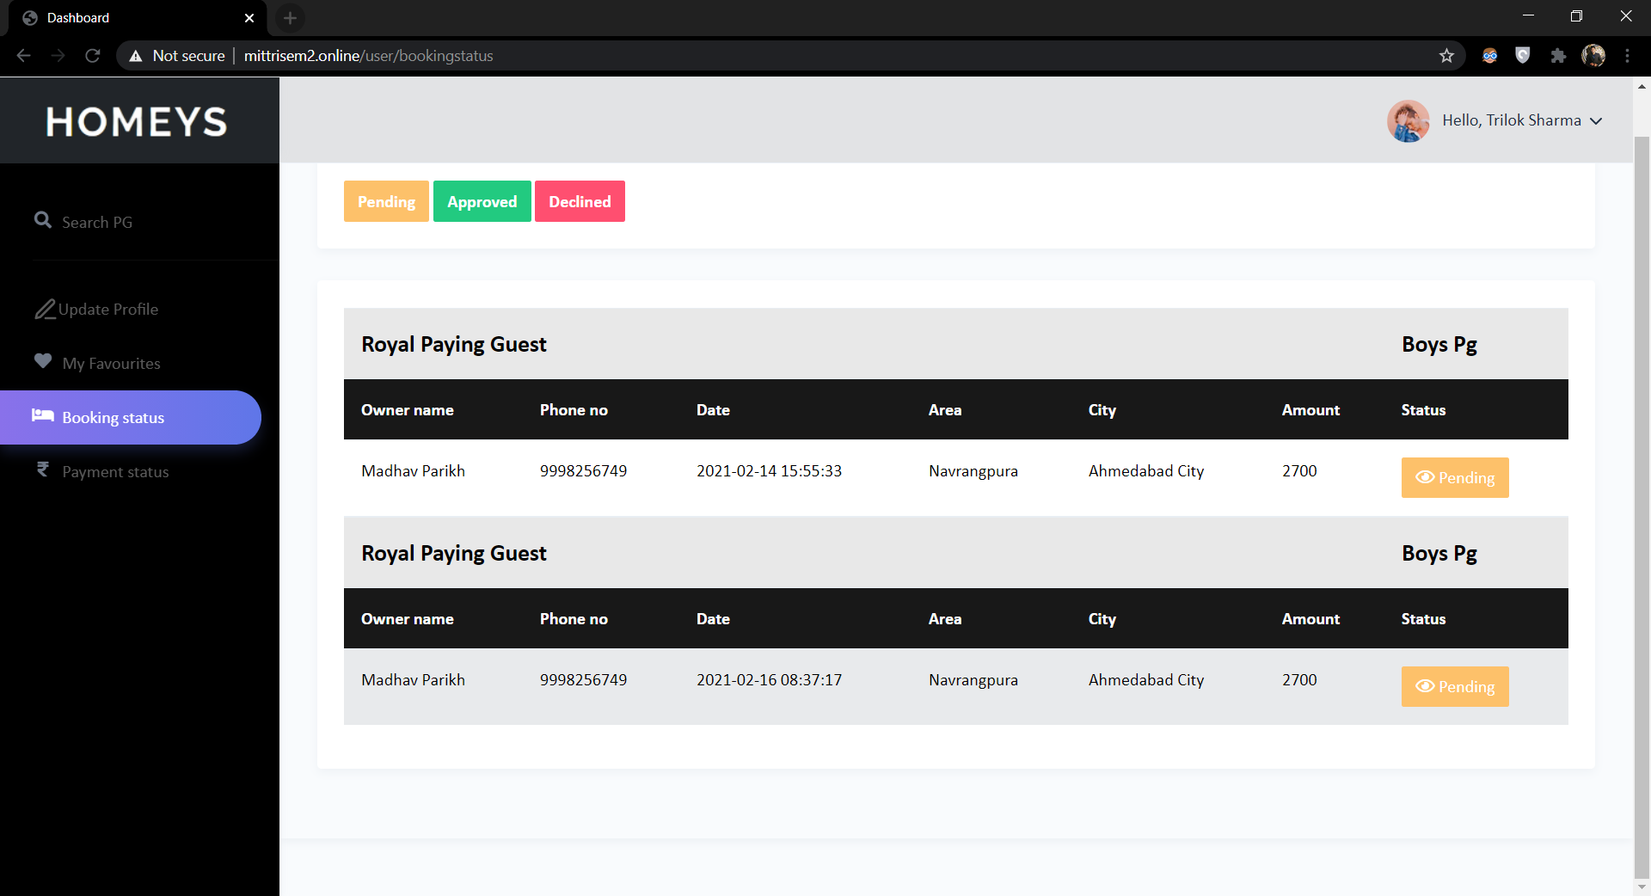

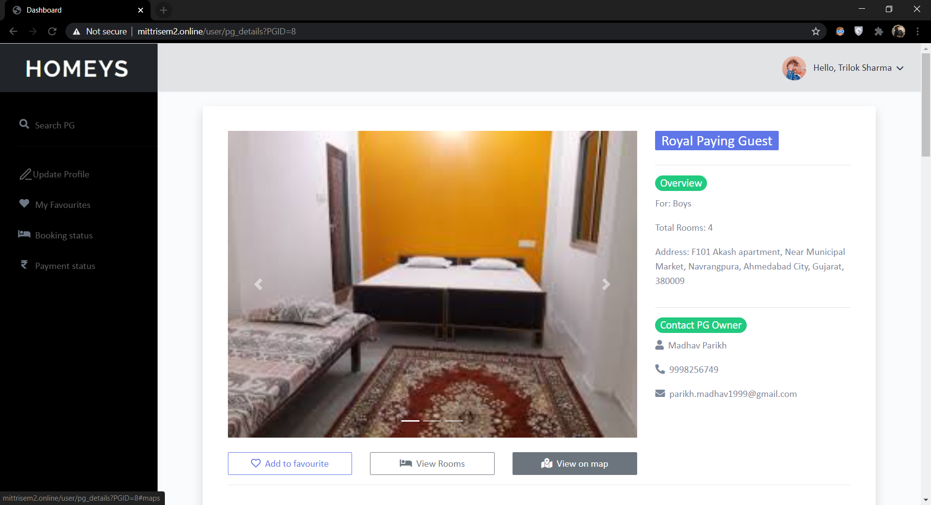

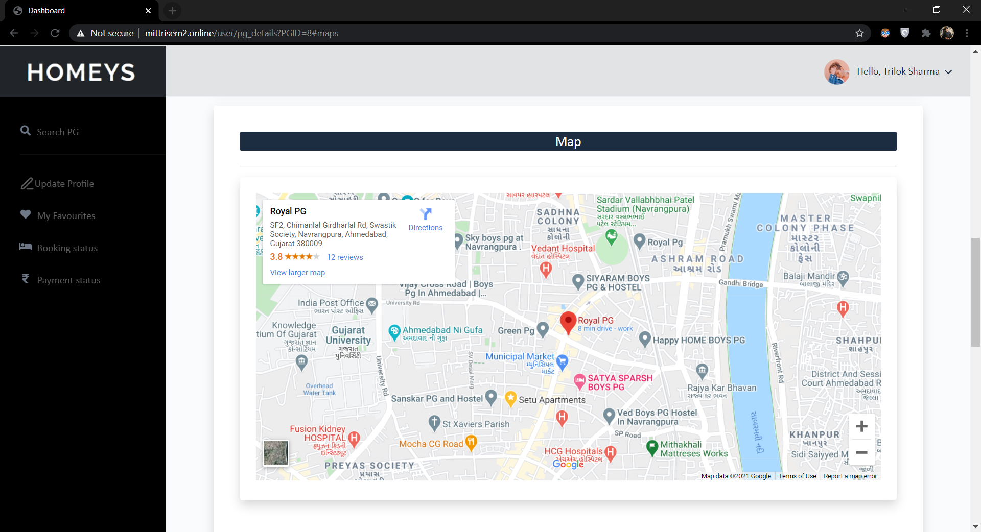

Update Profile

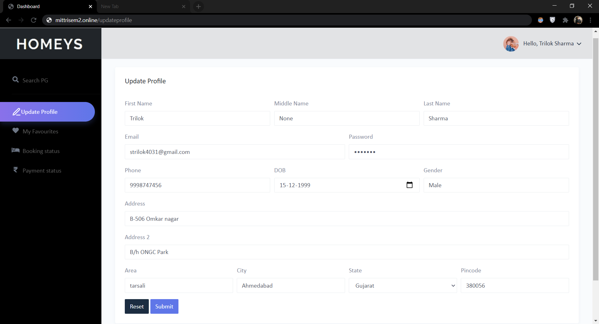

My Favourites

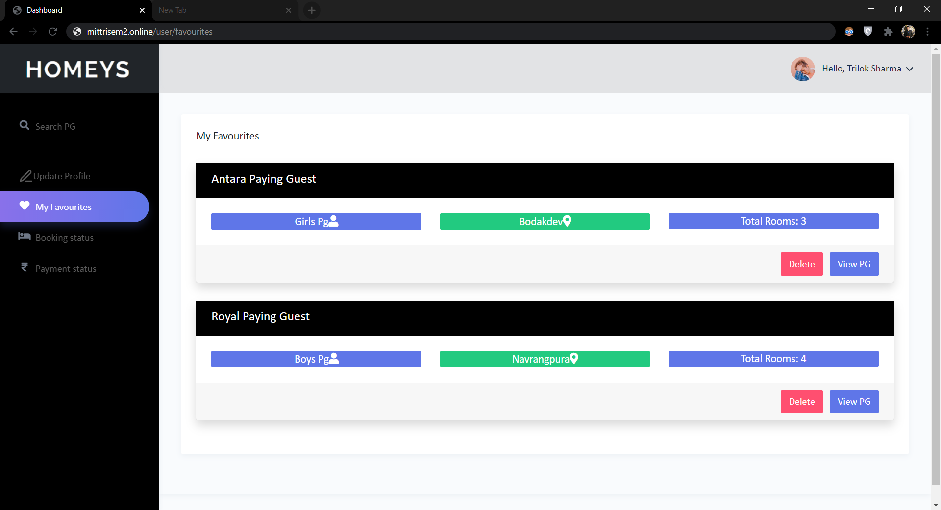

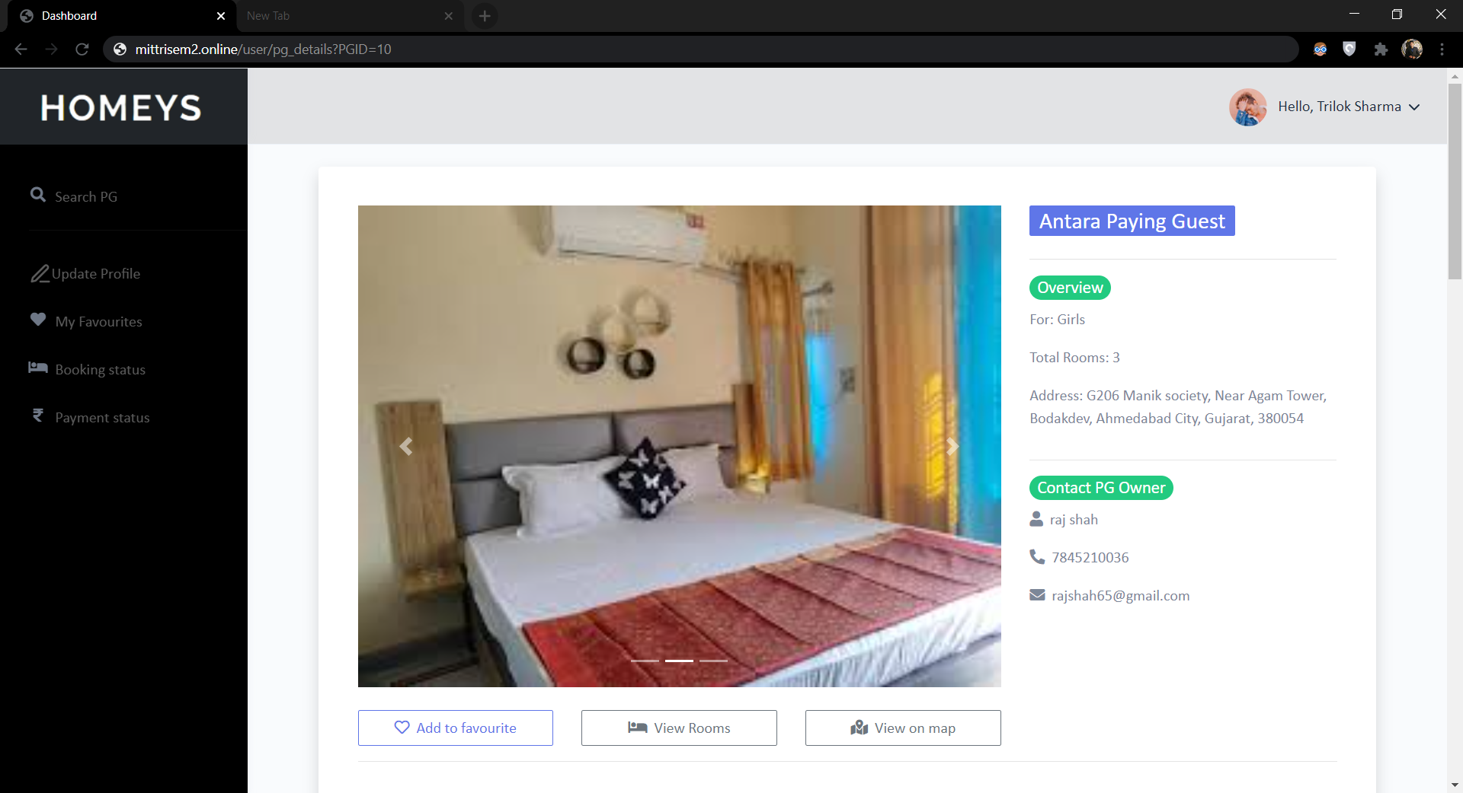

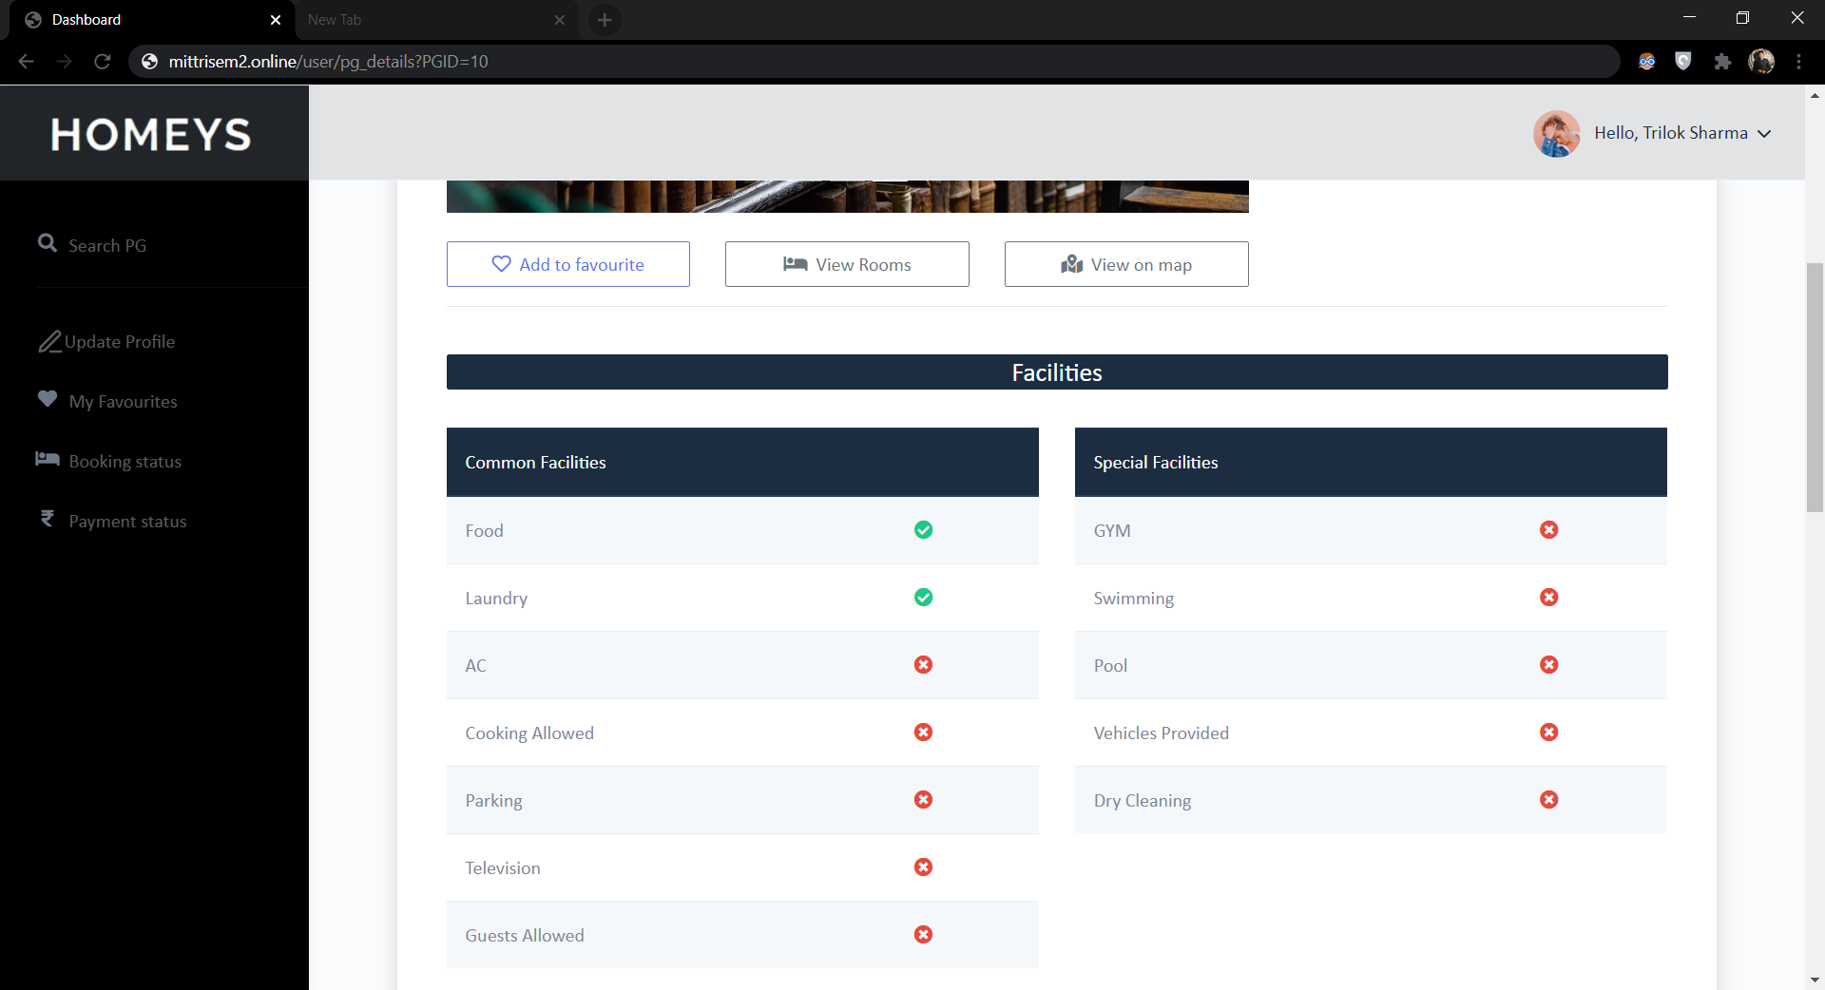

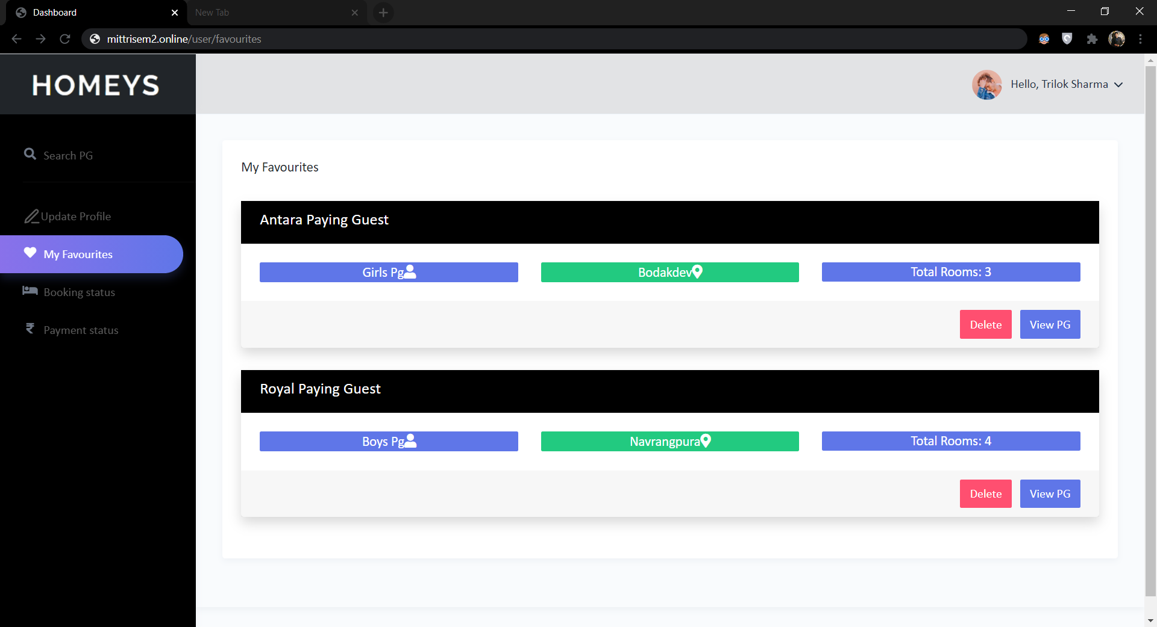

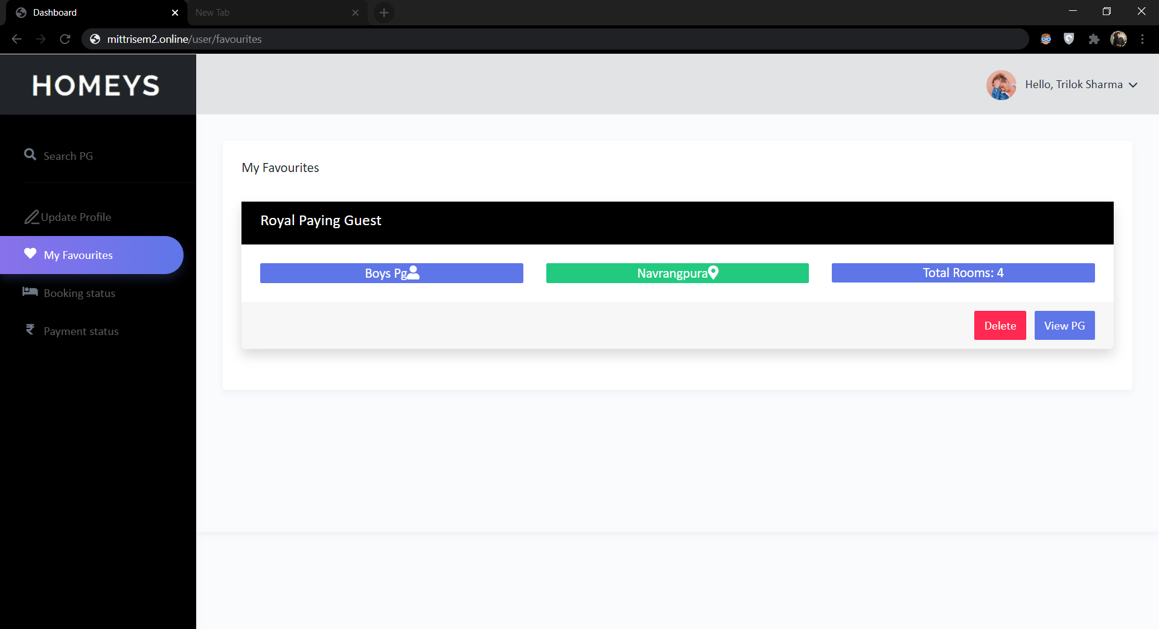

Booking status

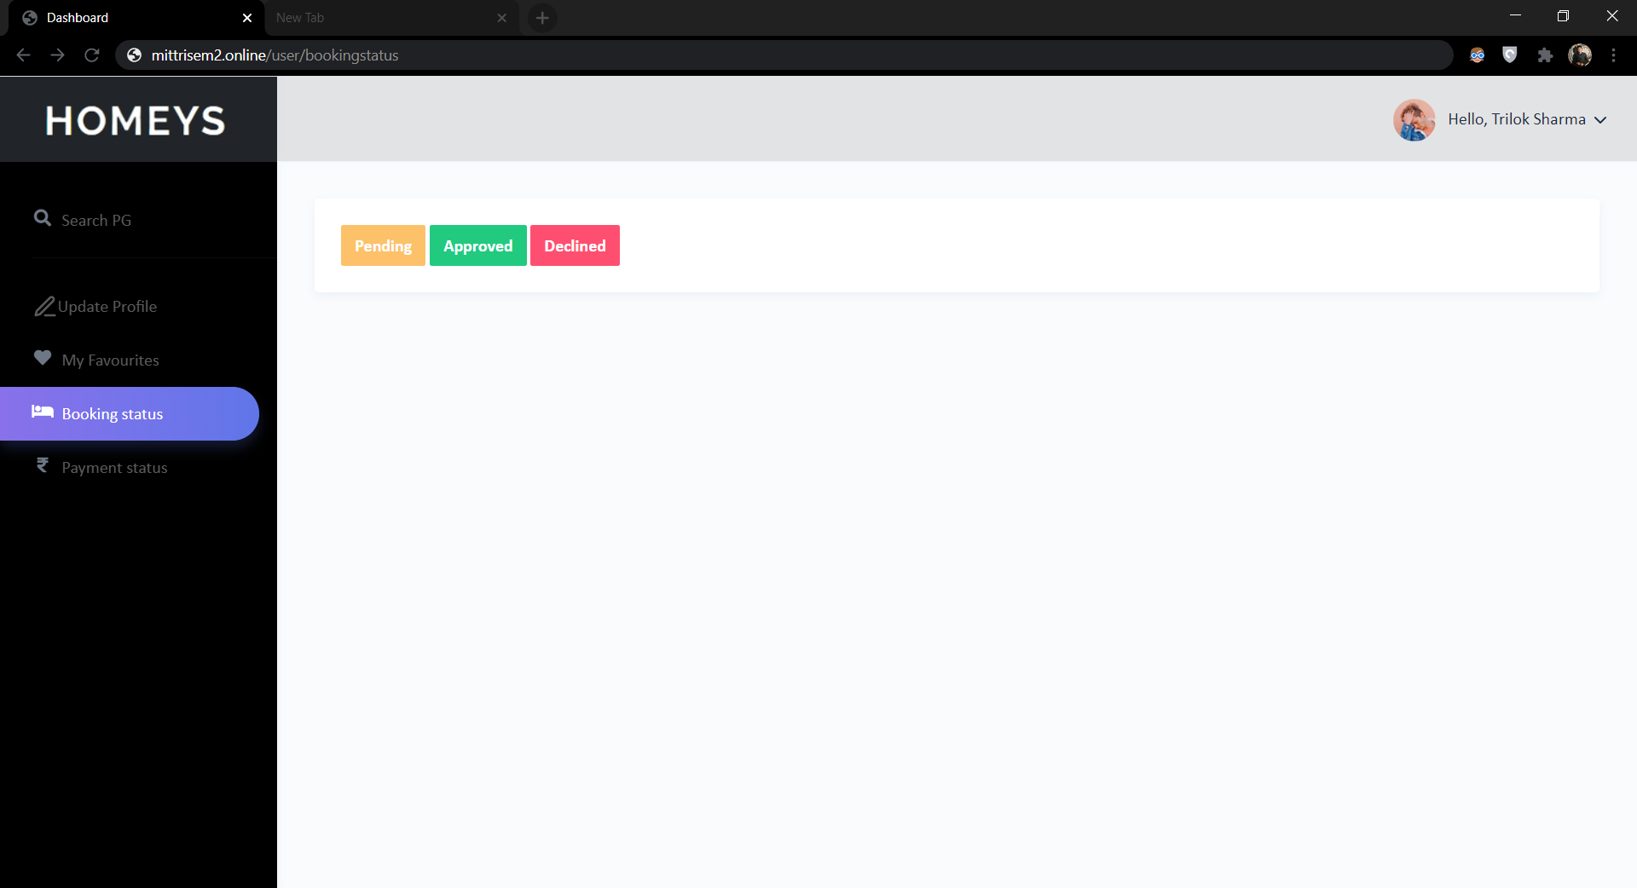

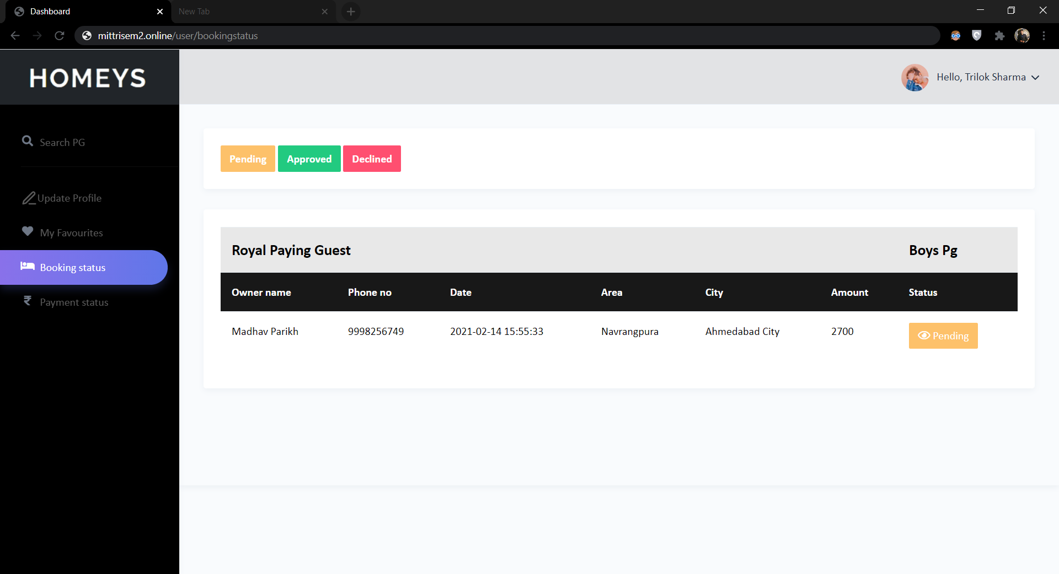

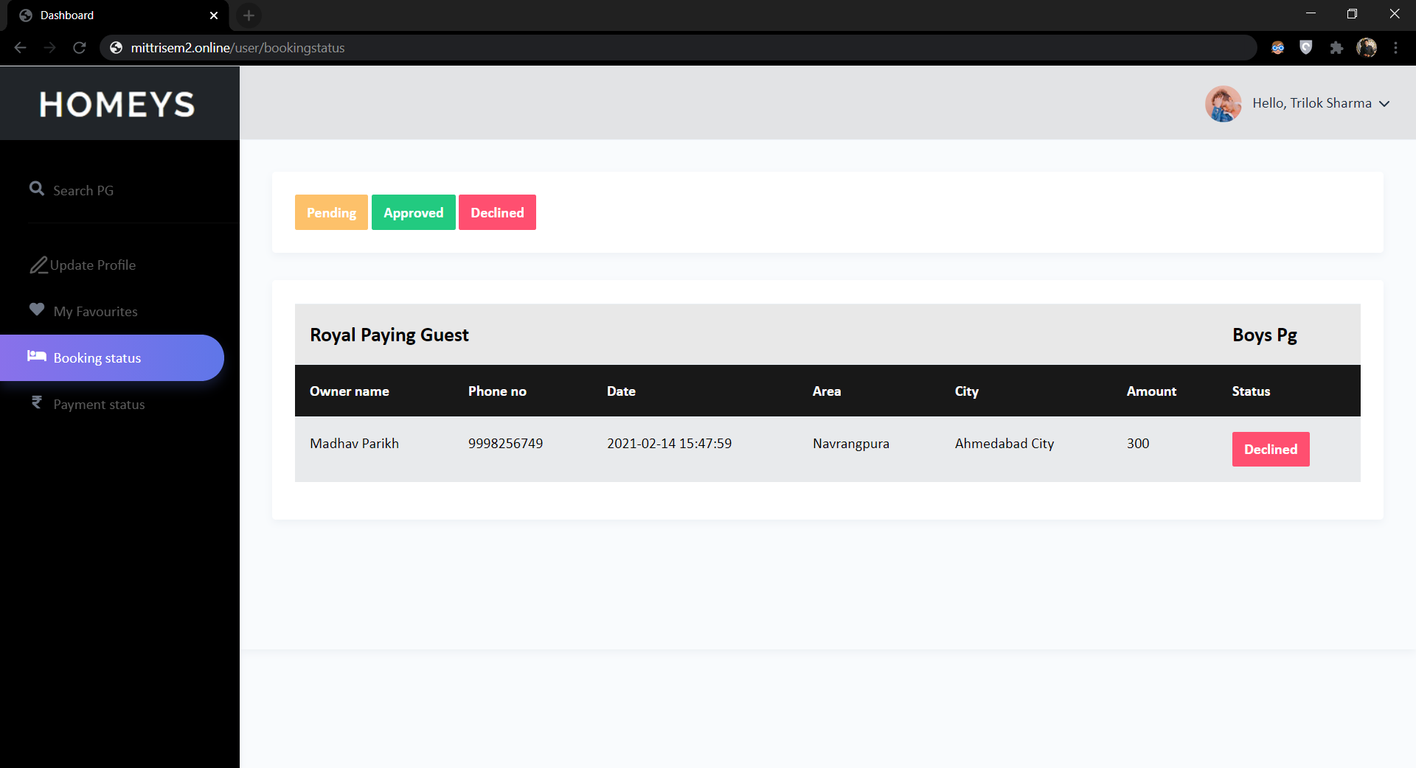

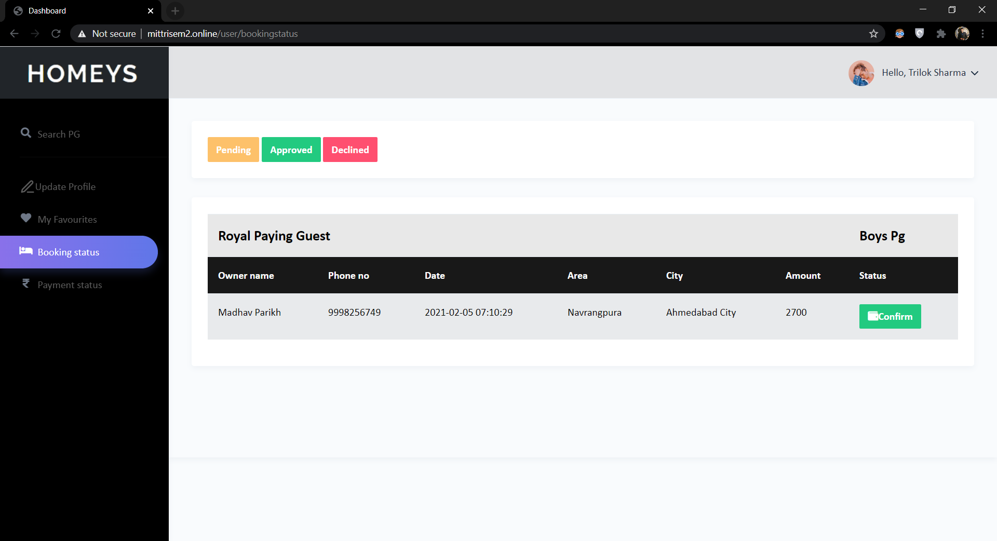

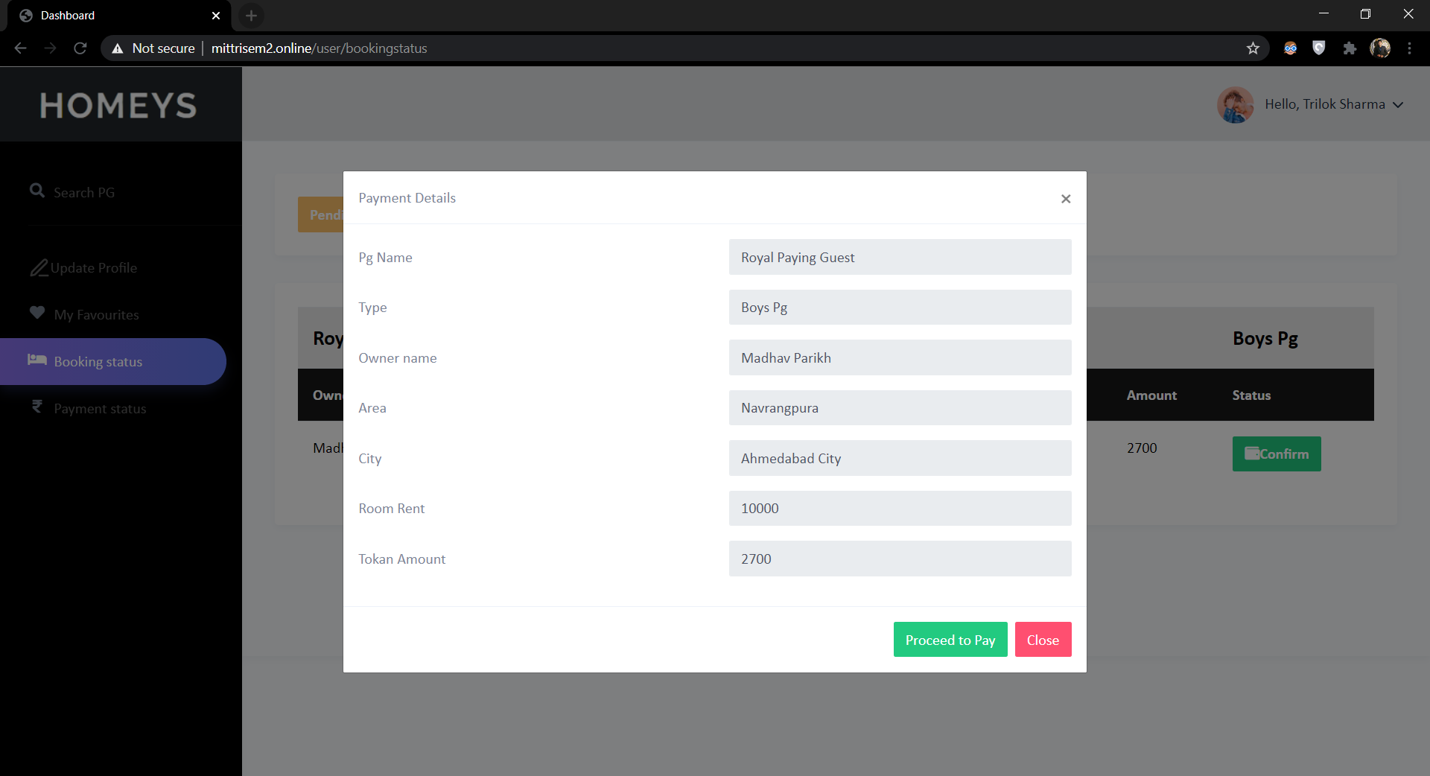



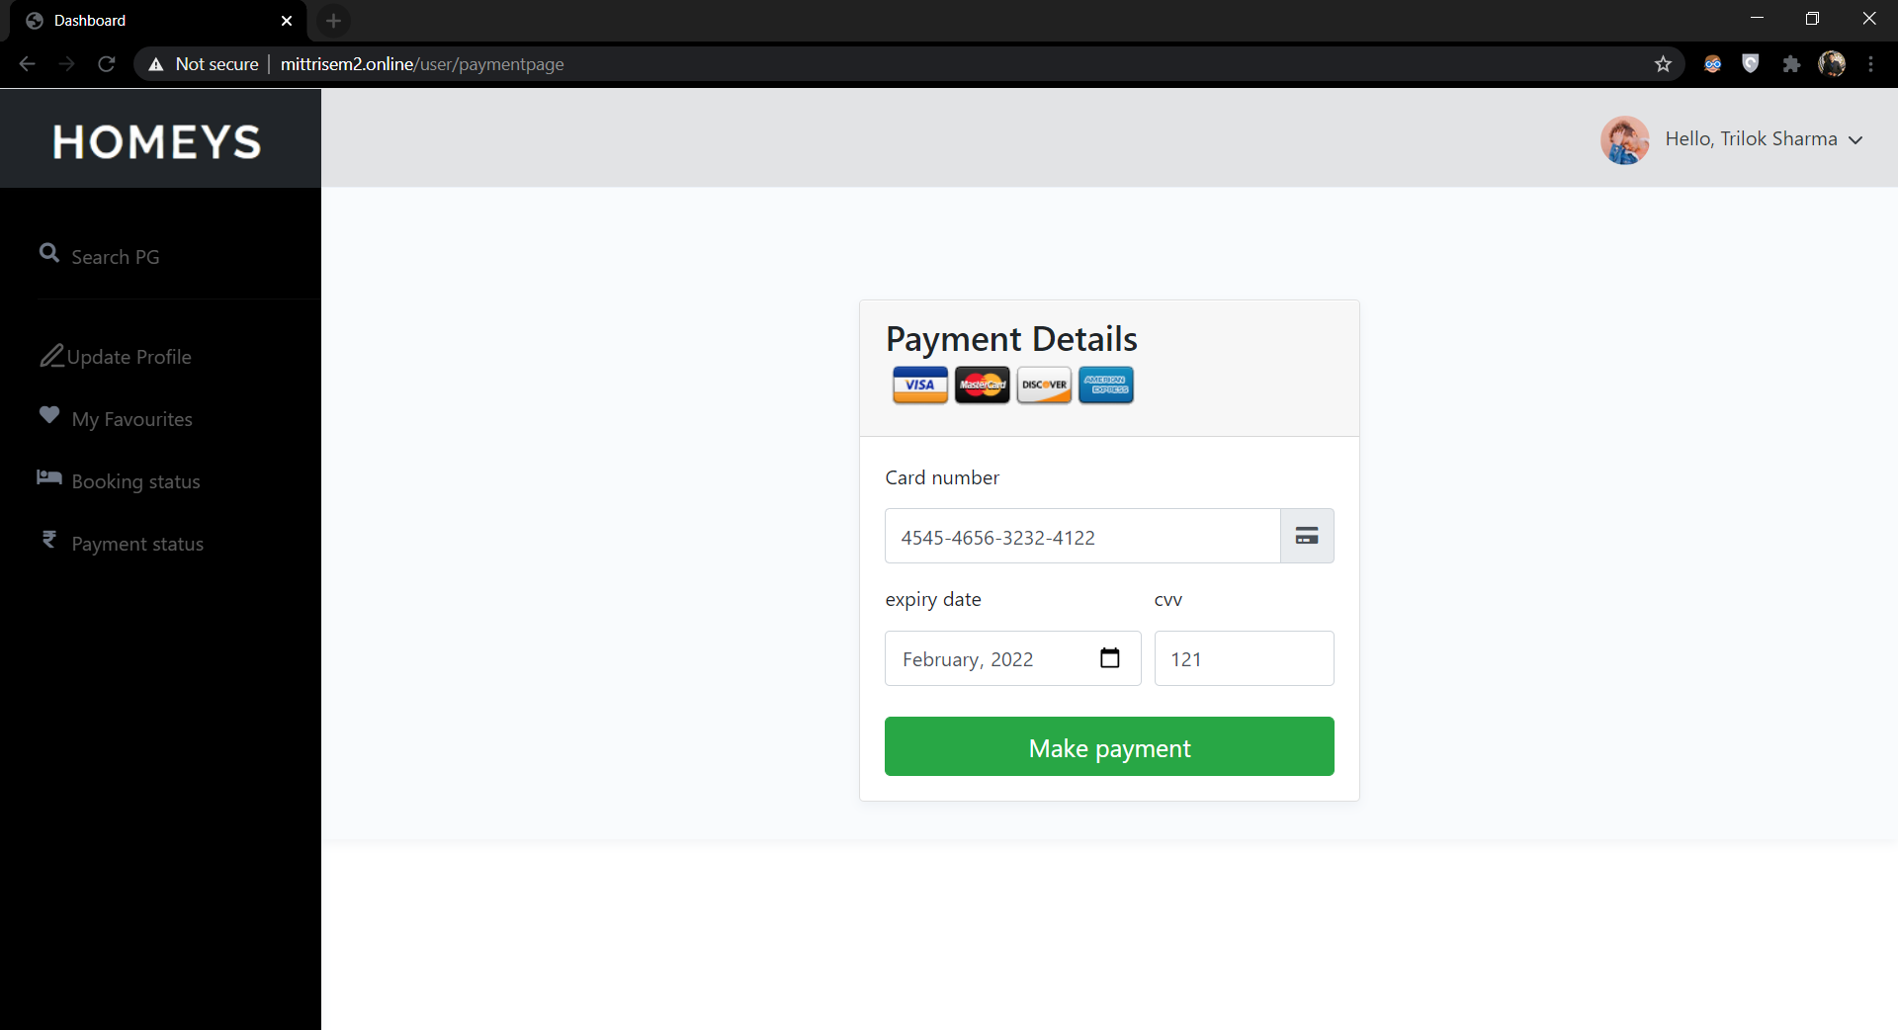

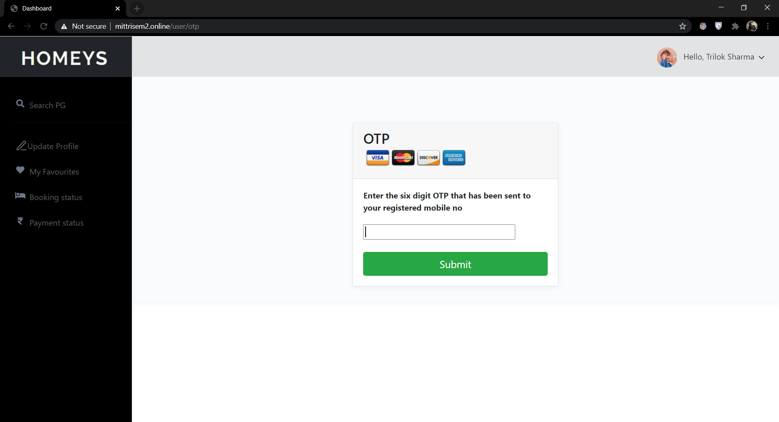

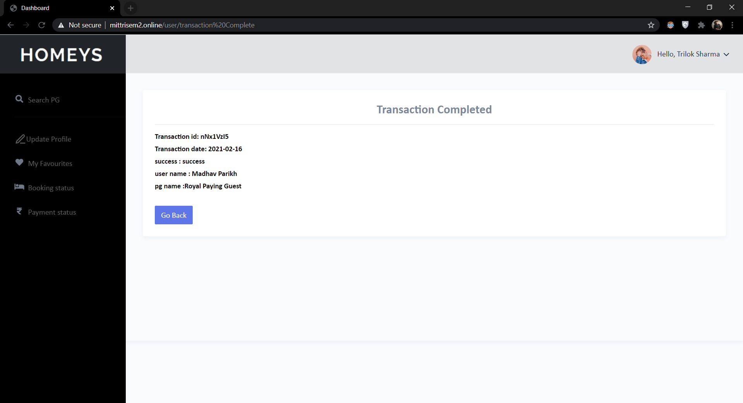

Payment status

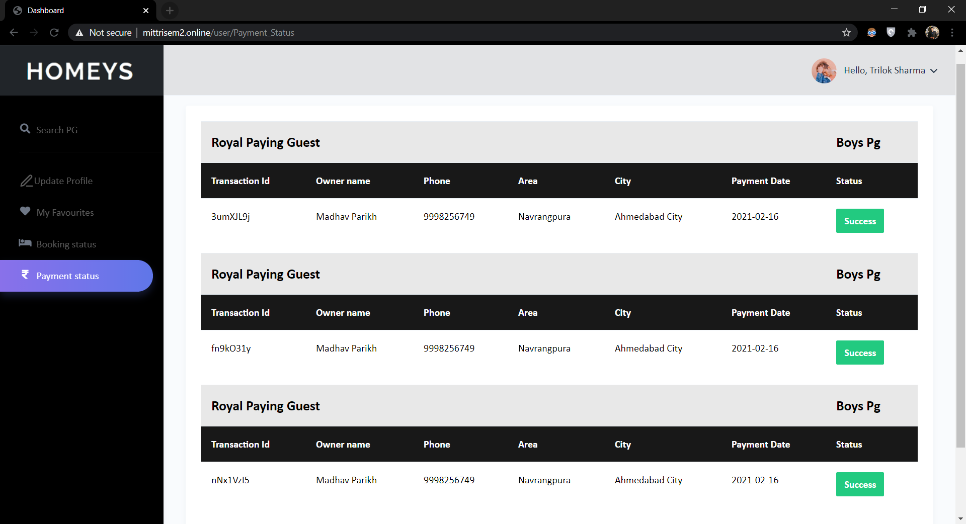

**Admin**

Dashboard

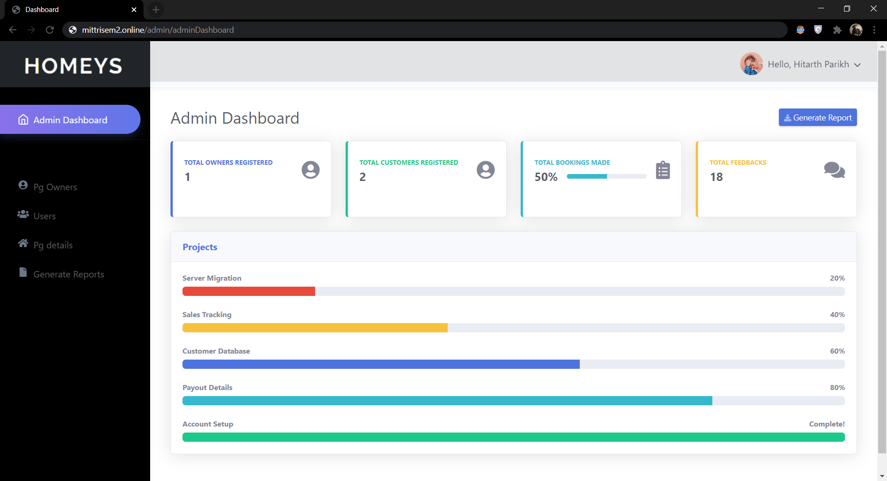

PG Owners

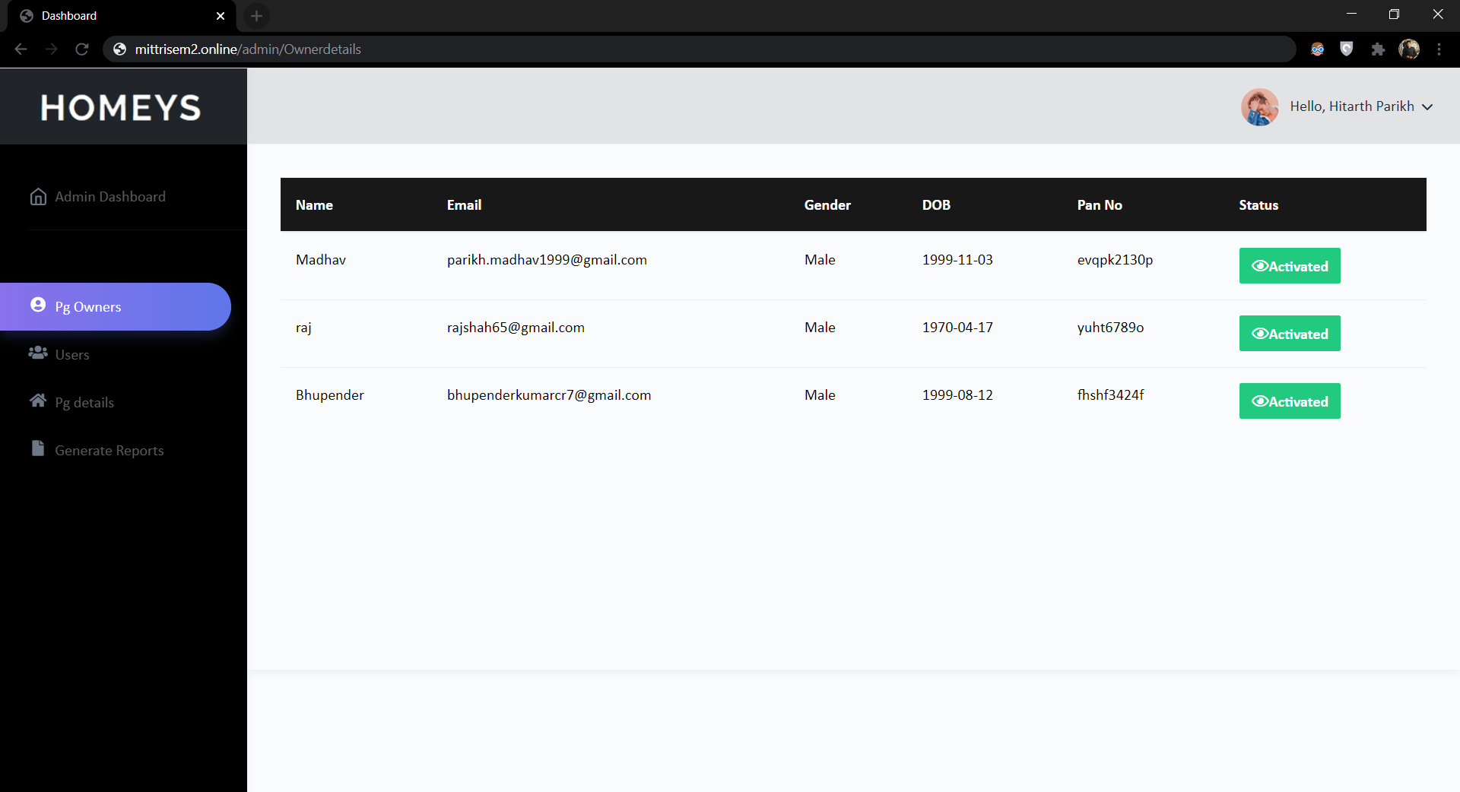

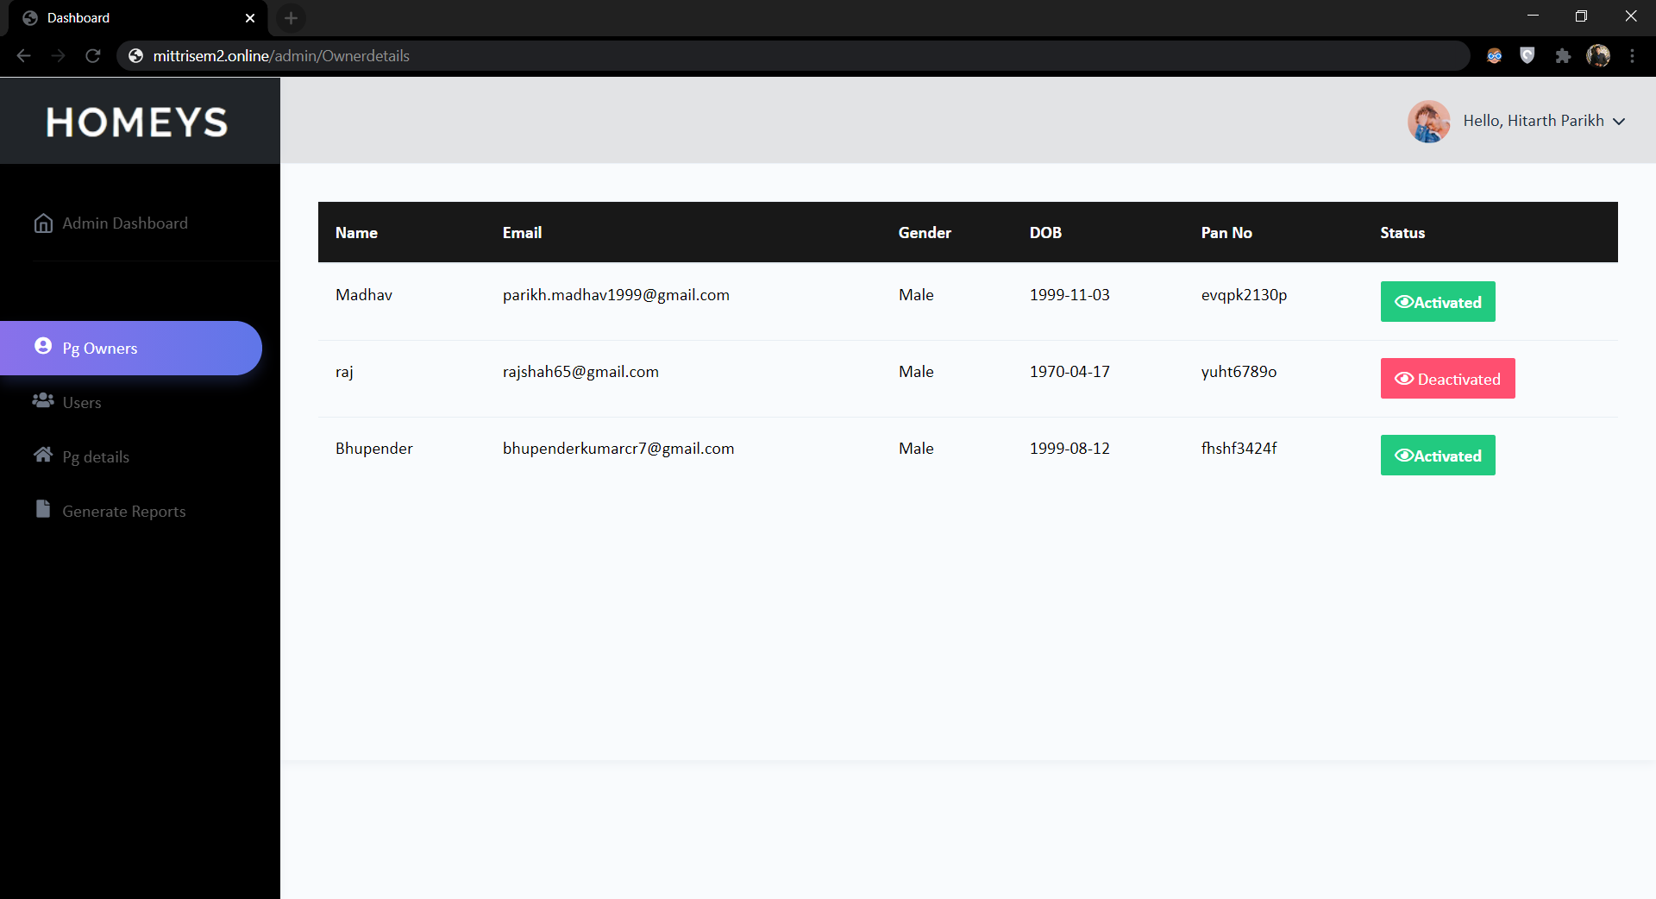

Users

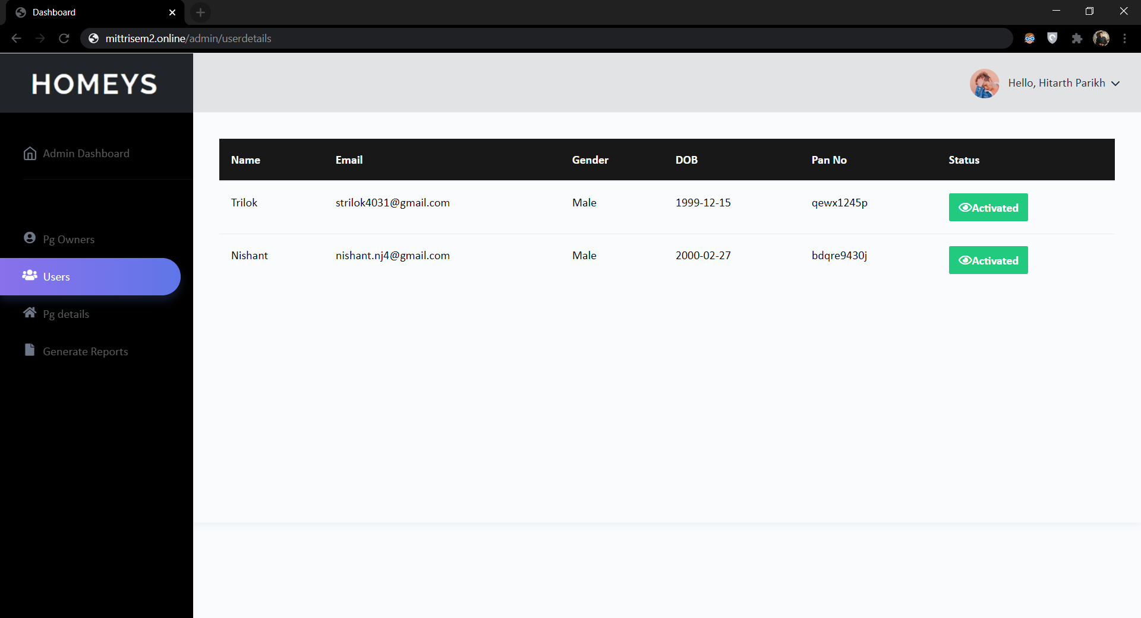

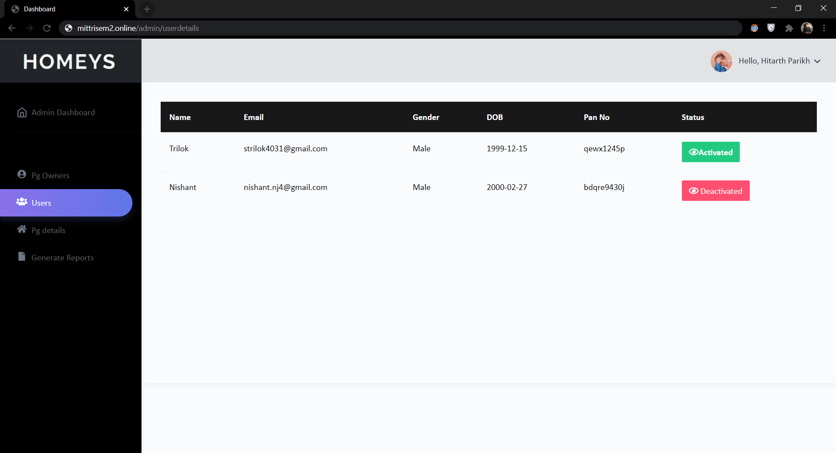

PG Details

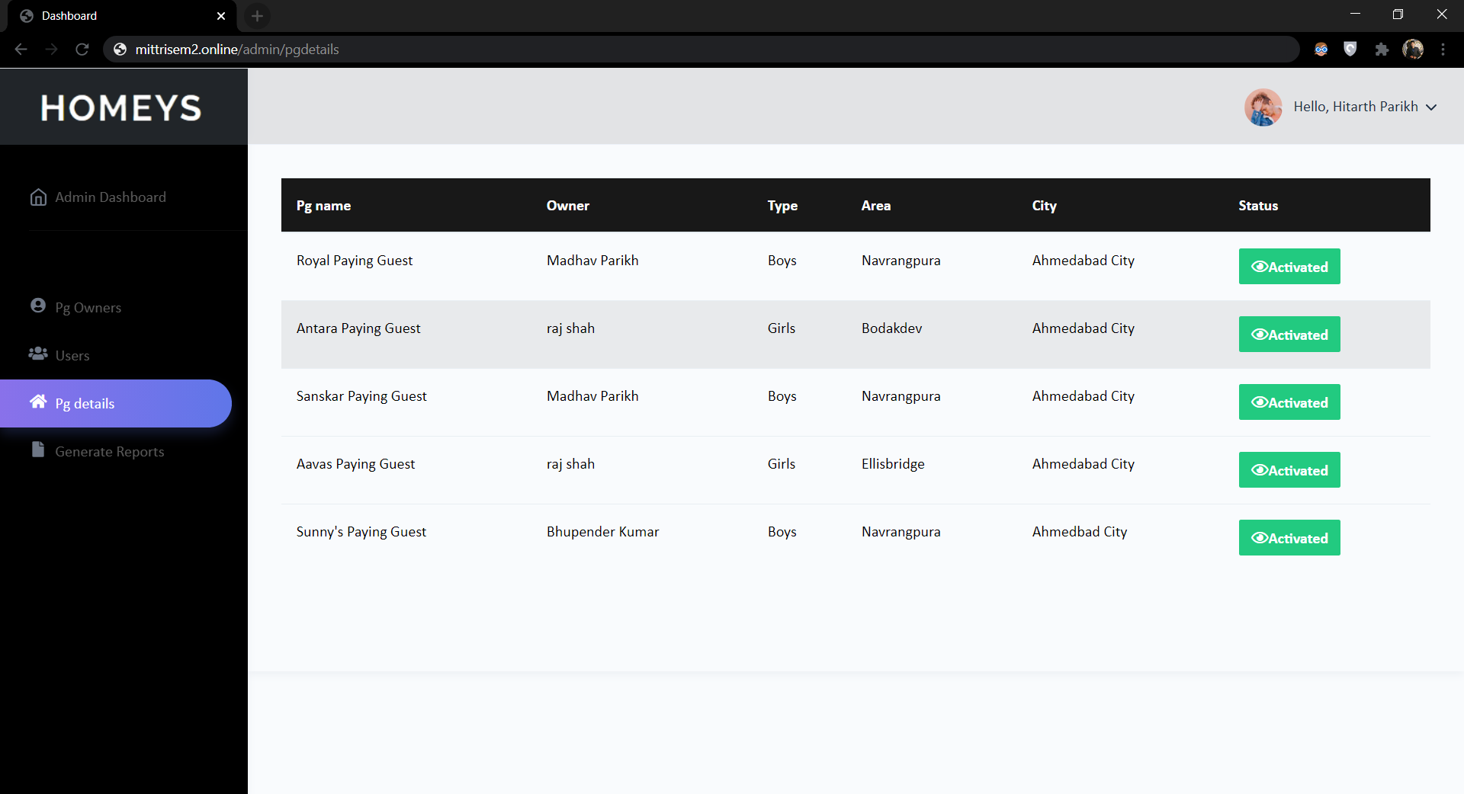

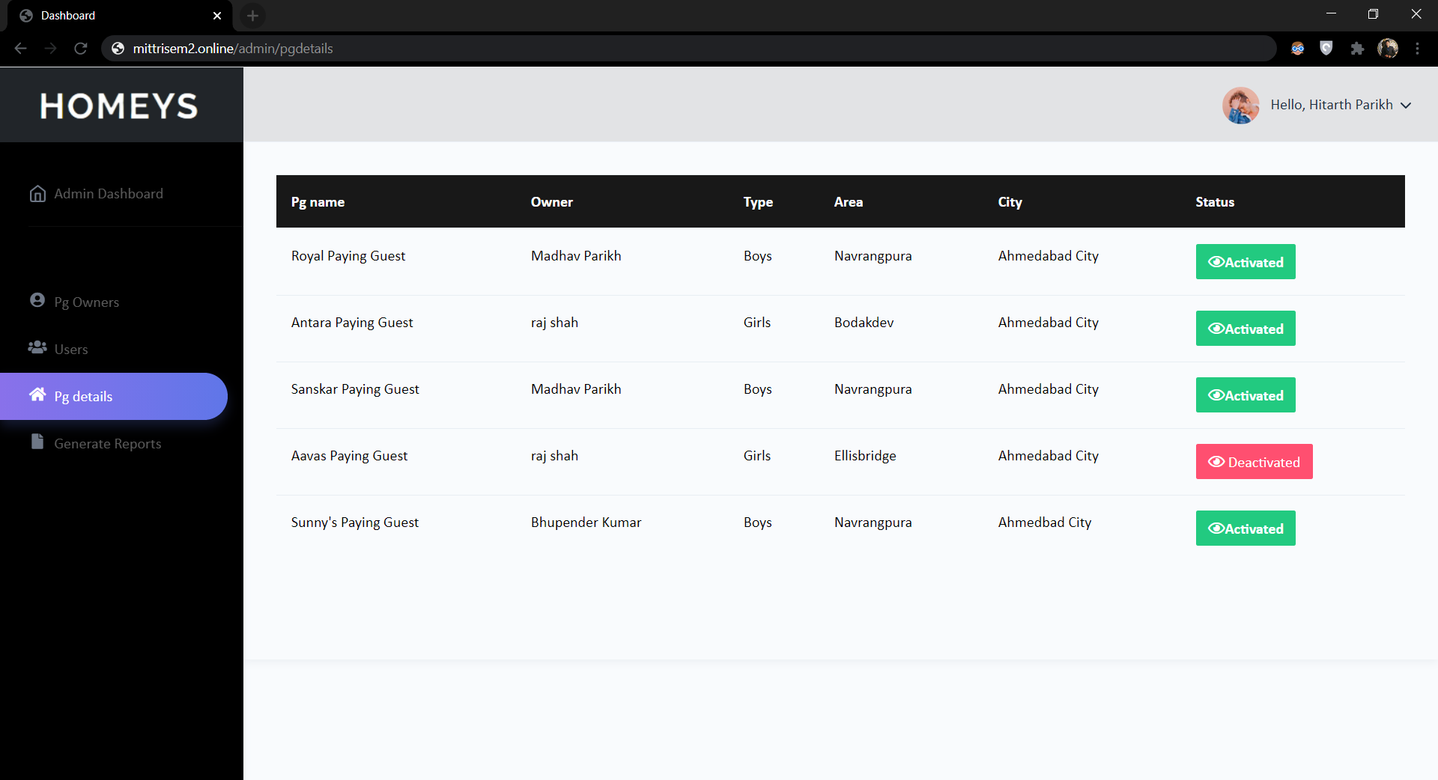

**REPORTS**

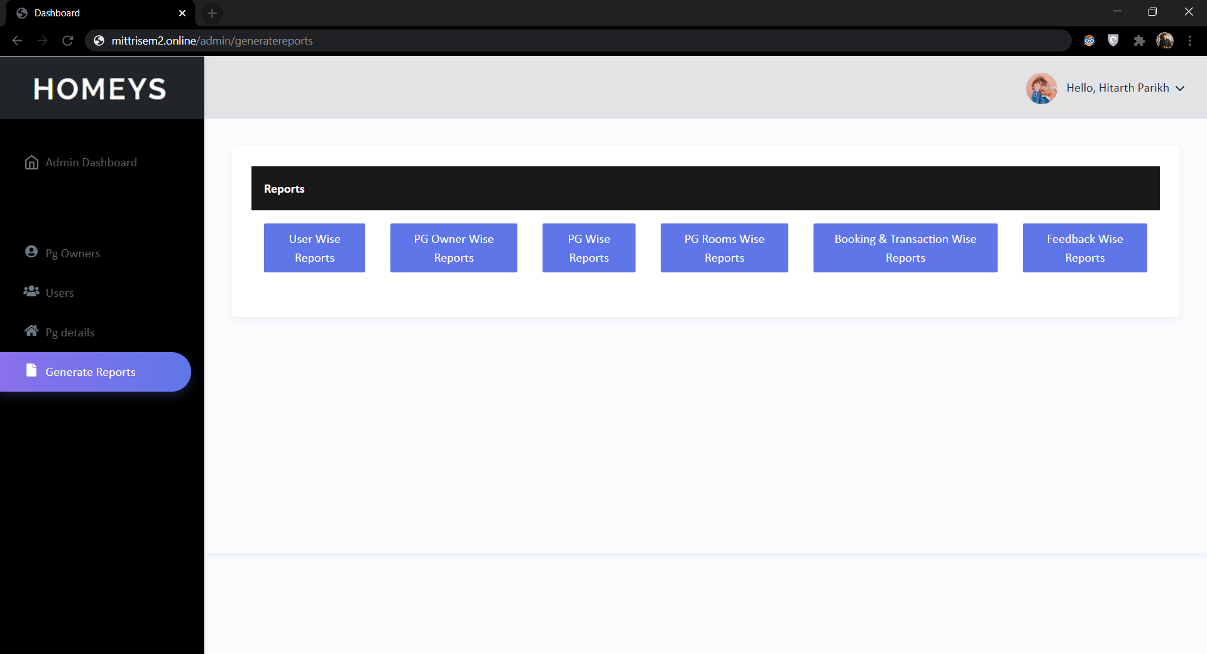

User Wise Reports

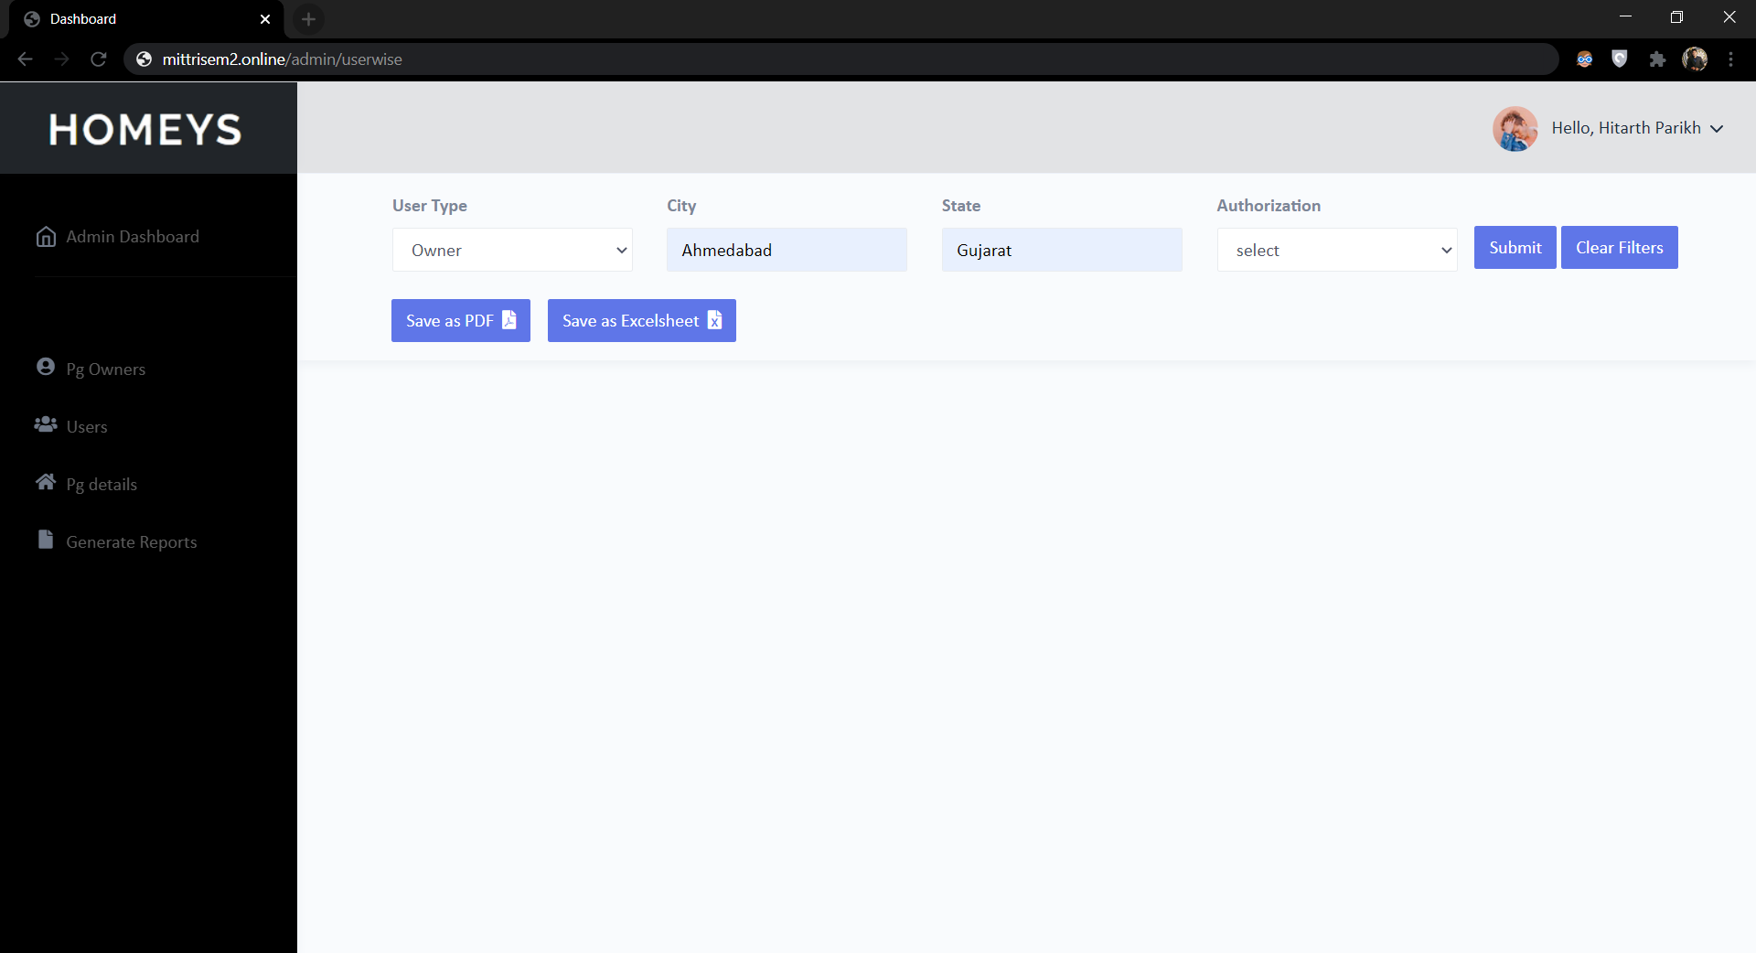

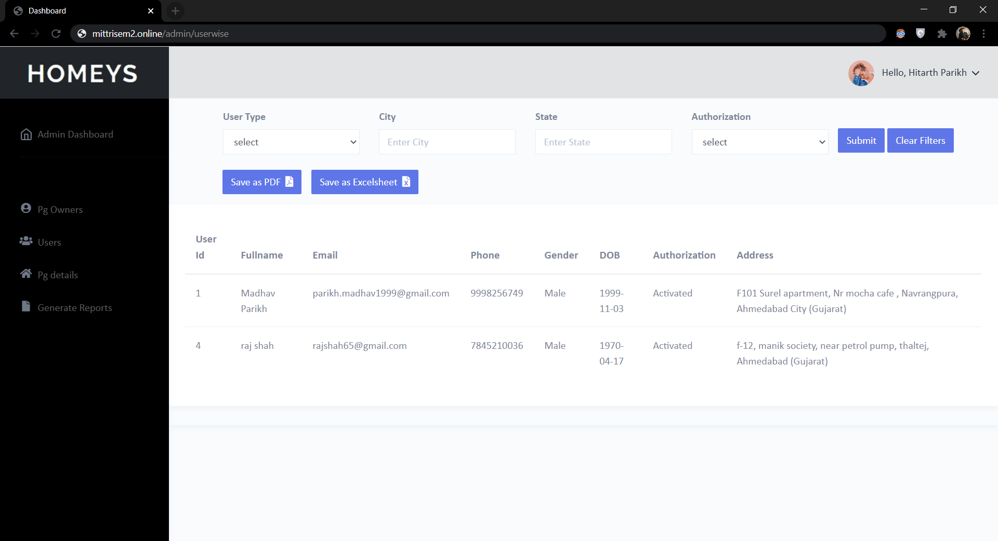

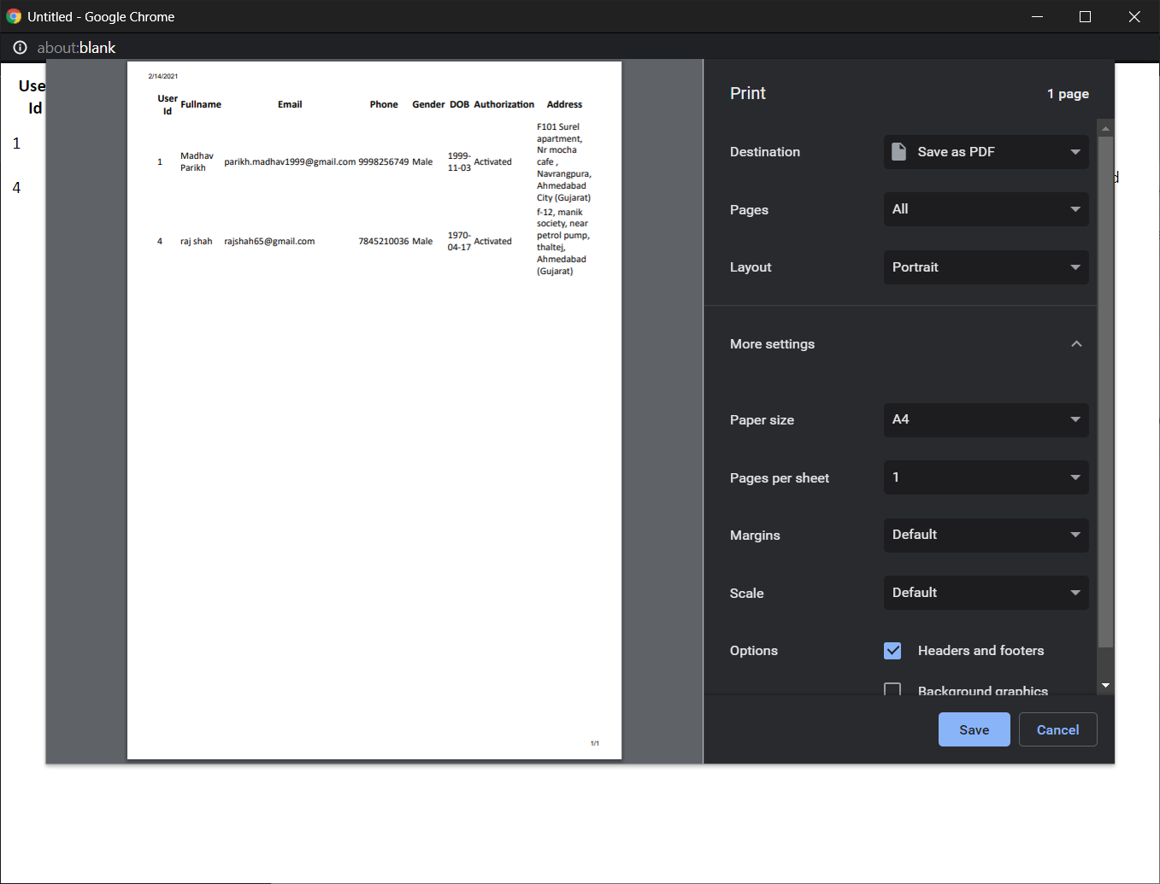



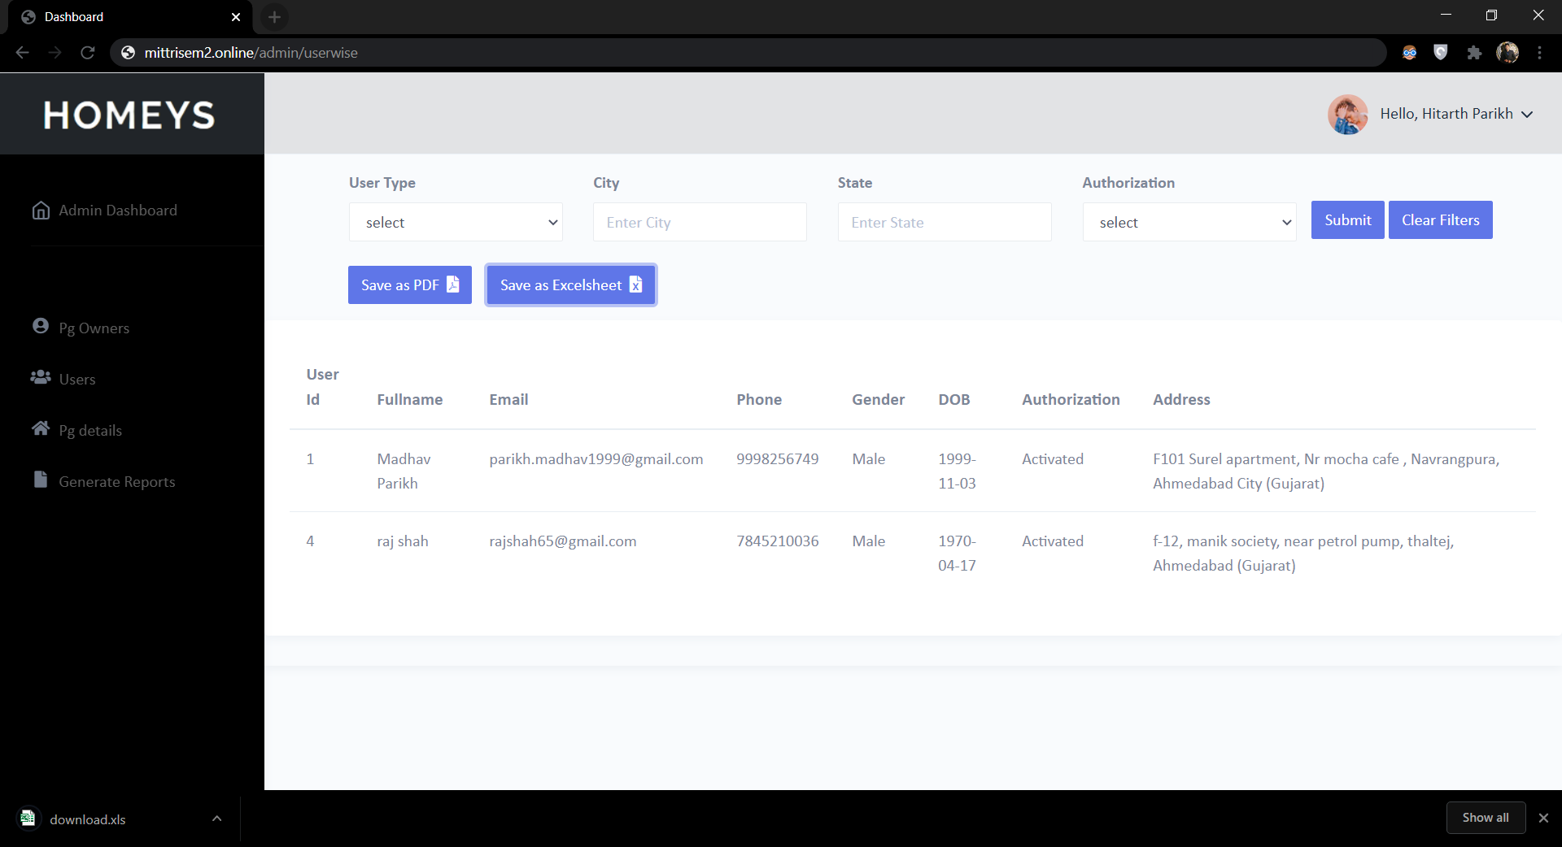

PG Owner Wise Reports

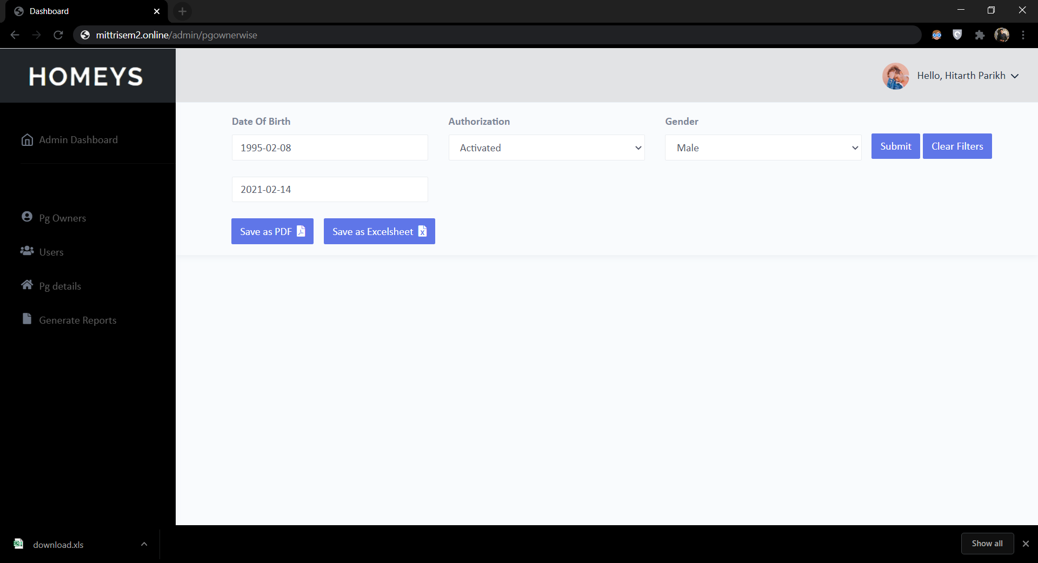

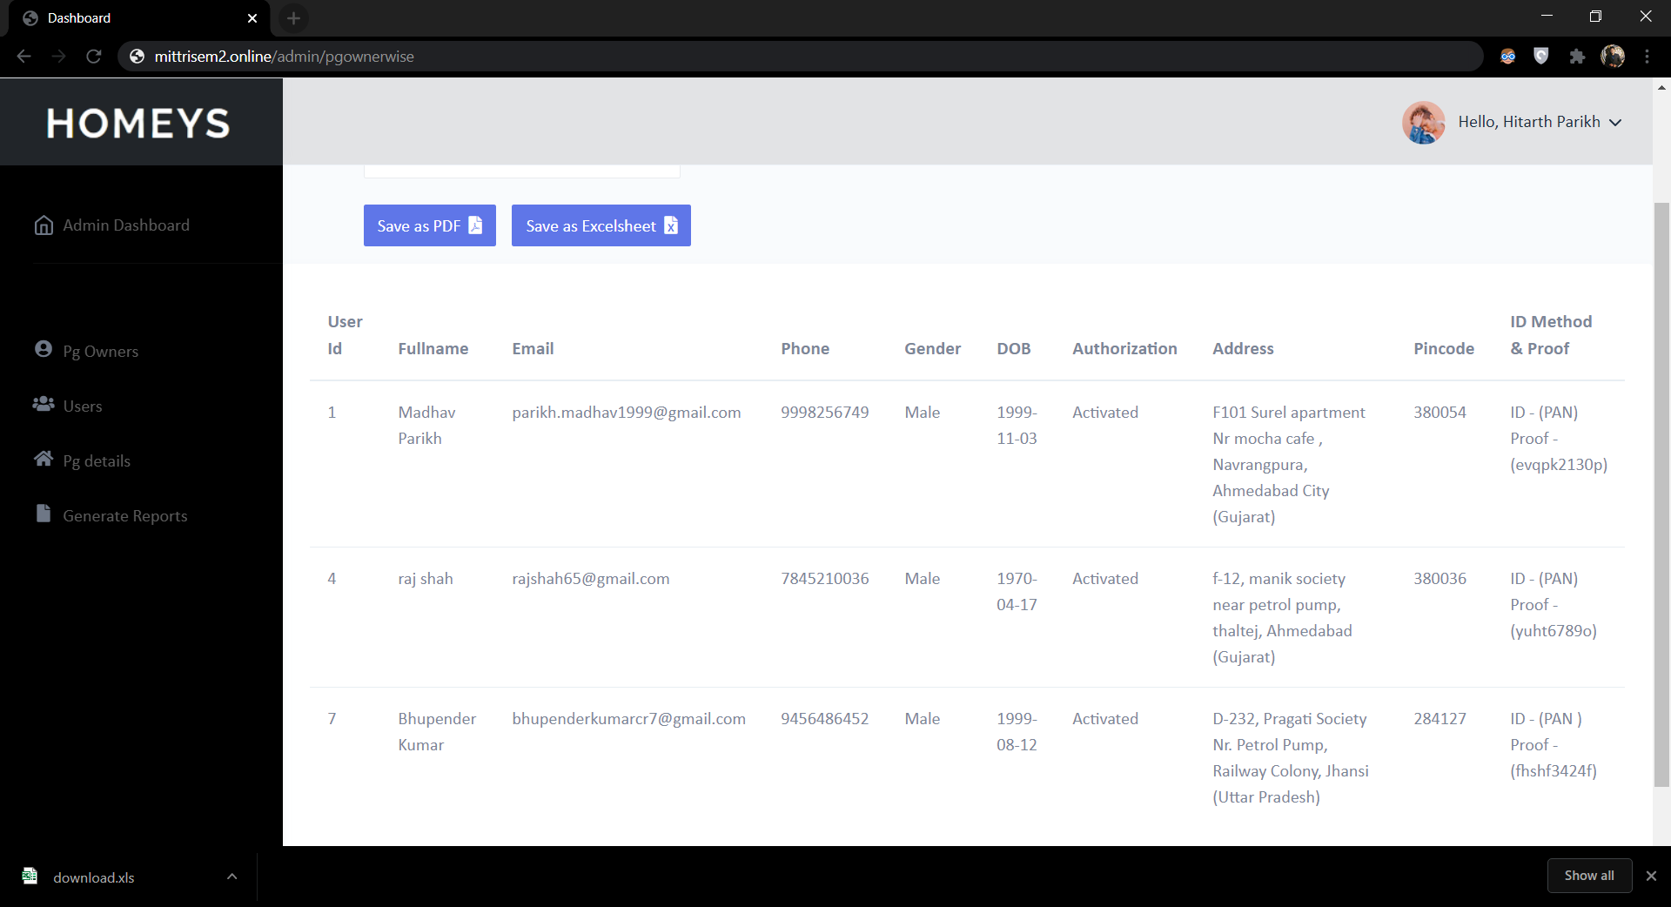

PG Wise Reports

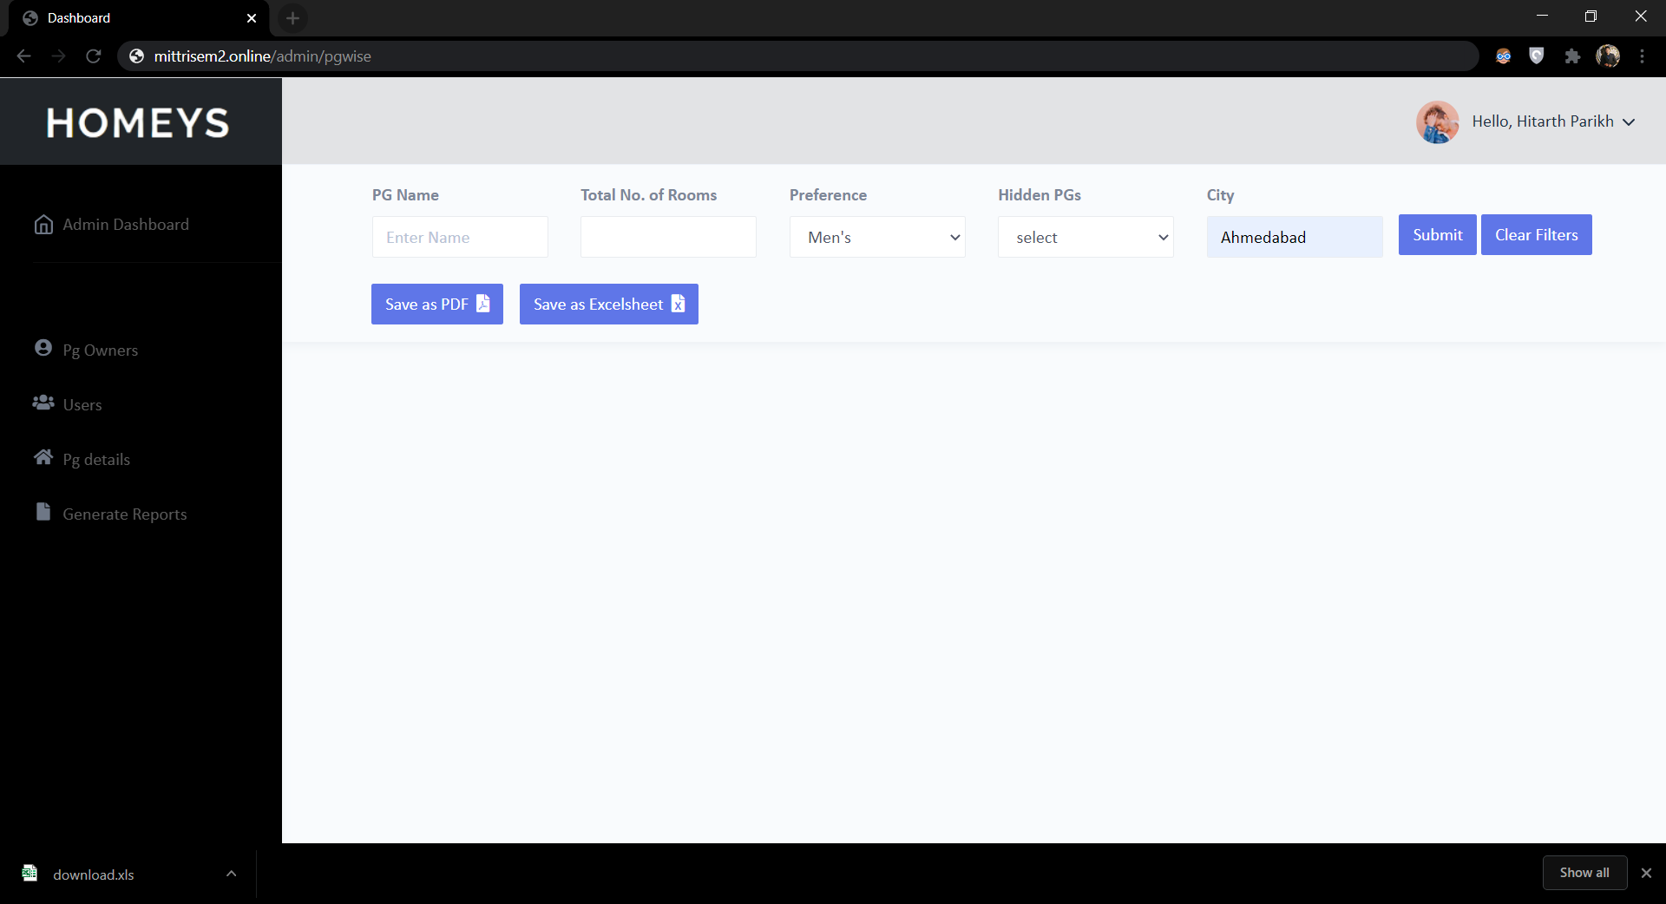

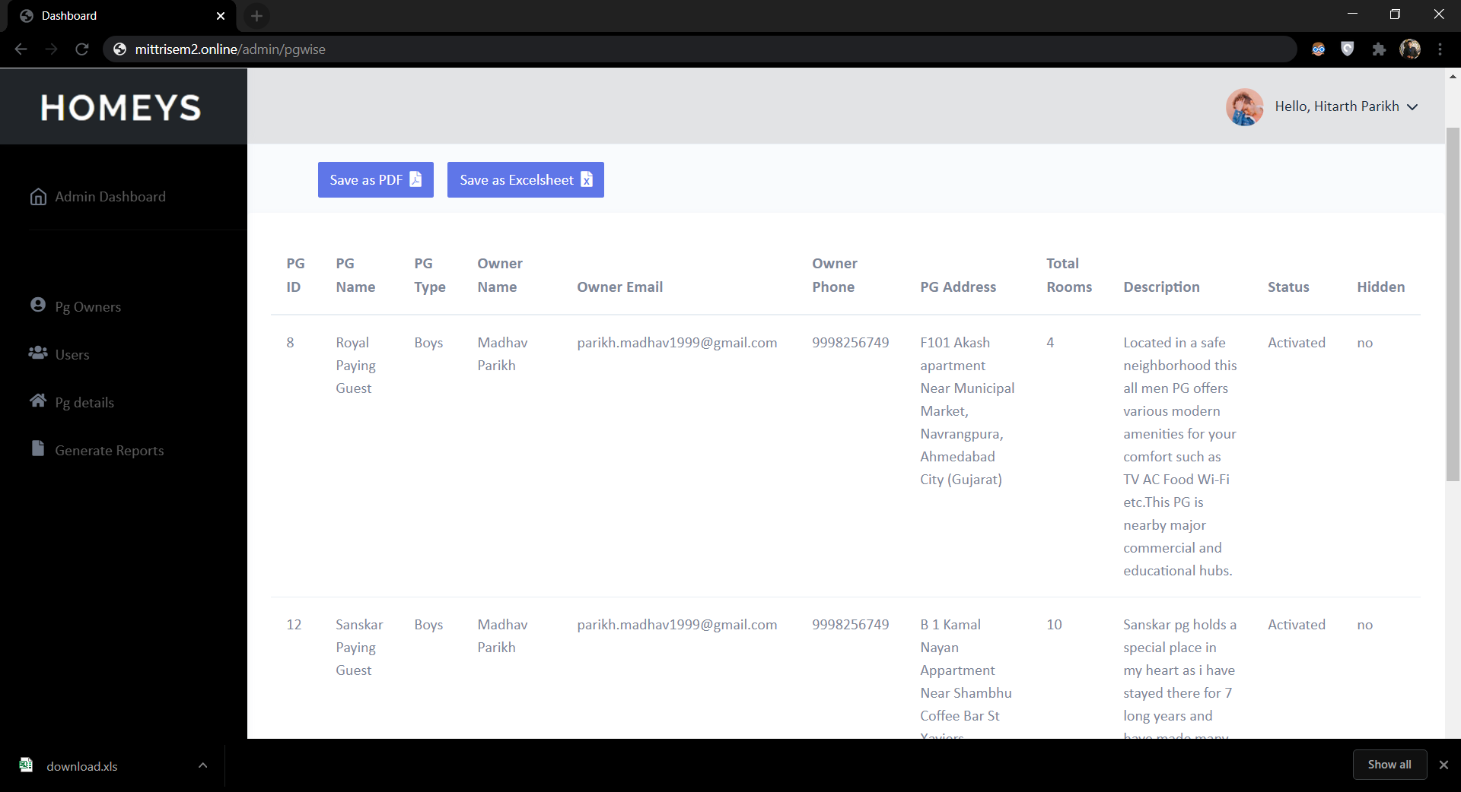

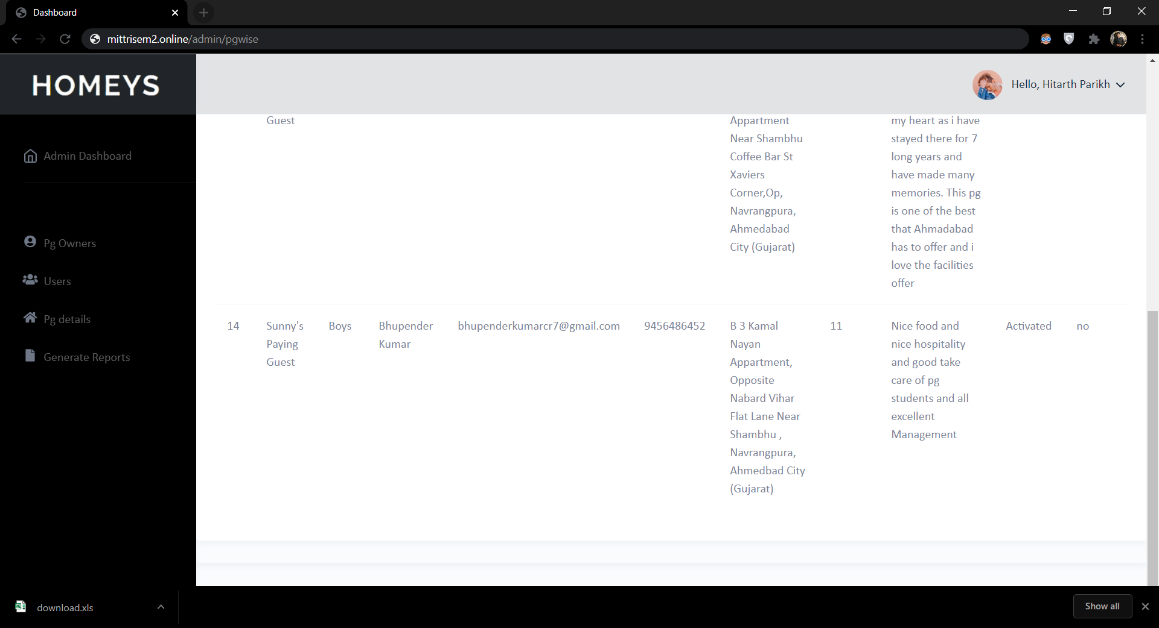

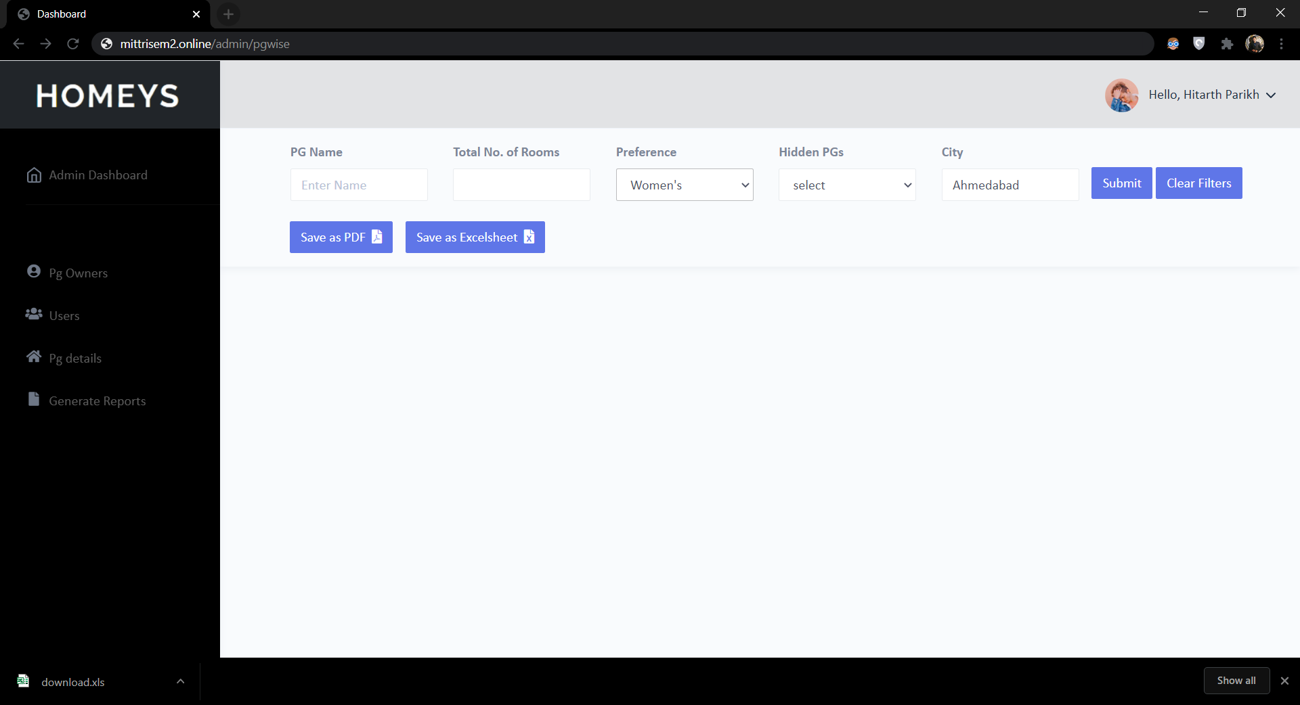

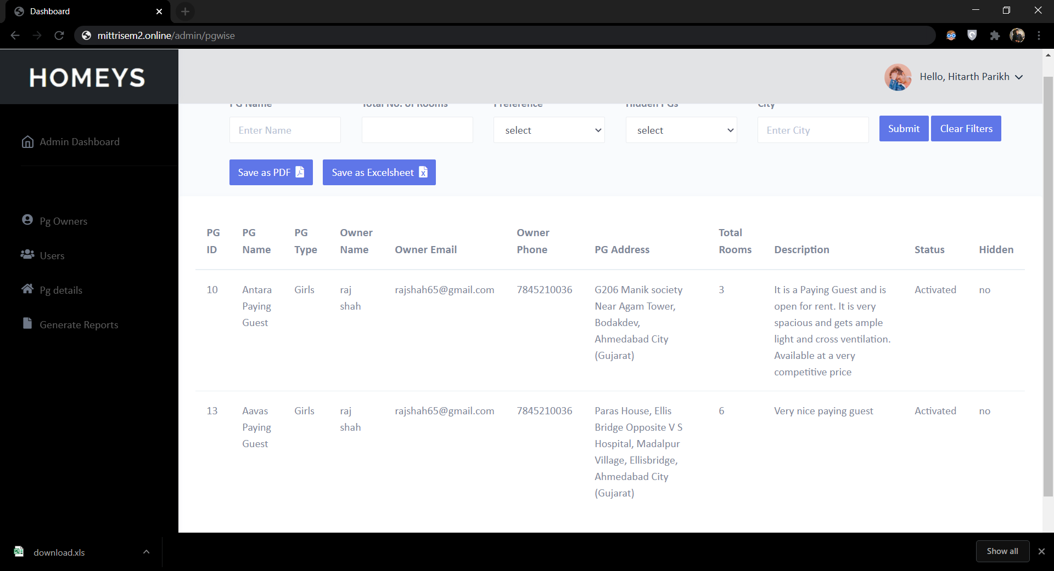

PG Rooms Wise Reports

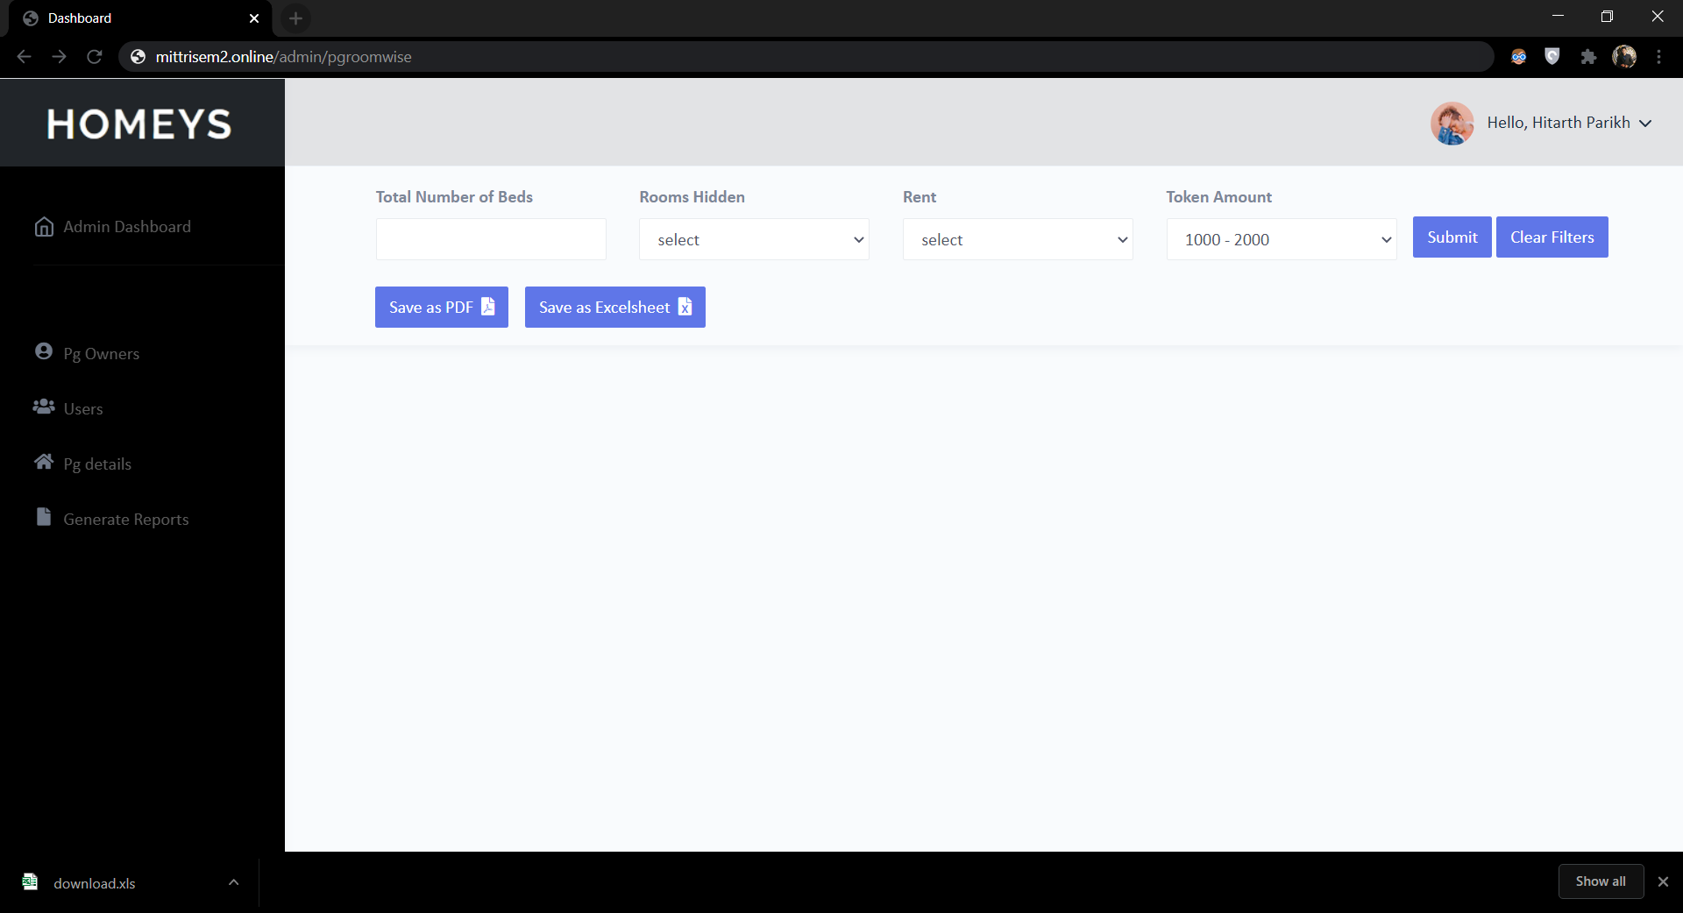

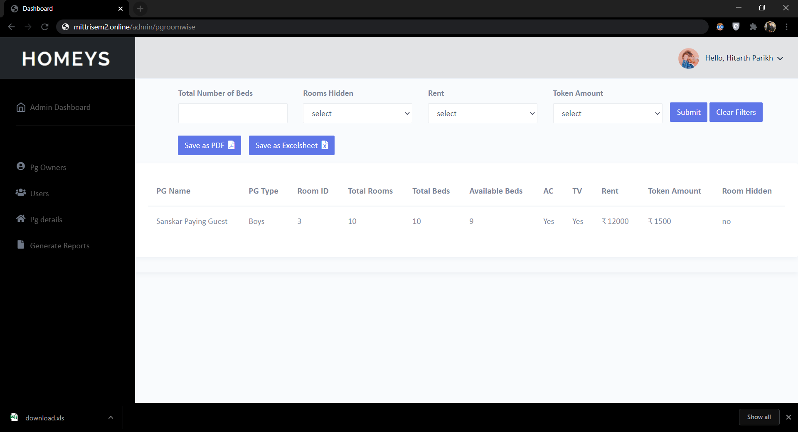

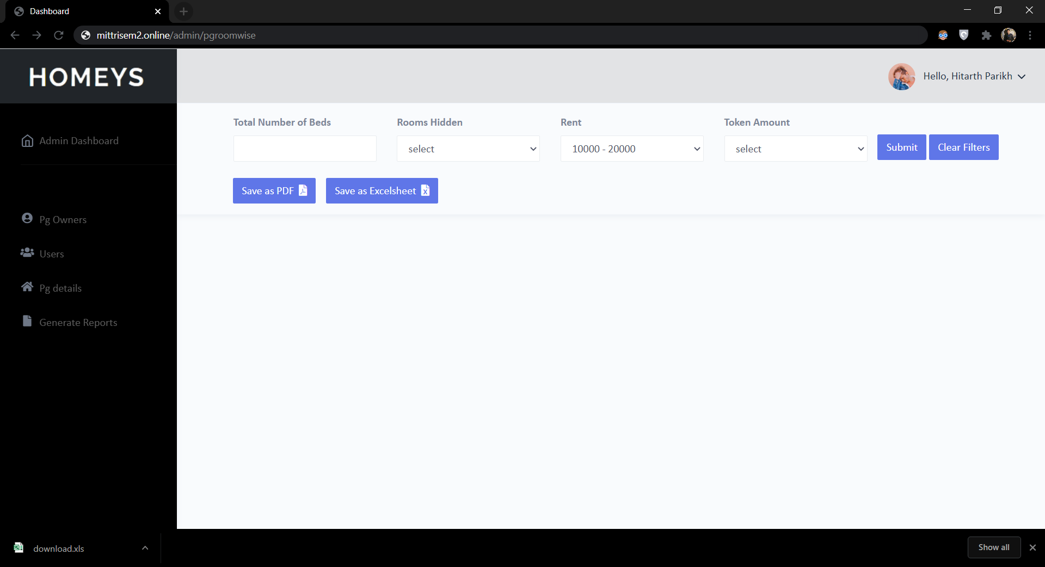

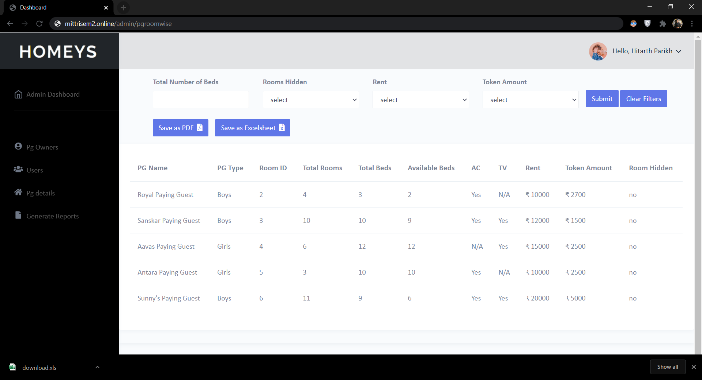

Booking and Transaction Wise Reports

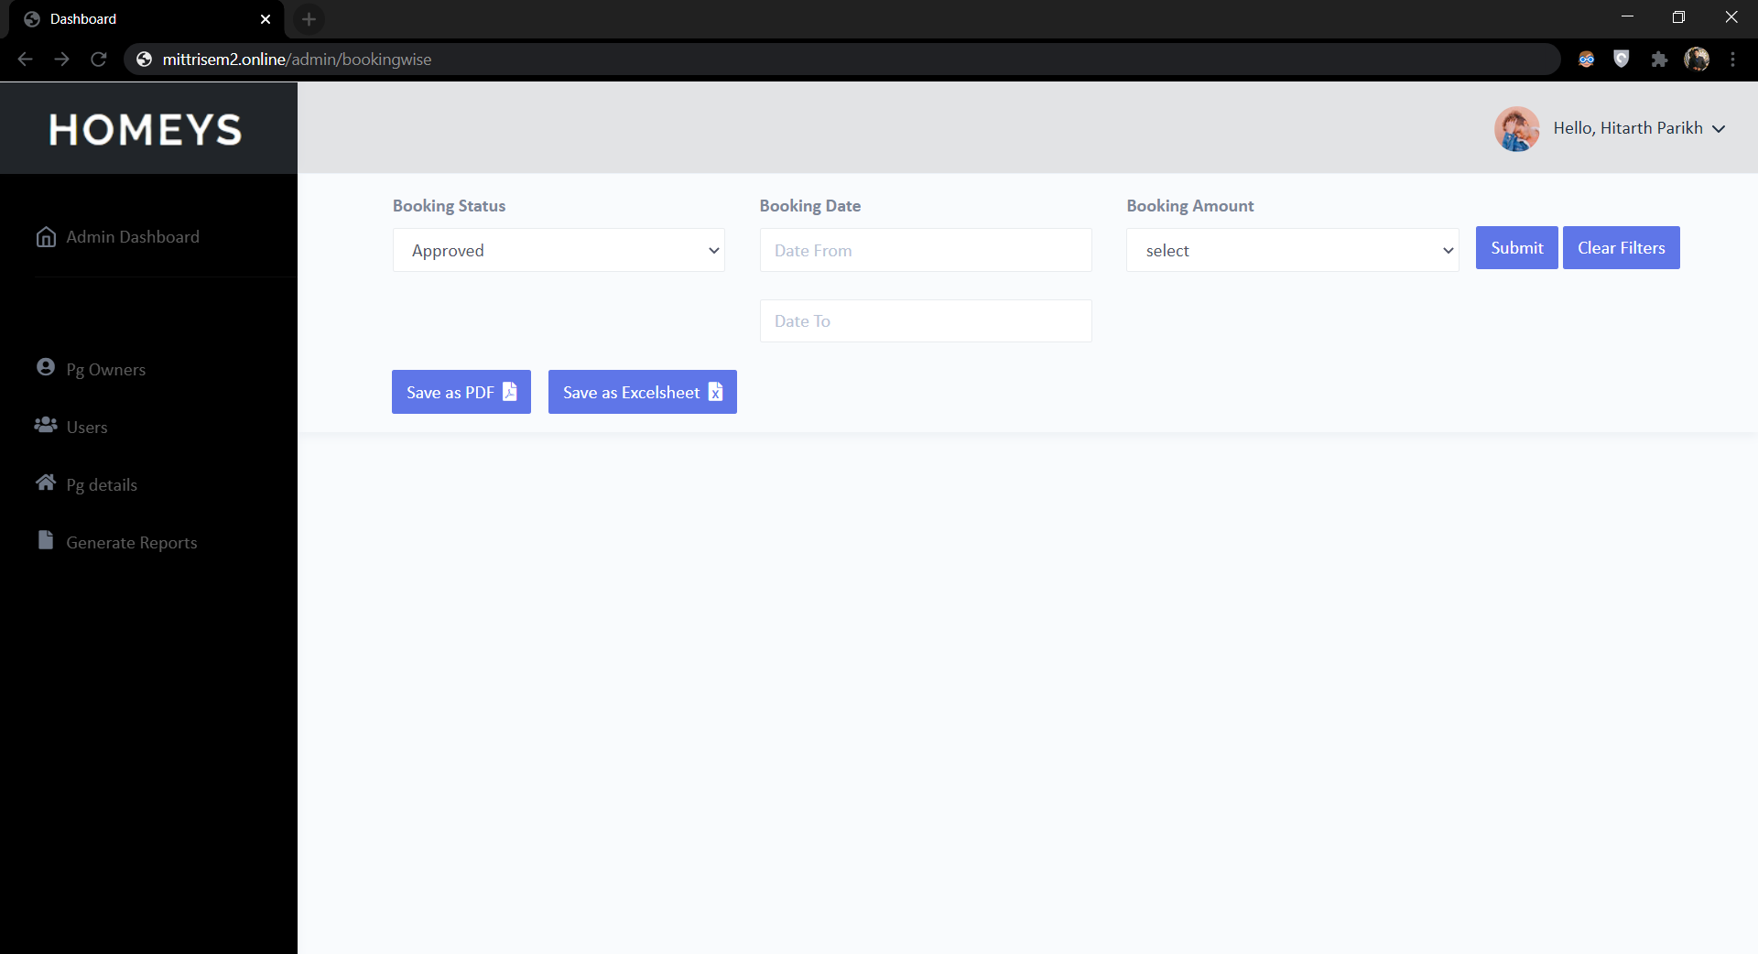

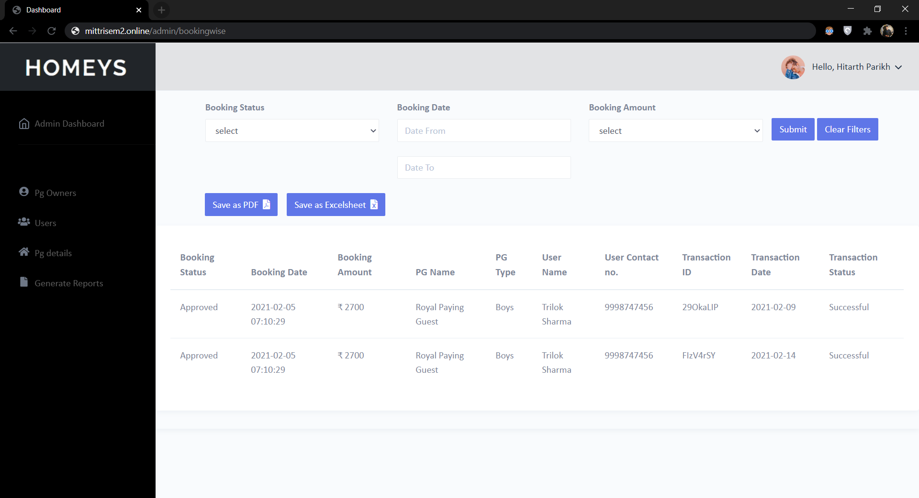

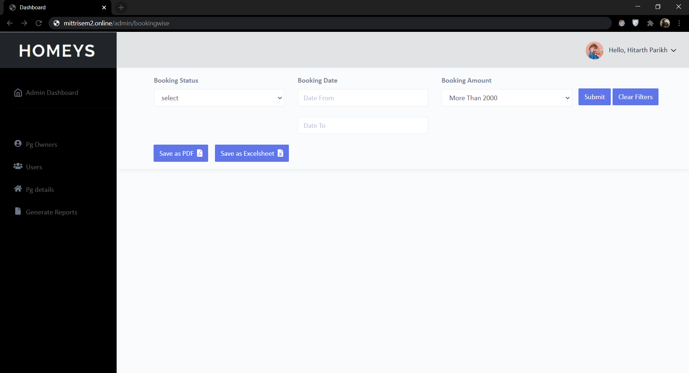



Feedback Wise Reports

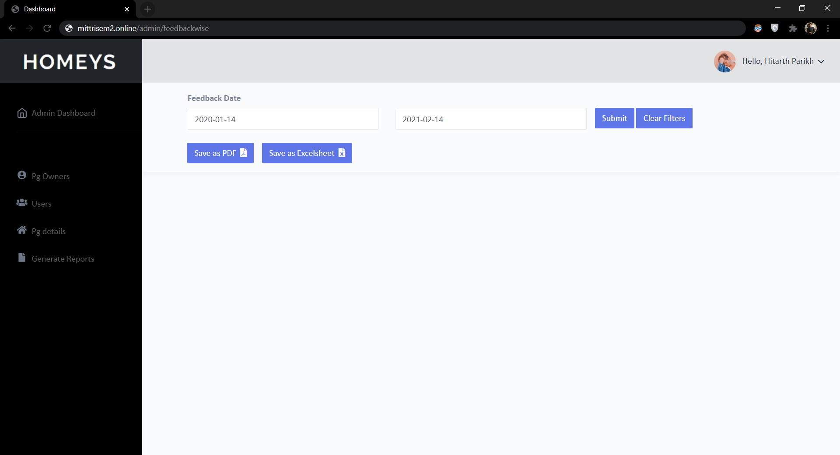

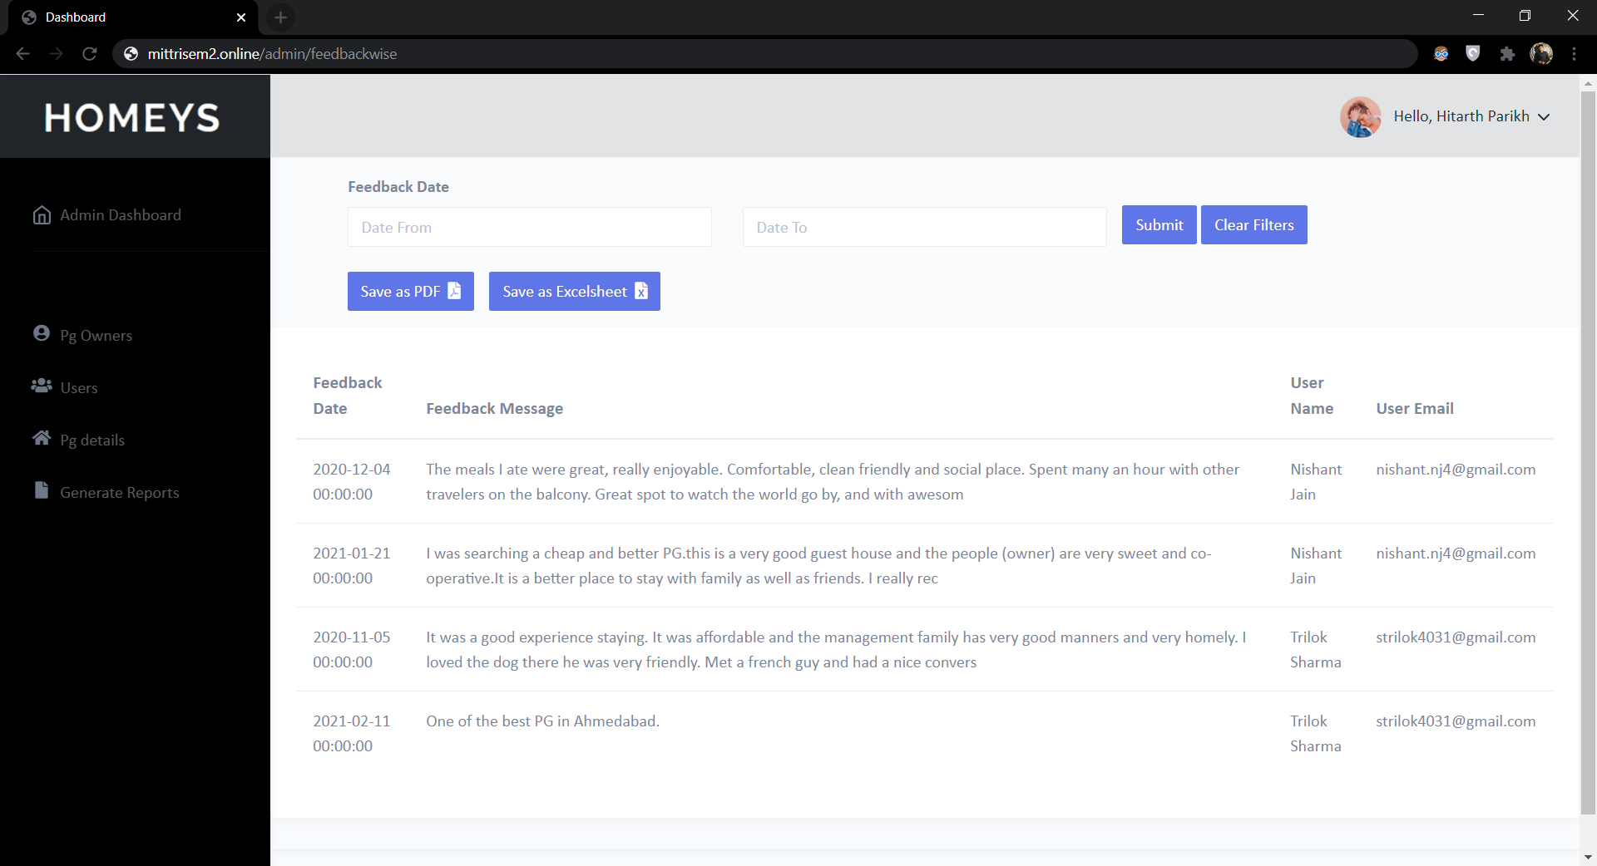

**CONCLUSION**

**Limitations & Drawbacks**

* We are collecting the Customers details manually on our platform.
* All the PGs in a particular area might not be listed on this platform.
* Requires an active internet connection throughout the process.

**Future Enhancements**

We will try to automatize the functionality of our website using API so that the user doesn't have to do majority of the work manually by creating a very flawless process for booking and locating the PG.

**Conclusion**

This platform will ease the process of booking PG Accomodation. The website is authorized and will never redirect you to some unwanted page, every PG is authentic and registered by his/her owner and verified from Admin.

**References & Bibliography**

* <https://stackoverflow.com/>
* <https://github.com/>